UNIT/01: RELATIONSHIPS

READING
IN THIS unIT YOU WILL
LEARN HOW TO
- answer questions using up to three words
- identify key words in a question
- scan a text to find specific information.

Lead-in

 | In pairs, explain the words in the box.  Example: sister: My sister is my parents' daughter / other daughter.  brother : My brother is my parents' son.  cousin : My cousin is my aunt or uncle's son or daughter.  father-in-law: My father-in-law is my husband or wife's father.  grandfather : My grandfather is my mother or father's father.  uncle : My uncle is my mother or father's brother.  aunt : My aunt is my mother or father's sister.  nephew : My nephew is my brother or sister's son.  niece : My niece is my brother or sister's daughter.  great-aunt : My great-aunt is my grandmother or grandfather's sister.  grandmother : My grandmother is my mother or father's mother.  Tell your partner who you live with. Which other family members are you close to?
  01
  sister | brother | cousin | father-in-law | grandfather | uncle
  aunt | nephew | niece | great-aunt | grandmother
 | You are going to read about some advantages of living in an extended family (i.e. not just parents and children living together). Which of the following advantages do you think are the most important?  2, 3, 4 and 5 are mentioned in the text.  - Older people are fun to live with.  - Older people are patient and experienced.  - You can save money by living together.  - Grandparents are not as busy as parents.  - Children get plenty of love and attention.  Read the text quickly and check which are mentioned. Ignore the highlighted words.  TIP 02 | - Blood is thicker than water. This means that family is more important than anyone else. Many young people, though, spend more time with their friends than with their family. They value their friends' opinions more and enjoy their company. When it's time to visit grandma or go to a cousin's wedding, teenagers often prefer to be left at home. But are they missing out?  - In Asia, the Middle East, South America and Sub-Saharan Africa over 40% of children live in families with other adults such as aunts, uncles and grandparents in addition to their parents. In South Africa, it is almost 70%. On the other hand, in Europe, Australia and North America, less than 25% of children live in extended families. Is the lack of close contact with relatives putting some children at a disadvantage?
  02
  Don't worry if you don't know a word in the text. You can often guess the meaning by reading the other words in the sentence. And you may not need to know the meaning to answer the questions.
  BLOOD IS THICKER THAN WATER

- The people they live with have a great influence on the way children grow up. Those who live with their extended family have many advantages. They usually get lots of love and attention. Grandparents often have more time to read to children and play with them. As they are often retired, they are not always busy and stressed as many parents are. They have learnt to be patient and they have already handled most of the problems children and young people face. | - Young people whose grandparents live far away can gain some of these advantages by keeping in close contact by phone, email, letters and visits. It is nice to know there is someone you can go to if you have a problem. As the Italian proverb says, 'Se non sta andando bene chiamare la nonna.'- 'If things aren't going well, call your grandmother."
- It is good for children to grow up to understand the needs of older people: they may become more caring and less selfish if they spend time helping their grandparents. Children learn about the past from grandparents' stories. Sometimes they feel closer to their grandparents than to their parents. | - Friends are important to young people, but friends come and go. Your family is always on your side. Grandparents won't be there forever. Appreciate them while you can.
- Young adults often feel that living alone will be exciting, but they forget that it can also be lonely. By remaining with the family during this stage of their lives, they can avoid this. They can also save money for their education and future.

VOCABULARY

 | Match the highlighted words from the text with their meanings. Start with words you already know. Use the context (the sentence it is in and other words around it) to work out the meaning of the other words.
  03
  - value h  - (have an) influence g  - stressed a  - handled b  - selfish f  - gain c  - proverb e  - appreciate d | - worried; not able to relax  - dealt with, had experience of  - get (something positive)  - be grateful for  - a well-known phrase giving advice  - caring only about yourself and not other people  - (have an) effect (on)  - believe something is important
[[[[[[[[[[SHORT-ANSWER QUESTIONS]

◉ In this type of task you have to answer questions using up to three words, or up to two words and/or a number. The instructions tell you how many words you can use. Short-answer questions test if you can find the right part of the text quickly and understand the information.

FINDING INFORMATION
 | To practise finding information quickly, have a race with your partner to find the following phrases in the text. They are not in order.  To find information quickly, don't read every word. Don't try to say the words. Move your eyes quickly across and down the text. Use your finger if you find it useful.  How did you do this? Can you explain to another student how to find information quickly?
  04
  - grandparents' stories  paragraph D  - cousin's wedding  paragraph A  - young adults  paragraph E | - extended family  paragraph B  - come and go  paragraph G  - Italian proverb  paragraph F

IDENTIFYING THE KEY WORDS IN A QUESTION

◉ Before you look for the answer to a question, it helps if you find the key words - the most important words - in the question. This will help you find the information you need.
Example: What do young people often think about older family members?

 | Identify the key words in these questions.  - What percentage of children live in extended families in Asia, the Middle East, South America and Sub-Saharan Africa?  percentage/children/ extended families / Asia, the Middle East, South America, Sub-Saharan Africa  - Why are grandparents often less busy and stressed than parents?  grandparents/less busy/stressed/parents  - What do young adults often think living alone will be like?  young adults/think/living alone
  05

SCANNING A TEXT

◉ When you are answering a question:
- Decide on the key words in the question and think of words with a similar meaning.
- Move your eyes quickly across and down the text, looking for the key words, or words that mean the same. Don't read every word. This is called 'scanning'
- If the text has headings, use them to help you decide which part of the text to look at first.
- When you find a key word, read the text around it to make sure you have found the right information.

 | Answer the questions in exercise 5. Follow the advice in the box.  over 40%  They are often retired.  (They think it will be) exciting.
  06
 | Read this exam task and the answers to the questions. What is wrong with the answers? Match the answers 1-4 with the advice a-d below.  Answer these questions. Choose NO MORE THAN TWO WORDS AND/OR A NUMBER from the passage for each answer.  - b  d  a  c  Question 1 What percentage of children in South Africa live with their extended family?  Answer 1: 20%  Question 2 What helps children in extended families learn about the past?  Answer 2: grandparents storys  Question 3 What negative word can describe how it sometimes feels to live alone?  Answer 3: Living alone can be lonely.  Question 4 According to the Italian proverb, who should you phone when you have a problem?  Answer 4: your gran  - Don't write more than the number of words you are given.  You mustn't write full sentences.  - Make sure that you use the correct information when you answer a question.  - Don't change words in the text. Remember, the instructions tell you to choose words from the text.  - Be careful with spelling. You can lose marks if your spelling is wrong. | TIP 07
  07
  Some grammar words (e.g. a, the, some) can be omitted in order to get the right number of words.
 | Now correct the answers in exercise 7.  - over 40%  grandparents' stories  lonely  your grandmother
  08

GRAMMAR FOCUS: TENSES

 | Answer these questions.  - What tense are most of the verbs in the text?  present simple  - Choose the correct reason for the choice of tense.  b  - The verbs describe events which are happening now.  - The verbs describe things that are generally true.  - The verbs give the writer's opinion.
  09

GRAMMAR FOCUS: ADVERBS OF FREQUENCY
 | Identify the frequency adverbs in these sentences from the text.  - Your family is always on your side.  always  - Teenagers often prefer to be left at home.  often  - As they are often retired, they are not always busy...  often; (not) always  - They usually get lots of love and attention.  usually  - Sometimes they feel closer to their grandparents than to their parents.  Sometimes
  10
  ◉ Grandparents often have more time to read to children.
  Often is an adverb of frequency. It gives us an idea of how often something happens. The present simple tells us about regular events, and adverbs of frequency are common with this tense.
 | Study the position of the frequency adverbs in the sentences in exercise 10. With a partner, work out some rules on the position of frequency adverbs.  The frequency adverb is usually between the subject and the verb. (I often cook). When the verb is 'to be', the adverb comes after the verb. (It is always cold.) Some frequency adverbs can also start a sentence. (Sometimes I watch TV.)
  11
[[[[[[[[[[EXAM SKILLS]
 | Read the passage and answer the questions below.
  12
SOCIAL MEDIA AND THE MEANING OF FRIENDSHIP
There have been a lot of scientific studies into what makes a friendship. It seems today that ideas of what friendship is are also changing. A study in 1993 at the University of Oxford showed that people could only maintain 150 relationships. However, with the explosion of social media since then, many people now have over 300 people who they think of as friends. Some people think that these friends are not real friends, but others believe that social media has helped us to expand and keep our friendships because we have more time and opportunities.  Another change from the past is that people don't stay in the place where they were born. They go to different cities and countries for education and jobs. People are in general more geographically mobile nowadays. This means that we have more chances to meet and make friends with people from different cultures and different backgrounds. People still often make friends at college who remain friends for life, but | making new friends at work is more difficult. People now have less security at work and this also means that they find it harder to build new relationships.  As people get older, they sometimes also have less free time. They become busier with their jobs and families and have less time to spend with friends. Friendships can be very different when we are at different ages. Young children often choose their friends because of convenience, for example, they go to the same school, they live near each other or their parents are friends. As we get older, friendships are more connected with having similar interests and opinions.  One thing is definitely true though, it doesn't matter how old we are or how many friends we have on social media, friendship is good for our health. People who spend time with friends have fewer mental health problems and are generally happier and in a better physical state of health than people who spend their free time alone.

Answer the questions below. Choose NO MORE THAN THREE WORDS from the passage foreach answer.
- What has enabled people to have more friends than in the past, according to some people?
social media
- What phrase does the writer use to describe people who don't stay in the same place?
geographically mobile
- What work-related problem do people have that makes them less likely to form friendships?
less security
- What frequently influences the friendships of young children?
convenience
- What are people with friends less likely to suffer from?
mental health problems

UNIT/01: RELATIONSHIPS

WRITING
IN THIS unIT YOU WILL
LEARN HOW TO
- describe a process (Writing Part 1)
- use sequencing expressions to describe the order of stages in a process
- use the present simple passive to describe a process
- write an introduction and overview.

Lead-in

 | What foods do you eat at a family celebration? Do you know how to prepare them? Do you need any special equipment?
  01
 | In Sri Lanka, a family meal often includes stringhoppers. To make stringhoppers you need some special equipment. Choose the best description of each piece of equipment. |  | 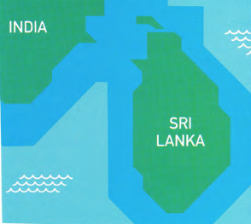
  02
  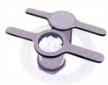 | - Stringhopper press B  - It has two parts which are different in shape but the same size. It is made of a light material such as plastic.  - It's made of heavy metal and has two parts which are similar in shape. The centre is round and there are handles on each side. One part fits into the other.  - It has two parts and one goes on top of the other. It is square in shape and made of wood.
  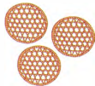 | - Stringhopper mats A  - These are round shallow baskets made of thin pieces of wood. The wood is in a criss-cross pattern to form large holes.  - These are cloth triangles with very small holes in them.  - These are thick pieces of wood with rectangular holes in them.
  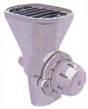 | - Stringhopper mats C  - It is made of metal and the top and bottom are the same size and shape.  - It is a metal machine with a wide base and a narrow tray on top.  - It is a machine made of metal with a wide tray at the top and a narrower base.

 | Complete the chart with words from exercise 2.
  03
  Materials | Parts | Shapes
  Plastic  metal  wood  cloth | Handles  base  tray | round  square  triangle  rectangular

[[[[[[[[[[PART 1: DESCRIBING A PROCESS]
 | The pictures show the process of making stringhoppers.  Match the short instructions to the pictures.  1: c 2: b 3: f 4: a 5: d 6: e |  |  | TIP 04
  04
  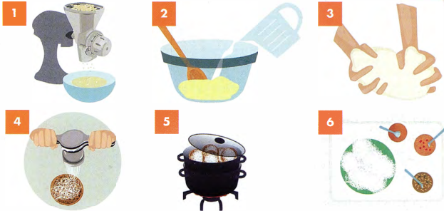
  Don't worry if you don't know a word in the text. You can often guess the meaning by reading the other words in the sentence. And you may not need to know the meaning to answer the questions.
 |  | - push through the stringhopper press onto the stringhopper mats  - add water to the flour  - put the rice into the grinder and grind into flour  - cook in a steamer  - serve with spicy curries  - mix well to form a dough
  ◉ We use the present simple passive to describe a process.
  We make them with rice. → They are made with rice.
  You mix it with water. → It is mixed with water.

GRAMMAR FOCUS: THE PRESENT SIMPLE PASSIVE

 | Complete the sentences about tea. Use the verbs in brackets in the present simple passive.  Tea leaves are picked(pick) by hand.  Only the best leaves are used(use).  A lot of water is needed(need) to grow tea plants successfully.  A lot of tea is grown(grow) in China and India.
  05

GRAMMAR FOCUS: SEQUENCING WORDS

 | Complete the sentences about making stringhoppers with words from the box.  - First, the rice is put through a grinder.  - After that, water is added to the flour.  - Then/ Next it is mixed and made into a dough.  - The next stage is to push the dough through the stringhopper press.  - Next I Then the stringhoppers are placed in a steamer.  - Finally, they are served with spicy curries. | TIP 06
  06
  After | Finally | First | Next | The next stage | Then
  When describing the stages in a process, it is important to use sequencing expressions, for example first, then, next, to clearly show the order of the stages.

WRITING AN INTRODUCTION AND OVERVIEW

 | Which of these is an introduction and which is an overview?  - There are six stages in the process of making stringhoppers, beginning with grinding the rice and making a dough and ending with using a steamer to cook the stringhoppers.  overview  - The diagram demonstrates the process of preparing stringhoppers, a kind of noodle.  introduction
  07
  ◉ In Writing Task 1 your answer should include an introduction and an overview. The introduction is usually the task question rewritten in your own words. The overview is a summary of the process.
 | Which of these are NOT overviews?  a and d are not overviews  - The process of making blue cheese can be seen in this series of pictures.  - To make a perfect omelette you need fresh ingredients, the right equipment and the correct technique. You must also cook it for the correct amount of time and pay attention to the temperature.  - The production of tea involves a range of stages, from picking the leaves from the plant to drying and distributing it.  - The diagram shows the various stages in the process of making strawberry jam.  The first stage is to pick the strawberries when they are ripe.
  08

STUDYING A MODEL ANSWER

 | Study the essay opposite and find:  - the introduction  The diagram demonstrates the process of preparing stringhoppers, a kind of noodle dish.  - the overview  There are six main stages in the process, beginning with grinding the rice and making a dough and ending with using a steamer to cook the stringhoppers.  - sequencing expressions  First, Next, After that, then, The final stage is  - verbs in the present simple passive  is put, is mixed, (is) formed, is put, is pushed, are placed, are... cooked  - descriptions of the equipment  a metal piece of equipment with two handles and holes in it; round baskets made of thin pieces of wood  - vocabulary from the short instructions  grind, rice, dough, steamer, grinder, flour, stringhopper press, stringhopper mats, cook, serve, spicy, curries  in exercise 4 | MODEL ANSWER
  09
  The diagram demonstrates the process of preparing stringhoppers. a kind of noodle dish. There are six main stages in the process, beginning with grinding the rice and making a dough and ending with using a steamer to cook the stringhoppers.
  First, the dry rice is put into a rice grinder to make it into flour. Next, the flour is mixed with water and formed into dough. After that, the dough is put into a stringhopper press, which is a metal piece of equipment with two handles and holes in it. The dough is pushed through the holes and it comes out as thin noodles. The noodle 'nests' are placed onto individual stringhopper mats, which are round baskets made of thin pieces of wood. They are then cooked in a steamer until they are ready. The final stage is to serve the stringhoppers with a variety of spicy curries.

 | Look at the pictures, which show the process of making cherry jam. Complete the sentences with a verb from the box in the correct form.  - A sheet is spread on the ground and the tree is shaken to get the cherries.  - The cherries are collected and are transported / taken to the processing plant.  - The leaves and stems are removed  - The cherries are washed  - The stone is taken out of the middle of the cherry.  - The cherries are cooked and extra ingredients are added.  - The quality of the jam is checked  - The jam is put into jars.  - A label is stuck on the jars.
  10
  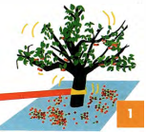 |  | 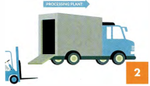 |  | 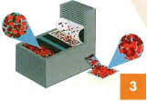
  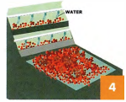 | 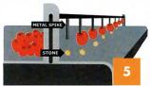 |  | 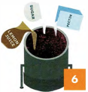 |  | 
  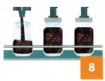 | 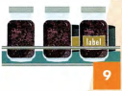
  add | check | collect | cook | put | remove
  shake | spread | stick | take | wash | transport
[[[[[[[[[EXAM SKILLS]
 | The pictures show the process of making cherry jam. Describe the process.  Describe the process.  Remember to:  - include an introduction and an overview  - use the present simple passive  - use sequencing expressions  - write 150 words.  Sample answer  The pictures show the stages in the production of cherry jam. There are a number of processes involved, from picking the fruit from the tree to putting it into jars ready to sell.  First, a sheet is spread on the ground under the tree and the tree is shaken by a mechanical arm to get the cherries down from the tree. Then, the cherries are collected and transported by lorry to the processing plant. There the leaves and the stems are removed and then the stone is taken out with a metal spike. Next, sugar, lemon juice and pectin are added to the cherries and the jam is cooked. After that, the quality of the jam is checked and then the jam is put into jars. A lid is put on top of the jars to keep the jam fresh. Finally, a label is added and the jam is ready to be sold in the shops. | TIP 11
  11
  Use the words on the pictures and diagrams in your answer. They are given to help you.

UNIT/01: RELATIONSHIPS

LISTENING
IN THIS unIT YOU WILL
LEARN HOW TO
- identify the speakers in a conversation.
- listen for numbers
- answer multiple-choice questions.

Lead-in
 | In Section 1 of the Listening test you will hear two people talking in everyday situations. Tick TWO situations that could be in Section 1 of the Listening test.  C, D  - Discussing a course assignment  - Describing changes in family life over time  - Choosing a gift  - Arranging a birthday celebration
  01
 | Listen and match the conversations with two of the situations above.  02  Conversation 1: D Conversation 2: C
  02

IDENTIFYING THE SPEAKERS

 | Listen to the conversations again and pay attention to the speakers. For questions 1-4, write M for male and F for female next to the people.  02
  03
   | Male or female? | Information wanted
  Conversation 1 | manager 1 M  customer 2 F | - The customer would like to ---  - book a table.  - order a meal.
  Conversation 2 | shop assistant 3 F  customer 4 M | - The customer wants to buy ---  - a necklace.  - earrings.
  ◉ In Section 1 of the Listening test you will hear two speakers. In Section 3, there will be two or three speakers. In each case the speakers' voices will sound different from each other to help you easily identify who is speaking. The answers could be given by any of the speakers. In Section 1, there is normally one person who has to find out information from the other.
 | Listen again and for questions 5 and 6, choose the correct answer, A or B.  - A  - B  02
  04

LISTENING FOR NUMBERS

 | Listen and circle the number you hear in each pair.  03  Listen and circle the number you hear in each pair.
  05
  - 1st/3rd  3rd  - $ 10.5 /$10.15  $ 10.5  - 6th/5th  6th  - 17/70  70 | - 19/90  19  - 52/62  62  - £110/£810  £110  - 22nd/27th  27th
  ◉ In Section 1 of the Listening test you need to listen for specific details. These details often include numbers.
 | Listen to the next part of conversation 1 and choose the correct answer.  04  - How many people does the woman want to make the booking for?  B  - What is the date of the booking?  C  TIP 06
  06
  - 8 | - 12 | - 16
  - 12th | - 16th | - 17th
  You will usually hear all the numbers given in the options but only one will be correct. It is important to listen carefully for key phrases, so that you can choose the correct one.
 | Look at the following phrases taken from the recording.  What number is missing?  - No, no, it's the day after – the ---.  16th/17th  17th  - The private room can seat up to --- people.  12/20  20
  07
 | Now listen to the rest of conversation 1 and choose the correct answer.  05  How much is the total cost of the booking?  B
  08
  - £218 | - £318 | - £380
 | Listen to the second part of conversation 2 and answer the questions.  06  - The price of the earrings now is ---  B  - How much does the customer pay for the gift wrapping?  B
  09
  - £10 | - £20 | - £30
  - £4 | - £5 | - £7
 | Listen again and complete this part of the conversation.  07
  10
  Customer | Oh, really? So, how much are they?
  Assistant | Well, they were 1 30 / thirty moment, so they're a little cheaper - only 2 20 / twenty pounds, but actually we've got a sale on at the pounds. So you can save 3 10 / ten pounds!

[[[[[[[[[[MULTIPLE-CHOICE QUESTIONS]
◉ In multiple-choice tasks, you choose the correct answer from three options, A, Bor C.
There are two types of multiple-choice question:
- a question followed by three possible options
- an unfinished statement followed by three possible endings

 | Match the words and phrases 1-5 to words and phrases a-e, which have a similar meaning. | TIP 11
  11
  - a goodbye party  c  - a soccer game  e  - a celebration  d  - brother and sister  a  - work in the same office  b | - members of the same family  - colleagues  - a leaving party  - a birthday party  - a football match
  The words in the questions and options (A, B, C) may not be the same as the words you hear on the recording. You need to listen for words with a similar meaning. It can sometimes help to rephrase the question in your own words before you listen.
 | Read questions 1-6 in the Exam skills task below and match them with the topic areas in the box.  - The relationship between the people  - The type of event  - Colour  - The meaning of something  - Food  - Presents
  12
  Colour | Food | Presents | The meaning of something
  The relationship between the people |  |  | The type of event
[[[[[[[[[[EXAM SKILLS]

 | Listen to the conversation and choose the correct letter, A, B or C.  08 | TIP 13
  13
  - Who are the two speakers?  A  - good friends  - work colleagues  - family members | - The purse represents  B  - good health.  - good fortune.  - wealth.
  - Who are the two speakers?  A  - good friends  - work colleagues  - family members | - What food do guests  C  - good health.  - good fortune.  - wealth.
  - Who are the two speakers?  C  - good friends  - work colleagues  - family members | - The purse represents  B  - good health.  - good fortune.  - wealth.
  Use the questions to help you to follow the recording. Multiple-choice questions are in the same order as the information in the recording. You will hear the answer to question 2 before you hear the information which gives you the answer to question 3.

UNIT/01: RELATIONSHIPS

SPEAKING
IN THIS unIT YOU WILL
LEARN HOW TO
- use simple adjective-noun collocations relating to family
- answer simple questions about your family
- give full answers to Part 1 questions.

Lead-in

 | Talk to a partner about these members of your family for 20 seconds each. Try to keep talking for the full 20 seconds.  Example: sister My sister is my parents' daughter I other daughter.
  01
  father | mother | brother | grandmother | grandfather

USING ADJECTIVES AND NOUNS TO DESCRIBE YOUR FAMILY

 | Listen to Hoi Chin talking about her family and read the first part of what she says. Which collocations does she use to describe her family?  (not) a large family, a small family, a typical family, a close, happy family  09 | TIP 02
  02
  Examiner | Let's talk about family. So, tell me about your family
  Hoi Chin | My family? Well, my family isn't a large family. It's quite a small family1 in fact - and quite a typical family for my country. Just my parents, my older brother and me. So, I'm the baby of the family! I think we're a close, happy family. We do a lot of things together, particularly preparing food - and eating it of course!
  ◉ Many words in English often 'go together' with other words. This is called 'collocation'. For example, we say a fast car, but we don't say a quick car.
  It is a good idea to use collocations in the Speaking test. This shows the examiner that you have a good vocabulary.
 | Which adjective in the box can you NOT use in this sentence?  You can't say 'a best family'. | TIP 03
  03
  We are a family.
    best | close | happy
    large | small | typical
  With a partner, describe your family using the collocations in the box.
  It is a good idea to make a list of useful words and add to the list as you meet new words when you read and listen, and also to write down words which go together.
  You may want to group words under headings to help you remember them.

GRAMMAR FOCUS: ADVERBS OF FREQUENCY
SOMETIMES, OFTEN, NEVER, RARELY AND ALWAYS

 | Listen to a candidate talking about the things he does with his family. Answer the questions.  10  - How often does he go out with his family?  once a week  - What days of the week does he go out with his family?  on Saturdays or Sundays/ at weekends  - Where do they often go?  to the beach  - What do they usually do when they get to the park?  They usually go for a long walk.  - Who sometimes comes with them?  His cousin sometimes comes with them.
  04
 | With a partner, use the questions above to discuss how often you do these things with your family.
  05
  eat out | go bowling | go to the cinema

[[[[[[[[[[ANSWERING PART 1 QUESTIONS]

 | Listen to Hoi Chin talking about her family and read the first part of what she says. Which collocations does she use to describe her family?  - asks you about your likes and dislikes?  c  - asks you about your personal preferences?  d  - asks you how regularly you do something?  b  - asks you to talk about who you are like in your family?  a  - Are you more similar to your mother or your father?  - How often do you go out with your family?  - What do you enjoy doing with your family?  - Do you prefer spending time with your family or your friends?  Now, ask and answer these questions with a partner. | TIP 06
  06
  ◉ In Part 1 of the Speaking test the examiner will ask you a few questions about yourself, for example about your family, your likes and dislikes, where you live.
  It is important to listen carefully to the questions that the examiner uses. Make sure you answer the question that is asked.
 | Listen again to Hoi Chin talking about her family and giving more information. Complete the notes below.  11  - Her parents and 1 older der brother  - They are a 2 close happy family.  - They like preparing food and 3 eating it.  - Her father is a better 4 cook than her mother.  - Her brother is getting 5 married next year.  - Hoi Chin would like to have a 6 niece or 7 nephew one day.  Tell your partner what you remember about Hoi Chin's family. Is your family similar or very different to hers?
  07

EXTENDING YOUR ANSWERS IN SPEAKING PART 1

 | Listen to three students answering the question Who are you most similar to in your family?  12  - Which student's answer was too short?  Student B  - Which student didn't answer the question?  Student A  - Which student's answer was the best?  Student C | TIP 08  TIP 08
  08
  ◉ You can add information to your answer by adding a reason, extra details or combining information:
  I don't see my grandparents very often because they live in the north of the country.
  I don't see my family very often but I miss them very much.
  I have a twin brother, so I am very close to him.
  I look very much like my father, although we have very different personalities.
  In Speaking Part 1:
  - keep to the topic
  - extend your answers
  - don't speak too much
  - do not try to memorise answers to questions.
  In Part 1 you need to give full answers to the questions, but don't talk for too long. Three sentences is plenty. You have chances to speak for longer in Parts 2 and 3.
 | Use one of the words in the box to help you complete the sentences with ideas of your own. Try to use a different word from the box in each sentence.  Sample answers, but many others are possible  - … because they are the most important people in my life.  - … but we still get along very well.  - … and she is going to move to a different city with her husband.  - … so I don't spend as much time with him as I want to. 4  - … even though he is quite a bit older.  - I visit my parents every weekend ...  - We have a large family...  - My sister is getting married next year...  - My father works very long hours, ...  - My brother likes the same things as me,
  09
  also | And | because | but | so | even though

PRONUNCIATION

 | What is the third person singular form of the words in the box?  Example: have - has She has a small family  Listen to the words and group them under /z/, /s/ or /ɪz/ according to how the end is pronounced.  13  /s/: asks, keeps, talks, wants  /z/: enjoys, plays  /ɪz/: chooses, watches | TIP 02
  10
  ask | choose | enjoy | keep | play | talk | want | watch
  ◉ Many words in English often 'go together' with other words. This is called 'collocation'. For example, we say a fast car, but we don't say a quick car.
  It is a good idea to use collocations in the Speaking test. This shows the examiner that you have a good vocabulary.
 | Listen and repeat the sentences. Be careful of the pronunciation of verbs with 's' endings.  Example: have - has She has a small family  14  Is there anyone in your family who annoys you sometimes?  - My father watches football on TV and shouts a lot.  - My brother plays on the computer all the time.  - My mother keeps telling me to tidy my room.
  11
 | With a partner, ask and answer the following questions.  - What activities do different members of your family enjoy doing?  My father enjoys mending old cars. My mother enjoys running and reading books.  - What do your mother and father want you to do in the future?  - What type of films do different members of your family watch?  - What do different members of your family talk to you about?
  12
[[[[[[[[[[EXAM SKILLS]
 | With a partner, ask and answer the questions below about your family. Try to talk for about 20 seconds for each question.  - Do you come from a large family?  - Is there anything you usually do together with your family?  - How often do you see your grandparents?  - Who do you like the most in your family?  - Would you like to spend more time with your family?  When your partner is speaking, make notes about any interesting vocabulary (particularly collocations} that you hear. Then, ask and answer the questions again.
  13

UNIT/02: PLACES AND BUILDINGS

READING
IN THIS unIT YOU WILL
LEARN HOW TO
- respond to sentence completion questions
- skim read a text
- recognise paraphrase
- practise using the present simple and past simple.

Lead-in

 | Tell your partner about the house or apartment you live in.
  01
  Is it big or | How many bedrooms | Is it old or | Does it have a

 | What kind of house would you like to live in?
  02
  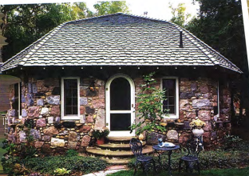  a house in the country |   a luxury apartment in the city
  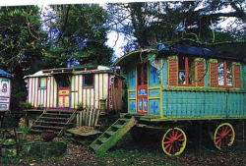
  a caravan

 | Find these in the pictures on this page.  Which ones would you like to live in?  A: treehouse B: shipping container homes C: igloo D: houseboat
  03
  igloo | treehouse | houseboat | shipping container homes
  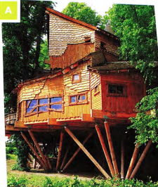 | 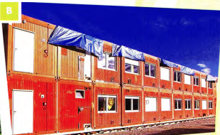
  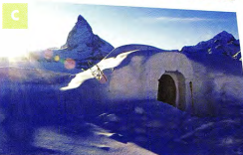 | 

SKIMMING AND SCANNING A TEXT

◉ The skills of skimming and scanning are very important in the Reading test.
Skimming is reading the passage quickly to get an idea of what it is about.
Scanning is also reading the passage quickly, but this time looking for particular information in the text, for example, the answer to a question.
- Before you look at the questions, read through the passage quickly. Don't spend more than a minute on this.
- Skim over (don't spend time on) words like the, they, our, through.
- Notice the 'content' words, such as nouns and verbs, to get an idea of what the passage is about.
- Read the questions.
- Scan the passage for the answers. Let your eyes move quickly over the text until you see one of the key words from the question, or words that have a similar meaning.
- Read that part of the passage carefully until you find the answer.

 | What is the passage about? Read it in ONE minute and choose one of the options.  b  - Life in different cities around the world  - Unusual places to live or stay around the world  The type of houses and flats most people live in
  04
 | Read the passage again to find the words from the box in exercise 3 as quickly as you can.
  05
 | Which of the two activities you have just done practised scanning? Which practised skimming?  exercise 5: scanning; exercise 4: skimming
  06
  AMAZING HOMES
  Most people live in a house or a flat. When they go on holiday they stay in a hotel or a guest house. But some places where you can live or stay are a bit different.
  - One unusual place to live is a houseboat. Amsterdam in Holland is famous for its houseboats - there are about 2,500 of them. They have everything that a normal house has: a living room, bedroom, kitchen, bathroom and even sometimes a terrace on the roof. They are cheaper than houses and people who live on houseboats enjoy being close to nature. Some houseboats can be moved to other parts of the river, while others are permanently in one place.
  - In Tokyo, Japan, there is a see-through house. It is like a normal Japanese house but all the walls are made of glass. There is plenty of daylight but no privacy. Architect Sou Fujimoto designed it for a couple to make their home. He based his ideas on early man living in trees. It wouldn't suit everyone but the couple who live there love the feeling of being surrounded by the natural world.
  - All around the world, people live in homes made from shipping containers. Some use only one container, while others are made from several containers joined together. One house in Chile was built from 12 containers. They are cheap to buy and eco-friendly. They can also be placed in the garden or drive as guest rooms, studies or utility rooms.
  - in Germany, you can stay in a one-metre-square house, the smallest house in the world, called the House NA. Van Bo Le-Mentzel, a refugee from Laos, built it to draw attention to the world housing shortage. It is a wooden structure on wheels and weighs 40 kg. It has a locking door and a window. You can turn it onto its side when you want to lie down. Franz from Munich spent the night in one recently 'just to see what it was like'. He found it a bit uncomfortable!
  - For an unusual holiday you can stay in an igloo, a house made of ice. These can be found in several countries including Sweden, Norway and Finland. They are built new every winter. Jenny and Callum, visitors from Australia, told us, 'We slept in an igloo last night. It's so cold here - minus 5 degrees centigrade. We used reindeer skins to keep warm!"
  - Another couple, Shaun and Rachel from Manchester, enjoyed a recent holiday in a treehouse in Sussex, England. They said, 'It was right up in the trees and had everything we needed, even wifi! It had a small kitchen and we did our own cooking. It was the perfect place to get away from our busy lives.

UNDERSTANDING PARAPHRASE

◉ In the Reading paper, it is very important to be able to understand paraphrase (when the same idea is given using different words). The words used in the questions won't be exactly the same as the ones in the passage.

 | Match these words and phrases from the text (1-6) with their paraphrases (a-f).
  07
  - Houseboats  c  - Permanently  e  - Privacy  a  - surrounded by the natural world  f  - uncomfortable  b  - Sweden, Norway and Finland  d | - not being watched by others  - not feeling pleasant  - homes on the water  - Nordic countries  - forever, always  - having nature all around
 | Choose the best paraphrase for these sentences from the text.  - The treehouse had everything we needed.  B  - We needed some more things for our stay in the treehouse.  - The treehouse was very well equipped.  - We need everything for the treehouse.  - Some houseboats can be moved to other parts of the river.  A  - Not all houseboats are permanently fixed in one place.  - Only some parts of the river have houseboats.  - You can move to a houseboat in another part of the river.  - One house in Chile was built from 12 containers.  B  - There are 12 houses in Chile made from containers.  - 12 containers were used to make one house.  - You need 12 containers to make a house in Chile.
  08

[[[[[[[[[[SENTENCE COMPLETION]

◉ in this task type you will have to complete a sentence with up to three words (or two words and/or a number) taken from the passage. The instructions will tell you how many words you are allowed to use.
Look at this example: Houseboat occupants like living
This is a paraphrase of the following sentence from the passage
People who live on houseboats enjoy being close to nature.
Because you have to use words from the passage in your answer, the answer is close to nature.

 | Follow the steps in the box opposite and complete the sentences.  Choose NO MORE THAN TWO WORDS from the passage for each answer.  - The two people who live in the transparent house love it, but it wouldn't suit everyone.  - The designer of the smallest house hopes to draw attention to the lack of houses all over the world.  - People who stay in igloos sometimes protect themselves from the cold by making use of reindeer skins.  - People who have busy lives would find a holiday in a treehouse ideal.
  09
  ◉ How to do sentence completion questions
  - Underline key words from the sentence (houseboat occupants, in the above example).
  - Scan the text for the key words or words that mean something similar (people who live on houseboats has a similar meaning to houseboat occupants).
  - Read the sentences near the key words carefully-like living means the same as enjoy being.
  - Find the words that seem to fit the sentence.
  - Check that the meaning of the sentence matches the meaning of the text.
  - Check the grammar of the completed sentence.
  - Check if the word(s) should be singular or plural.
  - Check that you have used the correct number of words.

GRAMMAR FOCUS: PAST SIMPLE AND PRESENT SIMPLE

 | Answer the questions in exercise 5. Follow the advice in the box.  - Which tenses does the passage use?  c  - present tenses  - past tenses  - both present and past tenses  - Which tenses are used:  - to describe the houses?  present simple  - to describe habit or things that are always true?  present simple  - to describe people's experiences on holidays?  past simple  - to talk about designing or building the house?  past simple | TIP 10
  10
  As part of your first quick look at the passage, identify whether it is written mainly in the past, present or future, and if the tense changes. This may help you understand the passage.
 | Choose the correct verb, present simple or past simple.  - Most people in China live / lived in flats.  live  - In the UK most houses have / had gardens.  have  - In 2010, my parents move / moved to Australia.  moved  - Nowadays Sarah usually spends/spent her holidays in cities.  spends  - In the past she prefers / preferred beach holidays.  preferred
  11
 | Complete the sentences with the correct form of the verb in brackets.  - Farid now shares (share) a flat with some other students.  - Last year he lived (live) at home with his parents.  - Once I stayed (stay) on a campsite next to a lake in Italy.  - My flat has (have) two balconies.  In 2014 we moved (move) into our new house.
  12

[[[[[[[[[[EXAM SKILLS]
HOME FROM HOME

I remember feeling the first time I left home that I would never be able to feel at home anywhere but in my home. No other place would have my mum and dad, my annoying little brother and my cat, Tilly. Nowhere would smell like my home - my mum's roast chicken in the oven and the salty, seaweed smell that drifted in from the nearby beach. The sound of seagulls squawking was the sound of home. Nowhere else would I feel comfortable enough to put my feet up under me and gaze into the log fire dreaming of the future.  I was 15 when I first went away from home on a school trip to Germany. My friends were going too, but we would all stay with different families. I was nervous about this. I knew the home I was going to would not be as comfortable as mine, the family would not be as kind, and who knew what the German food would be like? I knew I would spend three weeks, homesick and sad, missing my family back home.  We arrived in Germany late at night after a long journey by coach and boat. I was tired and hungry. We went into the school hall, where the host families were waiting to meet us. I wondered which one would be mine. Would they give me dinner at this time and would I be able to eat the unfamiliar food? Suddenly I heard my name called and the name of my exchange partner, Brigitte Schmitt. A pretty, blonde girl stepped forward, smiling widely. Behind her stood her parents, a pleasant-looking couple who were also smiling. They held out their hands and said, 'Wilkommen in Deutschland. Welcome to Germany." | I spent three happy weeks with the Schmitt family. Brigitte had an elder brother, Hendrik, and a younger sister, Lisa. They had two cats, Ping and Pong, who sat on my lap as I looked into the fire in the evenings. The whole family were kind and welcoming. My room was cosy and warm and looked out onto a forest. The fresh clean smell of the trees and of apples baking in the oven became familiar and comforting, like the smells of home. I learnt in those three weeks that you can feel at home anywhere that people are kind to you.  Later that year, Brigitte came to stay with me in the UK. I gave her my room and moved in with my brother. I cleared space for her clothes and put fresh flowers in a vase by the bed. I asked my mum to make her famous roast chicken and an apple pie to make our guest feel at home. We made a welcome banner and put it up on the front door. I did everything I could to help Brigitte feel at home with us. I now understood the importance of a warm welcome.

 | Read the passage and complete the sentences below. Choose NO MORE THAN THREE WORDS from the passage for each answer.  - The writer's mother often cooks roast chicken.  - She thought the visit to Germany would make her feel homesick and sad.  - Brigitte came to pick up the girl with her parents.  - The Schmitt family's pets' names are Ping and Pong.  - From her bedroom the girl could see a forest.  - The girl and her family tried hard to make Brigitte feel at home / feel welcome.
  13

UNIT/02: PLACES AND BUILDINGS

WRITING
IN THIS unIT YOU WILL
LEARN HOW TO
- describe changes over time as shown on a map
- use prepositions to explain location
- use past tense verb forms (active and passive) to describe change.

Lead-in

 | Which of these facilities do you expect to find on a university campus?  All of the places listed may be on a campus.
  01
  bank | bus stop | car park | halls of residence
  gym | library | laboratories | lecture theatres
  cafés | post office | tennis courts | recreation area
 | In Sri Lanka, a family meal often includes stringhoppers. To make stringhoppers you need some special equipment. Choose the best description of each piece of equipment.  The following are shown on the campus maps:  bus stop, Students' Union, recreation area, cafés, car parks, library, laboratories, squash courts, gym, halls of residence, tennis courts, football pitch, table tennis tables
  02
  Sunnyhills University 1995  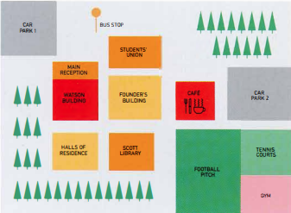  STUDENTS' UNION  MAIN RECEPTION  FOOTBAL PICH | Sunnyhills University today  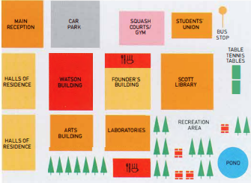  MAIN RECEPTION  SQUASH COURTS/GYM  HALLS OF RESIDENCE  TABLE TENNIS TABLES  LABORATORIESPOND

GRAMMAR FOCUS: PREPOSITIONS OF PLACE

 | Look again at the map of Sunnyhill University campus today. Which of these sentences are true?  Sentences 1, 2, 5 and 7 are true.  - The Founder's Building is between the Watson Building and the Scott Library.  - The bus stop is in the upper right-hand corner of the campus.  - The halls of residence are opposite the Students' Union.  - There are two car parks on the campus.  - There are two places to eat on the campus.  - The main reception is in the middle of the campus.  - The Students' Union moved to a different building between 1995 and today.  - The car park was moved towards the bottom of the campus. | TIP 03
  03
  Prepositions are important in any task including maps. It is important to say exactly where things are located in relation to other places.
 | Complete the sentences about the 1995 campus map using the prepositions in the box.  - The tennis courts were next to the football pitch.  - The Founder's Building was in the middle of the campus.  - The Scott Library was between the halls of residence and the football pitch.  - The cafe was opposite the football pitch.  - There were two car parks on the campus.  - The gym was in the bottom right-hand corner of the campus.  - The Watson Building was to/on the left of the Founder's Building.  - The main reception was part of the Watson Building.
  04
  between | in | next to | of | of | on | opposite | to
 | Complete the sentences to describe the map of the campus today to your partner. You can use the expressions in the box.  - The halls of residence are on the left side of the campus.  - The laboratories are opposite the Founder's Building.  - The bus stop is in the top right-hand corner.  - The recreation area is next to the laboratories (and the Scott Library).  - The table tennis tables are in front of / next to the Scott Library.  - The Students' Union is between the gym and the bus stop.
  05
  between | in front of | in the top right-hand corner
  next to | on the left | opposite

[[[[[[[[[[DESCRIBING CHANGES IN A MAP]
 | Read this Writing Part 1 task.  You should spend 20 minutes on this task.  Look at the two maps of Sunnyhills University campus in 1995 and today.  Summarise the information by selecting and reporting the main features, and make comparisons where relevant.  You should write at least 150 words.
  06
 |  | There are three important parts in a Part 1 essay. Match the parts 1-3 with their meanings a-c. Then find them in the model answer.  - The introductory sentence  B: Introductory sentence: The two maps show changes to the campus of Sunnyhills University between 1995 and today.  - The concluding sentence  c: Concluding sentence: So, it is clear that the university changed and expanded during this period.  - The overview  a: Overview: We can see that the university made many changes during this period, including new buildings and recreation facilities.  - A summary of the main points  - A description of what the data shows  - Writing the most important points again in different words | MODEL ANSWER
  07
  The two maps show changes to the campus of Sunnyhills University between 1995 and today. We can see that the university made many changes during this period, including new buildings and recreation facilities.
  In the past, the Scott Library was in front of the Founder's Building. It was relocated to the right, and in addition, it increased in size. The old library building now contains laboratories. In 1995 there was a car park in the top left-hand corner of the campus, whereas now the main reception is there. The halls of residence were moved to the far left of the campus and a new Arts Building was built opposite them.
  The old sports ground, gym and tennis courts were demolished; however, in their place the university created a new recreation area with a pond, trees and seating areas. What is more, the university developed new sports facilities, including table tennis tables, a new gym and squash courts. They also built two new cafes.
  So, it is clear that the university changed and expanded during this period.

VOCABULARY

 | Find these in the model answer:  - verbs describing change  was relocated, increased, were moved, was built, were demolished, created, developed, changed, expanded  - expressions describing where things are  in front of, to the right, in the top left-hand corner, the far left of the campus, opposite
  08
 | The underlined words in the model answer are useful for any essay. Among them, find two expressions which:  - mean 'and'  in addition, what is more  - mean 'but'  whereas, however  - refer to time  during this period, in the past  - refer to what you see in the chart or diagram  we can see, it is clear | TIP 09
  09
  It is important to use plenty of different words in the essay to show you have a wide vocabulary. Make a list of similar words in your notebook and try to use them when writing your practice essays.
 | Find words in the model answer with these meanings.  - moved to a different place  relocated  - made (2 words)  created, developed  - knocked down  demolished  - got bigger (2 words)  expanded, increased(in size)
  10

GRAMMAR FOCUS: PAST SIMPLE - REGULAR AND IRREGULAR FORMS

 | Find these past tense forms in the model answer. Which of them are irregular? What are the infinitives of these verbs?  Made, was and built are irregular. The infinitives are:  expanded-expand, changed-change, developed-develop, moved-move, was-be, created-create, made-make, built-build, increased-increase
  11
  expanded | changed | changed | made | built
  increased | developed | moved | was
 | These sentences could also be used to describe the maps. Put the verb in brackets into the past tense to complete the sentences.  - They (cut) down trees to build the halls of residence.  cut  - The old café (become) the new library.  became  - In 1995 students (catch) the bus outside the Students' Union.  caught  - The university (need) laboratories.  needed  - They (put) table tennis tables in front of the Scott Library.  put  - There (be) not enough halls of residence in 1995.  were  - They (dig) a pond in the recreation area.  dug  - They (plant) lots of new trees.  planted  Two of the verbs are regular. Which ones?  Needed and planted are regular.
  12

GRAMMAR FOCUS: PAST SIMPLE - ACTIVE AND PASSIVE

 | Read the information about active and passive verbs.  Are sentences 1-4 about the map active or passive?  - The library was relocated to the right of the Founder's Building.  passive  - They also built two new cafés.  active  - The university created a new recreation area.  active  - The old gym and tennis courts were demolished.  passive
  13
  ◉ The university developed the campus during this period. - active
  - The subject (the university) did the action.
  - The verb is a single word (developed).
  New halls of residence were built. - passive
  - The subject (new halls of residence) didn't do the action (build), but someone else did the action to it.
  - The verb consists of two words: the correct form of be (were) + past participle (built).
 | Change these sentences from active to passive.  - The university expanded the campus. The campus was expanded.  - They planted trees in the recreation area.  Trees were planted in the recreation area.  - The authorities moved the bus stop.  The bus stop was moved.  - They built a new main reception.  A new main reception was built.
  14

[[[[[[[[[EXAM SKILLS]
 | Answer the task below. Take as much time as you need and try to write 150 words.  The verbs in the box may be useful. Check the meaning of any unknown words.  Remember to:  - write an introductory sentence  - include an overview  - use the present simple and past simple, both active and passive  - use prepositions to explain where things are/were.  Sample answer  The maps show the changes to Colwick Arts Centre between 2005 and the present day. We can see that the Centre expanded and new facilities were added during this period.  One of the major changes is that the outside area was developed. In 2005 there was an empty area of land outside the Centre. Trees were planted there and an outdoor exhibition area was made. The café was moved to the front of the Arts Centre and tables were added outside.  Inside, a central exhibition area was created. The information desk was moved to the front of the central area. In the past there were two galleries but now there is only one; however, a drama studio was built. In 2005 the concert hall and cinema were in the same space, whereas now they are separate. In addition, an extra meeting room was constructed. The toilets moved to the opposite side of the Centre.  So, it is clear that Colwick Arts Centre is more attractive today and has better facilities than in 2005.
  15
  add | build | construct | create | develop | expand | move | plant trees
  The maps below show Colwick Arts Centre in 2005 and today.
  Summarise the information by selecting and reporting the main features, and make comparisons where relevant.
  2005  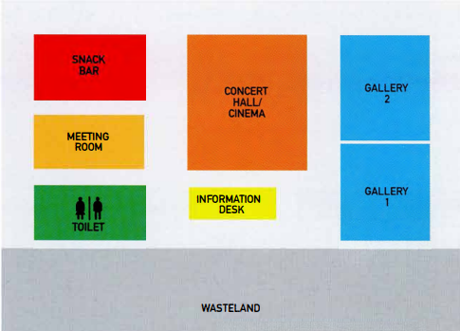  SNACK BAR  MEETING ROOM  TOILET  CONCERT HALL/CINEMA  INFORMATION DESK  GALLERY  WASTELAND | Today  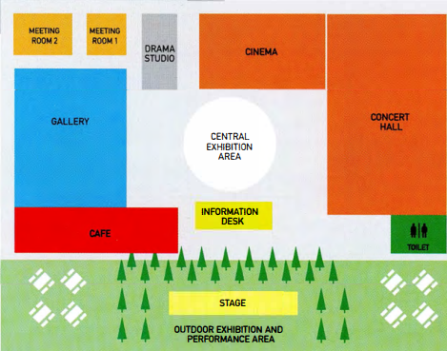  MEETING ROOM  DRAMA STUDIO  CINEMA  CENTRAL EXHIBITION AREA  CONCERT HALL  STAGE  OUTDOOR EXHIBITION AND PERFORMANCE AREA

UNIT/02: PLACES AND BUILDINGS

LISTENING
IN THIS unIT YOU WILL
LEARN HOW TO
- answer short-answer questions
- spell names correctly.

Lead-in
 | Here are some pictures of places in a town. Match pictures A-G with the words in the box.  - sports centre  - museum  - bank  - railway station  - bus stop  - restaurant  - harbour
  01
  railway station | museum | bank | harbour
  sports centre | restaurant | bus stop
   |  |  |  |  | 
   |  |  |  | 
 | Put the words in exercise 1 into the correct group. There is an example to help you.  Travel and transport: harbour, bus stop, railway station  Sports and leisure: sports centre, restaurant  Arts and culture: museum  Money: bank
  02
 | Put the words in exercise 1 into the correct group. There is an example to help you.  15  Conversation 1: sports centre  Conversation 2: bank
  03

SPELLING NAMES

 | Listen to the rest of conversations 1 and 2 and answer the questions.  16  Conversation 1  - What is the address of the sports website?  A  Conversation 2  - What is the man's name? James Clarke  - What is his address? Waddington Road
  04
  - www.getactive.com | - www.getaktive.com
  ◉ In Section 1 of the Listening test you may have to write the name of a person, a place or a website. Usually the names will be spelled for you. You need to know the letters of the English alphabet so that you can write the words correctly. If you don't, your answer will be wrong. You will hear the spelling once only.
 | Listen again and complete the extracts from the two conversations.  The first letter of each word is given to help you.  17  - 'Get active' - Is that a __ o __ w __ ?  all one word  - Is that[ ... ] w __ an 'e' or without?  with  - It's got an 'e' at the e __ .  end  - Is that[ ... ] with ad __ 'd', did you say?  double
  05
[[[[[[[[[[SHORT-ANSWER QUESTIONS]

 | Read the questions and underline the key words.  The first one has been done for you.  - What did the speakers order in the restaurant?  - How much did each person pay for their meal?  How much did each person pay for their meal?  - What time is the bus due?  What time is the bus due?  - Where is the bus stop?  Where is the bus stop?  - How long did the course last?  How long did the course last?  - Which TWO things did the speaker do on the course?  Which TWO things did the speaker do on the course?  - What is the date of the next course?  What is the date of the next course?  - Who will lead the course?  Who will lead the course?
  06
  ◉ You often use short answers in note completion tasks. In this type of task you answer questions using up to three words, or two words and/or a number.
 | Complete the table. Use the key words in the questions in exercise 6 to help you. The first one has been done for you.
  07
  Which questions need ••• | Question
  - a date | 7
  - a price | 2
  - a period of time | 5
  - a time | 3
  - a meal or a kind of food | 1
  - a name of a person | 8
  - the names of activities or skills | 6
  - a place? | 4

 | Look at the table you completed in exercise 7. For which questions do you need to write a number?  Questions 2, 3, 5, 7
  08
 | Listen to the conversation and answer the questions.  Write NO MORE THAN ONE WORD AND/OR A NUMBER for each answer.  18  - What did both speakers order?  steak  - How much did each person pay for the meal?  20 £
  09
 | Read this question about a shopping trip, and choose the correct answer.  Why is the other answer incorrect?  Answer the question. Write NO MORE THAN ONE WORD AND/OR A NUMBER for each answer.  What did the boy buy in the shopping mall?  Answer: shoes / he bought shoes  'Shoes' is correct - 'he bought shoes' is three words, and the question asked for 'no more than one word and/or a number'. | TIP 10
  10
  It is important to check the instructions carefully to see how many words you can write in your answer.
 | Listen to the conversation and choose the correct answers.  Why are the other answers incorrect?  Answer the questions. Write NO MORE THAN ONE WORD AND/OR A NUMBER for each answer.  19  - What time is the bus due?  7.50 is the correct answer; seven fiftty is incorrect because it is spelt wrong; 7.15/seven fifteen is not the correct time.  seven fifteen / seven fiftty/7.15/7.50 pm  - Where is the bus stop?  Blythe Road  Blithe Road / Blith Road / Blythe Road / Blyth Road | TIP 11
  11
  It is important to check your spelling carefully. If you spell the word incorrectly, your answer will be marked wrong. When you need to answer a question with a number, it is easier and quicker to write it as a number rather than writing it in words. And also you are less likely to make a mistake.

 | Listen to Alicia telling a friend about a sailing course and answer the questions.  Write NO MORE THAN ONE WORD AND/OR A NUMBER for each answer.  20  - How long did the sailing course last?  two/2 days  - What was the first thing that Alicia learnt?  Safety rules  - What is the date of the next course?  1st (of) September / 1 September  - Who will lead the next course?  Jon Galloway
  12

[[[[[[[[[[EXAM SKILLS]

 | Read questions 1-8 below. For which questions do you need to write a number ONLY?  You need to write a number only for questions 3 and 5.
  13
 | Find the key words in questions 1-8 below.  - What kind of tour did the woman do?  - How did she find out about the tour?  - How many people were on the tour?  - What is the address of the hire shop?  - How much did each student in the group pay?  - Which TWO items were included in the cost of the hire?  - Which TWO items were included in the cost of the hire?  - What is the website address of the hire shop?
  14
 | Listen and answer questions 1-8.  Then read your answers carefully.  21  - Did you check your spelling?  - Did you write numbers in digit form?  - Did you check that you have written the correct number of words?  Questions 1-5  Answer the questions below. Write NO MORE THAN TWO WORDS AND/OR A NUMBER for each answer.  - What kind of tour did the woman do?  bike/cycle/cycling (tour)  - How did she find out about the tour?  (by) email  - How many people were on the tour?  8/eight  - What is the address of the hire shop?  22 Barkway Street  - How much did each student in the group pay? $  15/fifteen (dollars)  Questions 6-7  Which TWO items were included in the cost of the hire?  - helmet/lock  - lock/helmet  Question 8  What is the website address of the hire shop?  tradelectric.com
  15

UNIT/02: PLACES AND BUILDINGS

SPEAKING
IN THIS unIT YOU WILL
LEARN HOW TO
- use prepositions to talk about your home town
- use adjectives to describe your home town
- use the correct tense when responding to questions
- pronounce regular and irregular past simple tense endings.

Lead-in

 | What tense would you use to answer these questions? Select the correct answer A-C below.  - Is there much for young people to do in your home town?  B  - What was your home town like in the past?  C  - Has your home town changed since you were a child?  A  - Present perfect, e.g. Many things have changed in my home town over the years.  - Present simple, e.g. There are lots of things for young people to do in my home town.  - Past simple, e.g. There were more factories and the houses were smaller.
  01
 | Now, with a partner, ask and answer the three questions in exercise 1.
  02

[[[[[[[[[[ANSWERING PART 1 QUESTIONS]

USING PREPOSITIONS TO DESCRIBE YOUR HOME TOWN

 | Listen to a boy describing his home town and read the script.  Match the places the boy talks about with A - H on the map.  A: cinema B: art gallery C: shopping mall  D: harbour E: stadium F: swimming pool  G: library H: town hall  22
  03
  town hall H | library | art gallery | cinema
  shopping mall | harbour | stadium | swimming pool
  Well, I live in a small town in the north of my country. It has quite a few interesting places to visit. For example, in the centre of town, on the north side of the square we have the historic town hall, which was built in 1895. In front of it, there's a beautiful fountain. Opposite the town hall there's the library. Then if you go over the bridge, we have the art gallery, a big modern building, which often has interesting exhibitions. The art gallery is actually between the cinema (to the north) and a big shopping mall, where I often meet up with my friends.  To the south of the town, there's a harbour, where you can take a boat to the islands. And then next to the harbour is the stadium, where people go to watch our local football team. And just behind it is the public swimming pool. It's an outdoor pool-lovely in summer, but very chilly the rest of the year. | 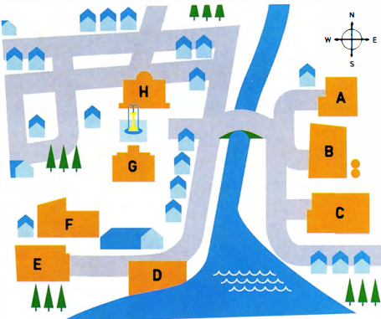
 | Now describe your home town. You might want to draw a map to help you.
  04

USING ADJECTIVES TO DESCRIBE YOUR HOME TOWN

 | Choose the correct heading from the box for the words and phrases in the table below.
  05
  Areas | Buildings | Climate | Location | Opinion
  1 Location | 2 Opinion | 3 Climate | 4 Areas | 5 Buildings
  on the coast  in the north-east  in the centre  outdoor  inland | busy  crowded  dirty  exciting  lively  quiet | hot  humid  mild | industrial  business  financial | tall  historic  ordinary  modern  old

 | Look at the words and phrases in the box and write them in the correct column of the table in exercise 5.  With a partner, add two more adjectives of your own to the table.  Location:  in the south, indoor  Opinion:  colourful, incredible, magnificent, polluted  Climate:  cool  Areas:  tourist  Buildings:  ancient, narrow, enormous, high-rise, huge
  06
  ancient | colourful | cool | enormous | high-rise
  tourist | in the south | indoor | incredible | magnificent
  narrow | polluted | huge
 | Complete the sentences with pairs of adjectives from the table in exercise 5.  - I come from a very modern city. You can see tall and high-rise buildings everywhere.  - In summer it's very wet and uncomfortable in my town. It's very hot and humid.  - There's usually a light breeze from the sea, so it's very cool and mild.  - There's a lot of rubbish on the streets. It's quite dirty and polluted.  - There's a great atmosphere in my city, especially at night. It's very lively and exciting. | TIP 07
  07
  It is a good idea to use pairs of words with similar meaning when you talk about your home town.
  This shows the examiner that you have a good range of vocabulary.
  For example: A lot of people live and work in my city. It's very busy and crowded.
 | Look at the photographs below. Try to describe each place using the headings and the words in exercise 5.  Possible adjectives  - huge, incredible, magnificent, busy, crowded, exciting  - ancient, flat, outdoor, narrow, historic, quiet  - hot, humid, crowded, narrow, flat, exciting, lively, colourful
  08
  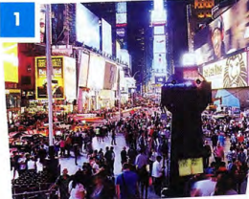 | 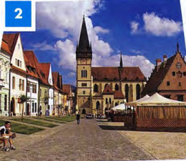 | 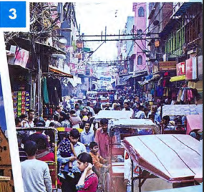

GRAMMAR FOCUS: TENSES

 | Read the questions on the examiner's card.  Then match them with the verb tenses.  Let's talk about the town or city where you grew up.  - Where did you grow up?  past simple  - Is it a good place to live?  present simple  - Do you think it has changed a lot? How?  present simple | TIP 09
  09
  present simple | present perfect | past simple
  ◉ In Part 1 of the Speaking test the examiner will ask you questions about familiar everyday topics such as your home town. To answer the questions you might need to use a range of tenses.
  It is important to listen very carefully to the questions the examiner asks you. This will help you to decide how to form your answer and what tense to use. One thing you can do is repeat or 'echo' the examiner's question to help you do this, but don't do this too often!

 | Read the Part 1 questions from different Speaking tests and choose the correct tense in the candidates' responses.  Listen and check your answers.  23
  11
  Examiner | Where were you born?
  Candidate 1 | I (1) am / was born in Dubai, in the Middle East. It (2) is / was as situated on the north-east coast of the United Arab Emirates.  - was  - is
  Examiner | Where did you grow up?
  Candidate 2 | I (3) am / was born in a small village in China, but I (4) grow up / grew up in Chengdu, which (5) is / was a very big city in south-west China.  - was  - grew up  - is
  Examiner | Has your home town changed much since you were a child?
  Candidate 3 | In the last ten years Baku (6) changed / has changed a lot. Ten years ago we (7) haven't had / didn't have so many tall buildings and there (8) isn't / wasn't as much to do then. The biggest problem is that everything (9) is / was more expensive now.  - has changed  - didn't have  - wasn't  - is
  Examiner | Is there anything that you used to do in your home town that you don't do now?
  Candidate 4 | Well, I (10) used to / was used to go to the beach every summer when I (11) have been / was younger, but now I don't have time. One summer, I even (12) used to go/ went fishing. I'd like to do that again. Perhaps I'll have time next summer after my exams.  - used to  - was  - went
 | Listen to the sentences and tick the correct column, /t/, /d/ or /ɪd/ according to how the verb ending is pronounced.  /t/:  bought, built, developed, used to  /d/:  called, changed, designed, discovered, said  /ɪd/:  situated, located, started  24
  12
     | /t/ | /d/ | /ɪd/
    - bought
    - built
    - situated
    - called
    - located
    - changed
     | /t/ | /d/ | /ɪd/
    - developed
    - designed
    - discovered
    - started
    - used to
    - said
  ◉ In the past simple, the ending of the verb can be pronounced in one of three ways: /t/, /d/ and /ɪd/.
  Examples:
  /t/ work-worked
  /d/ play-played
  /ɪd/ decide-decided

 | Complete the sentences with ideas of your own. Then say them to your partner, pronouncing the verb carefully.  - Our family bought --- in the middle of town.  - The --- was built in ---.  - Our town is situated ---.  - The --- is called 'the ---.  - --- is located across from the ---.  - --- have/has changed over the years in my home town.  - --- was/were developed by the harbour.  - --- was designed by ---.  - Recently, scientists discovered --- near our village.  - Recently, many young people have started to ---.  - A long time ago many people used to ---.  - A tourist who visited recently said our town is ---.
  13
 | Read an examiner's questions, then listen to four students answering them. Match the speakers 1-4 with the examiner's questions a-d.  25  - What is your favourite place in your town?  - What do people do for fun in your town?  - Is it easy to travel around your town?  - What is the oldest part of your town?  Speaker 1 b Speaker 2 a  Speaker 3 d Speaker 4 c  Now ask and answer questions a-d with a partner.
  14
[[[[[[[[[[EXAM SKILLS]

 | Ask and answer the questions below about your home town with a new partner.  Listen to your partner's answers and note any new ideas or vocabulary you hear. Then, ask and answer the questions again and try to improve your answers.  - Can you describe the town where you grew up?  - What places of interest are there in your home town? Where are they?  - Is it a good place for young people? Why?  - Where do young people in your town meet their friends?  - What is your town like at night?  - How has your town changed in the last 10 years?  - Have any new buildings been built?  - A long time ago, where did people from your town used to work?
  15

UNIT/03: EDUCATION AND EMPLOYMENT

READING
IN THIS unIT YOU WILL
LEARN HOW TO
- identify the main ideas of a passage
- find information in a text quickly
- deal with multiple-choice questions.

Lead-in

 | Are these words about work or studies? Put them in the correct column. | TIP 01
  01
  academic | blended learning | business
  degree | employers | retirement
  job | qualification | primary education
  office | lifelong learning | seminars
  Work | Studies
  business, employers, job, office, retirement | academic, blended learning, degree, qualification, primary education, lifelong learning, seminars
  Divide your vocabulary notebook into topics. Leave space to add new words as you learn them.
 | How many of the words can you find in the text opposite in ONE minute?  All the words except office are in the text.
  02

[[[[[[[[[[MULTIPLE-CHOICE QUESTIONS]
  FINDING THE ANSWER
   | Spend another ONE minute quickly reading the text and answer this question.  Does the text express a positive or negative view of globalisation in education?  The text is more positive than negative.
    03
   | Spend another ONE minute quickly reading the text and answer this question.
    04
    - Blended learning means  C (Para A) You only need to read part of the paragraph (studying partly in a traditional way in the classroom and partly on line or via email).  - continuing to learn throughout your life.  - studying online or via email.  - mixing traditional and modern methods.  - learning in a classroom. | - All of these are advantages of globalised education except  D (Paras Band C) You need to read the whole of paragraph Band the beginning of C. The elite having most of the opportunities is not a benefit.  - Students in developing countries can get better jobs.  - Students can get a degree at a cheaper price.  - Universities benefit from international students.  - The elite get most of the opportunities.
  ◉ In multiple-choice questions, you have to choose the correct answer from four options: A, B, C, D.
  In the test, you will not have time to read the whole passage in detail. You need to quickly find the part of the text that contains the answer.
  First, skim the text (read it very quickly) so you know what it is about.
  Next, look at the main part of the questions (NOT the options A, B, C, D) and decide which words will help you find the answer. These are the 'key' words.
  Then, read the text again quickly. This time you are only looking for the key words or words which mean the same. That is the part of the text where the answer is.

GLOBALISATION OF EDUCATION AND THE WORKPLACE
A  Globalisation has affected most aspects of our lives. One area which has changed is education. More and more people move to different countries for their studies. At the same time, more people stay at home and study by distance learning. It is now easy to learn without attending a college or university, or attending less often. 'Blended learning' means studying partly in a traditional way in the classroom and partly online or via email. These changes also mean that there is now more interest in 'lifelong learning', the idea that we go on learning throughout our working lives and even into retirement. It is easy to attend 'webinars' or online seminars without being away from our offices. Many adults go back to college later in life because it is so easy to get a qualification without giving up work or disrupting family life.  B  Different countries have benefitted from the globalisation of education in different ways. Many British, Australian and American universities run their degree programmes in countries throughout Asia, and many students, parents and employers feel this is a valuable opportunity. Students can get an internationally recognised degree at a much cheaper price than going abroad and so can improve their chances of getting a good job. At the same time, those in the countries providing world-class degrees also benefit. They have greater access to ideas and knowledge from all over the world and having international students enriches their universities.  C  However, it is not good news for everyone in some developing countries. It is usually the elite - or the richest people in the large cities - who have access to international education. Many people in rural areas have not even had a primary education. Also, those areas usually do not have reliable internet connections and most people do not own a computer. It will take a bit more time for international opportunities to reach everyone in developing countries. | D  One concern people have about globalisation is that it can start to mean 'westernisation'. In other words, local knowledge can be lost and money seen as more important than culture. Education should treat every culture with respect; it should not be just learning about the West, but should include different ways of teaching and approaches from around the world. The aim is to enrich and share; the flow of ideas and information should go from East to West as well as from West to East.  E  Educational institutions have changed their focus due to globalisation. There are so many benefits of having overseas students that universities are competing for them, using strategies from the world of business. For example, they visit Education Fairs all over the world and spend time and money creating publicity material and advertisements. There is also more emphasis on the student experience. There is more focus on customer care, especially helping international students to settle in, improve their English and understand the academic culture of the host country.  F  There are many advantages to the globalisation of education and the workplace. More people get benefits that were only available to those in the developed countries before. There is more understanding between different nations as people learn about each other's cultures. However, it is important to make sure the benefits reach everyone and don't leave many citizens of the developing world behind.

LOOKING FOR WORDS WITH SIMILAR MEANINGS

 | If you see these words (1-7) in a question, what words might you expect to find in the text? Choose a word or phrase from the box below.  The words you don't need are examples of the type of words which are likely to be the same in both the question and the text.
  05
  - abroad  overseas  - benefits  advantages  - disturbing  disrupting  - going to  attending | - make better  enrich  - useful  valuable  - workplaces  offices
  advantages | attending | distance learning | overseas
  globalisation | enrich | lifelong learning | offices
  Disrupting | valuable | westernisation
  ◉
  - Sometimes the words in the text are the same as the key words in the question, for example the technical term 'blended learning'.
  - Sometimes the words in the text are different to the key words, but they mean something similar.
  - When you are looking for the key words in the text, it is important to look for words, or groups of words, that mean the same. We call these 'paraphrases'.

IDENTIFYING THE MAIN IDEA

 | Which FOUR sentences represent the main ideas of the passage?  Sentences 1, 3, 4, 6.  - There are both advantages and disadvantages to the globalisation of education.  - Many people study after retirement.  - It is important that globalisation should not be westernisation.  - Universities have had to become more business-focused.  - University fees rose dramatically in the UK in 2012.  - Many poorer people in developing countries do not benefit from globalisation.  - Most lecturers work part-time.  Where in the paragraph can the main ideas be found?  The main ideas can usually be found in the first sentence of the paragraph. | TIP 06
  06
  ◉ Questions often relate to the main ideas of the passage. It is therefore important that you are able to identify them.
  Read the first paragraph and the first sentence of every other paragraph, as this is where the main ideas can usually be found.

MULTIPLE-CHOICE QUESTIONS: ANOTHER WAY TO DO THEM

 | Write your own answers to these questions.  - Who benefits from globalised education in developing countries?  - What is the meaning of 'westernisation'?  - How has the focus of educational institutions changed?  Look at the options and find the one closest to your answer.  - Who benefits from globalised education in developing countries?  B  - almost everyone in those countries  - mainly well-off people in big towns  - only those in developed countries  - only those who own a computer  - What is the meaning of 'westernisation'?  A  - learning only about the West  - learning local knowledge  - not learning about culture  - treating culture with respect  - How has the focus of educational institutions changed?  C  - They have become poor value for money.  - Staff are not committed to their students.  - They are focused on attracting students.  - They only want foreign students.  Then read the passage again and answer the questions. Was it helpful to try to answer the question yourself first?
  07
  ◉ There is another way to do multiple-choice questions.
  - Identify the key words (the most important words) in the question.
  - Find the part of the passage that gives the answer.
  - Try to answer the question yourself.
  - Look at the options and find the one that matches your answer.

GRAMMAR FOCUS: THE PRESENT PERFECT

 | Look at this example of the present perfect from the first sentence of the passage:  Globalisation has affected most aspects of our lives.  Did this happen in the past or present? -It began in the past.  Does it have results in the present? -Yes. We are still affected by globalisation.  Look at the options and find the one closest to your answer.  - Look at these present perfect sentences from the passage. Do they relate to both the past and the present? How?  The sentences all relate to the present and the past.  a: The level was raised in the past and is still high in the present.  b: They were not educated in the past, which affects their present.  c: They became businesses in the past and they are still businesses.  - Different countries have benefitted from the globalisation of education in different ways.  - Many people in rural areas have not even had a primary education.  - Educational institutions have changed their focus due to globalisation.  - Which of these tenses is used most in the passage?  b  - simple past  - simple present  - present continuous  - Choose the best reason for this choice of tense.  a  - The situation affects people now.  - Most of the changes happened in the past.  It is a constantly changing situation.
  08

[[[[[[[[[[EXAM SKILLS]
 | Read the text on work-based learning and answer the questions that follow.
  09
  ◉
  - Read (skim) the text very quickly so you understand what it is about.
  - Read the main part of the questions and find the key words (the words
  - that will help you find the answer in the passage).
  - Find the key words or words that mean the same in the passage.
  - Try to answer the question without looking at the options A-D.
  - Find the option, A, B, C or D, that matches your answer.
  - Check that the other options are incorrect.

EDUCATION
AND THE WORKPLACE
IN THE UK

A  There has been a trend towards creating a closer connection between education/training and the workplace. This is because many employers felt that school leavers were not prepared well enough and didn't have the skills they would need to do well at work. Having a close relationship between training and work is not new: apprenticeships were a common way of learning in the past. Young people learnt by working with an expert, but this was most common in trades such as builders or electricians. The trend now is for a closer connection between education and the workplace at all levels and in many different types of job.  B  In 1944, the UK government created a new system of education. Education was divided into three parts. Children who passed an exam at 11 went to grammar schools. Pupils who didn't do well in the exam went to 'secondary modern' schools or technical schools. At technical schools they studied work-based subjects. In practice, however, only 0.5% of pupils went to technical schools, and this system divided students at a very young age into academic and non-academic. The system did not produce good results, and changed to a more equal system in the 1970s. B  C  In the 1980s the British government introduced NVQS or National Vocational Qualifications so that young people could get certificates to show their practical skills. It helps employers understand what workers can do. In 1994, the government started a programme which aimed to provide 'quality training on a work-based (educational) route'. These 'modern apprenticeships' are available at three different levels. | D  At the higher levels of education, too, there has been more emphasis on work-based learning, which links academic study closely to practical experience. At degree level, companies have linked with universities to create specialised qualifications, such as the BA in Distribution run between Middlesex University and Asda Supermarket. Such partnerships also exist at Masters and even doctorate level.  development of technology has helped work-based learning to develop. Blended learning means part of the course can be delivered online, so people don't have to miss work to go to classes. Older or recently retired employees have been given the opportunity to develop new skills as tutors, mentors and coaches for the work-based part of these courses. This kind of work-based training was common in fields such as nursing and teaching, but has now spread to careers which were traditionally not closely linked to education.  F  There are some challenges involved in work-based learning. Some lecturers might find it difficult to teach students with a lot of work experience. It may also be difficult to find teachers who can teach in different places and at different times. However, it is a positive trend as there are more ways to learn and people can study at different stages of their lives.

- Apprenticeships  B  - are a new way of learning.  - were common in the past.  - only existed in the past.  - did not help people do well at work.  - The education system introduced in 1944  C  - only affected 0.5% of students.  - taught only technical subjects.  - was not a great success.  - was for academically gifted students. | - Blended learning  D  - mainly benefits older or retired people.  - involves mainly face to face classes.  - is mainly for teaching and nursing.  - is convenient for working people.  - The challenges of work-based learning include  A  - practical issues like when classes are held.  - students who are not very experienced.  - more types of learning are acceptable.  - older people can't use computers well.

UNIT/03: EDUCATION AND EMPLOYMENT

WRITING
IN THIS unIT YOU WILL
LEARN HOW TO
- describe different types of data
- describe changes in numbers
- use prepositions with numbers.

Lead-in

 | Match the diagrams with their names.  1: line graph 2: pie chart 3: bar chart 4: table  Which of them describe changes to numbers over time?  1 and 4 describe changes to numbers over time.
  01
  table | bar chart | pie chart | line graph
  % of graduates in the population (UK)  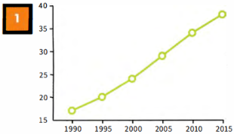 | Which English-speaking country do foreign students want to study in?  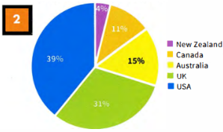
  Participation of 18-year-olds in education and training, 2014  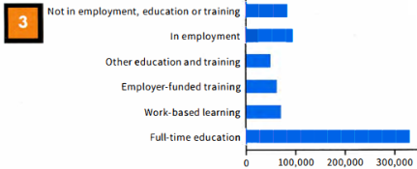  Not in employment, education or training  In employment  Other education and training  Employer-funded training  Work-based learning  Full-time education |  | New entrants to primary teacher training programmes 2007 - present  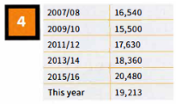

DESCRIBING CHANGES IN NUMBERS

 | Put the words into the correct column. Are they verbs (V), nouns (N) or both?
  02
  decline | decrease | drop | fall | growth | increase | rise
  ↑ | ↓
  growth (N)  increase (V, N)  rise (V, N) | decline (V, N)  decrease (V, N)  drop (V, N)  fall (V, N)
 | Write the past simple and past participle forms of the verbs.
  03
  infinitive | past simple | past participle
  fall | fell | fallen
  increase | increased | increased
  drop | dropped | dropped
  decrease | decreased | decreased
  decline | declined | declined
  rise | rose | risen
  grow | grew | grown
 | Use the correct verb or noun form of one of the words from above to complete the sentences about the table.  New entrants to primary teacher training programmes 2007 - present  - The number of new entrants to primary teaching during rose the period.  - There was a fall/drop/decline/decrease from 2007/08 to 2009/10.  - There was a steady rise/growth/increase in numbers from 2009/10 to 2015/16.  - The numbers declined/decreased/fell/dropped OR have declined/have decreased/have fallen/have dropped again this year.
  04
  2007/08 | 16,540
  2007/08 | 16,540
  2009/10 | 15,500
  2011/12 | 17,630
  2013/14 | 18,360
  2015/16 | 20,480
  This year | 19,213

[[[[[[[[[[GRAPHS AND BAR CHARTS]
 | Which is the better description of the line graph: A or B? Why?  B is better because it gives an overview and summarises the data with an example. A is just a list of all the data. | TIP 05
  05
  - The graph shows the percentage of graduates in the UK population between 1990 and 2015. In 1990 17% of the population of the UK were graduates. This rose to 20% in 1995 and 24% in 2000. In 2005, it went up to 29%, in 2010 to 34% and up to 38% in 2015.  - The graph shows an upward trend in the % of graduates in the population between 1990 and 2015. The percentage rose gradually throughout the period. It increased by about 3 to 5% every five years, for example between 1990 and 1995 it increased from 17 to 20%. | % of graduates in the population (UK)  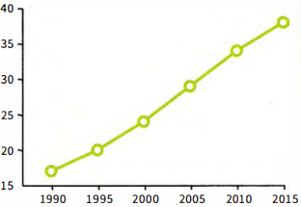
  Select information that is important-don't include everything. You must include some data to support your description.
 | Read sentences 1-9 about the bar chart, and answer the questions.
  06
  - Which TWO sentences should NOT be included?  Sentences 2 and 7 should not be included. | - Which of the other sentences include the most important information about the bar chart, do you think?  Sentences 1, 6, 8 and 9 are probably the most important. (To some extent this is a matter of opinion, but the answer should include the highest and lowest numbers, for example.)
  - There were about 330,000 18-year-olds in full-time education.  - Work-based learning is really useful for young people.  - 60,000 were in employer-funded training.  - Around 70,000 of the age group were involved in work-based learning.  - Only about 50,000 were in the 'other education and training' category.  - There were three times more 18-year-olds in full-time education than in employment.  - The situation is very different in my country.  - About 90,000 were not in employment, education or training.  - More 18-year-olds were in employment than not in employment, education or training. | Participation of 18-year-olds in education and training, 2014  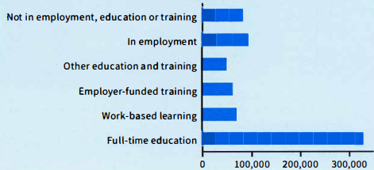  Not in employment, education or training  In employment  Other education and training  Employer-funded training  Work-based learning  Full-time education
 | Complete the sentences with a preposition from the box.  - 17% of the population are graduates.  - The number of graduates went up.  - It rose from 21% to 29%.  - It increased by about 4%.  - Between 1992 and 1996 there was an increase.  - There was a rise in graduate numbers during the 1990s.
  07
  between | in | from | of | of | to | by

STUDYING A MODEL ANSWER

 | Read the model answer and find:  - the introductory sentence  The line graph shows the number of unemployed recent graduates and non-graduates in the population of 21 to 30-year-olds in the years between 1990 and 2015.  - the overview  Overall, the numbers have not changed much: we can see a fall, followed by a rise, in both groups. The non-graduates are a larger number than the recent graduates at all points.  - a description of data  (sample answer) There was a small change in the middle period./The number of non-graduates dropped and then grew during that period.  - some data to support the descriptions  Over the five years from 2010 to 2015, the numbers of both non-graduates and recent graduates returned almost to their 1990 figures of 14% and 10%.  - past simple verb forms  was, dropped, grew, returned  - a present perfect verb form  Overall, the numbers have not changed much  in exercise 4  Why is the past simple used more than the present perfect?  The past simple is used more because most of the verbs refer to actions completed in the past. The one example of the present perfect is used because it refers up to the present. (The text was written in 2015.) | MODEL ANSWER
  08
  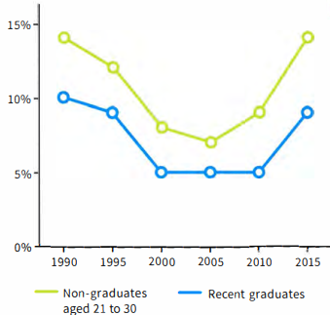
  The line graph shows the number of unemployed recent graduates and non-graduates in the population of 21 to 30-year-olds in the years between 1990 and 2015. Overall, the numbers have not changed much; we can see a fall, followed by a rise, in both groups. The non-graduates are a larger number than the recent graduates at all points.
  Between 1990 and 2000 there was a decrease in the number of unemployed recent graduates and non-graduates. The fall was small from 1990 to 1995, but greater between 1995 and 2000. There was a small change in the middle period. The number of non-graduates dropped and then grew during that period. Over the five years from 2010 to 2015, the numbers of both non-graduates and recent graduates returned almost to their 1990 figures of 14% and 10%.
  Overall, it is clear that having a degree is helpful in finding employment as more non-graduates than recent graduates are out of work.

[[[[[[[[[[DESCRIBING A PIE CHART] | TIP 09
   | Which country matches these phrases?
    09
    - over a third  USA  - a little under a third  UK  - the lowest number of students  New Zealand  - about 1 in 10  Canada  - just under a sixth  Australia  - the most popular country  USA  - the country in second place  UK  - the least popular country  New Zealand
      Which English-speaking country do foreign students want to study in?
      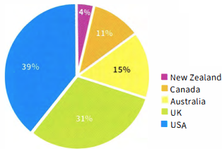
  ◉ In multiple-choice questions, you have to choose the correct answer from four options: A, B, C, D.
  In the test, you will not have time to read the whole passage in detail. You need to quickly find the part of the text that contains the answer.
  Select information that is important-don't include everything. You must include some data to support your description.

[[[[[[[[[EXAM SKILLS]
 | Look at the Writing Part 1 task below. Before you start writing, answer these questions about the graph.  - What are the two groups in green and purple?  green - male, purple - female  - What do the vertical and horizontal axes show?  vertical - percentage of people who are literate; horizontal-region of the world  - Which two regions had the highest literacy rates?  Central Asia, Central/Eastern Europe  - How many regions show different literacy rates for men and women?  five  - Which region shows the biggest difference between men and women?  South and West Asia  - What are the male and female literacy rates in the least literate region?  male - about 70%, female - about 59% (Sub-Saharan Africa)  - What is the percentage difference between the most and least literate areas?  male - about 30%, female about 41%  You should spend about 20 minutes on this task.  The bar chart shows the literacy rate (% of people who can read and write) by region and gender in 2011.  Summarise the information by selecting and reporting the main features, and make comparisons where relevant.  Write at least 150 words.
  10
  Literacy rate by region and gender 2011
  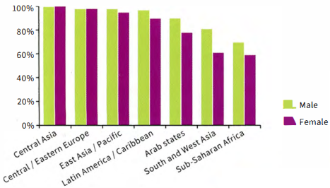
  Central Asia
  Central/Eastern Europe
  East Asia/Pacific
  Latin America/Caribbean
  Arab states
  South and West Asia
  Sub-Saharan Africa
 | Write your answer.  Sample answer  The data shows the literacy rate for both males and females in seven different regions of the world. The horizontal axis lists the regions and the vertical axis shows percentage. In all regions except two, there is a difference in the literacy rates of men and women.  Central Asia and Central/Eastern Europe have the highest percentage of citizens who can read and write. Almost 100% of men and women are literate in those regions. The lowest literacy rates are in Sub-Saharan Africa.  In five out of the seven regions, there are different literacy rates for men and women. The greatest difference between men and women is found in South and West Asia. In this region, about 80% of men are able to read and write, but only about 60% of women. Overall, the difference between the most literate area and the least literate is about 30% for men and just over 40% for women.  In conclusion, literacy rates vary between regions, with males having higher levels than females in most regions. (171 words)  Remember to:  - include introductory and concluding sentences and an overview  - use expressions with prepositions  - use the past simple tense.
  11

UNIT/03: EDUCATION AND EMPLOYMENT

LISTENING
IN THIS unIT YOU WILL
LEARN HOW TO
- identify key words in sentence completion tasks
- use strategies to help you answer sentence completion tasks
- follow a conversation
- recognise synonyms and paraphrase.

Lead-in
 | Pictures A-G show different areas of work or study. Match the pictures with the words in the box.  - construction  - sports and leisure  - retail  - hotel and catering  - health  - art and design  - information technology
  01
  hotel and catering | construction | health | sports and leisure
  information technology | art and design | retail
   |  | 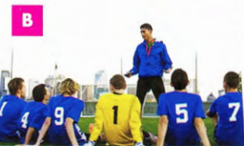 |  | 
   |  |  | 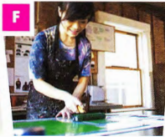 |  | 
  ◉ In the Listening test you may hear people talking about their area of work or studies. And in the Speaking test you may have to talk about your job or your course. It is important to understand and use words related to these topics to help you do this.
 | Look at the words in the box. Do they describe a job or a type of course?  Put J for 'job' or C for 'course' next to each word. The first one has been done for you.
  02
  architect  J | chef  J | building engineering  C | badminton coach  J
  computing  C | doctor  J | fitness training  C | food technology  C
  graphic designer  J | medicine  C | shop management  C | store assistant  J
  web designer  J | textiles  C

 | Complete the table. Use the words in exercise 2. There are two examples to help you.
  03
  Job | Area of work or study | Course
  - graphic designer | art and design | textiles
  - architect | construction | building engineering
  - doctor | health | medicine
  - chef | hotel and catering | food technology
  - web designer | information technology | computing
  - store assistant | retail | shop management
  - badminton coach | sports and leisure | fitness training
 | Identify the TWO correct endings for each sentence.  - I've done a course in computing/ badminton coach / food technology.  computing, food technology  - My sister has worked on a cruise ship as a chef/medicine/doctor.  chef, doctor  - Our son had a job as a(n) architect / store assistant/building engineering.  architect, store assistant  - He's very keen on web designer/fitness training/textiles.  fitness training, textiles | TIP 04
  04
  It is important to listen carefully to the ending of words. For example, words ending in -ology and-tion can be used to talk about different areas of work or study. Words that end in -er may refer to people and jobs.
 | Listen to two short conversations. Are the speakers talking about a job or a course? Put J for 'job' or C for 'course'.  26  Conversation 1: J Conversation 2: C
  05

[[[[[[[[[[SENTENCE COMPLETION] | TIP 06
   | Read the sentences carefully. Underline the key words before and after each gap.  - Anna has got a job as a ___.  Anna has got a job as a ___.  - She has recently completed a course in ___.  She has recently completed a course in ___.  - The new name of the department which sells computers and phones is ___.  The new name of the department which sells computers and phones is ___.  - The Food Photography course takes place on the ___ September.  The Food Photography course takes place on the ___ of September.  - There is a total of ___ places available on the course.  There is a total of ___ places available on the course.
    06
  ◉ In this type of task you complete sentences by writing up to three words, or two words and/or a number, in the gaps. The instructions tell you how many words you can write.
  The gaps can come
  - at the beginning of the sentence
  - in the middle of the sentence
  - at the end of the sentence.
  The sentences have a main verb and a subject.
  It is useful to underline the key words in the sentence before you listen to the recording. Doing this will help you decide what kind of information you need to listen for.
 | Match questions 1-5 in exercise 6 with the type of information you need to listen for, given below. The first one has been done for you.  an area of study: 2  a type of job: 1  a number only: 5  a name of a place: 3  a date: 4 | TIP 07
  07
  It is important to think about what type of word will go into each gap. This helps you to be ready to hear it during the conversation.
 | Listen again to Anna talking to the store manager and complete the sentences.  Write NO MORE THAN TWO WORDS for each answer.  27  - Anna has got a job as a store assistant.  - She has recently completed a course in information technology.  - The new name of the department which sells computers and phones is Moving Images.
  08

 | Choose the correct grammatical answer. Why are the other answers incorrect?  - Anna has got a job as a assistant/ store assistant.  store assistant (it can't be assistant because the word before is 'a' not 'an')  - She has recently completed a course in informations technology/information technology.  information technology (informations is incorrect because it is a plural form - the word information is uncountable)  - The new name of the department which sells computers and phones is Moving Image / Moving Images / The Moving Images.  Moving Images (The Moving Images consists of three words and the instructions tell you to use no more than two words. Moving Image is incorrect because it is singular, and the speaker uses the plural.) | TIP 09
  09
  Take care with singular and plural forms when you write your answers. If you use the wrong form, your answer will be wrong.
 | Listen to the student and the receptionist again and complete the sentences. Write NO MORE THAN ONE WORD AND/OR A NUMBER for each answer.  26  - The course takes place on the 19/19th [of]/nineteenth [of] September.  - There are a total of 12/twelve places available on the course.  TIP 10
  10
  Pay attention to the number of words you need to write. NO MORE THAN ONE WORD AND/OR A NUMBER means that if you write two words or more, your answer will be wrong. But you can write one word and a number.
  Check to make sure that you have not written 'extra' words that are already in the sentence.
 | Look at the question below and read the answers that different candidates wrote. Which answers are correct? Why are the other answers incorrect?  The correct answers are: 19, 19th, nineteenth of  Complete the sentence below. Write NO MORE THAN ONE WORD AND/OR A NUMBER for your answer.  The course takes place on the September.  Candidates' answers  19  19th  the 19  nineteenth of  19th of September  19 Sept | TIP 11
  11
  You can write numbers in figures or in words. It is a good idea to write them in figures as it takes less time and you will not make any spelling mistakes.

  FOLLOWING A CONVERSATION
   | Read the questions carefully. Then put the topics below in the order they will be mentioned in the conversation. The first one has been done for you.  Complete the sentences below. Write NO MORE THAN TWO WORDS AND/OR A NUMBER for each answer.  - The title of the course the speaker wants to do is ___.  - The course starts at ___.  - It lasts for a period of ___ hours in total.  - The course aims to teach people how to use different ___.  - Part of the course is held at a nearby ___.  - The total cost of the course is ___.  - the price of the course - 6  - the location of the course - 5  - the name of the course - 1  - the starting time of the course - 2  - the purpose of the course - 4  - the duration of the course - 3
    12
  ◉ The questions always follow the order of the information you hear in the conversation. This means that you will hear the answer to question 1 before you hear the answer to question 2.

LISTENING FOR SYNONYMS AND PARAPHRASE

◉ The speakers you hear often use different words to those in the questions. You may hear a synonym or paraphrase (a word or words with a similar meaning). Before you listen, try to identify key words and phrases in the sentences and think about possible synonyms for each one.

 | Match the words and phrases 1-9 with their synonyms a-i.
  13
  - price - h  - name - i  - duration - f  - starts - e  - takes place - d  - purpose - c  - ends - b  - location - a  - practical - g | - place  - finishes  - reason for  - is held  - begins  - length  - hands-on  - cost  - title
[[[[[[[[[[EXAM SKILLS]

 | Match the highlighted words in exercise 14 with the words and phrases used on the recording.  - title - it's called  - starts-begins  - lasts goes on  - teach - train  - part - some; nearby-local  - total cost - full fee
  14
  begins | full fee | goes on | it's called
  local | some | train | a range of
 | Listen to the rest of the conversation between the student and the receptionist and complete the sentences. Ignore the highlighted words for now. Write NO MORE THAN TWO WORDS AND/OR A NUMBER for each answer.  28  - The title of the course the student wants to do is Food Photography.  - The course starts at 9.30/nine thirty [am] a.m.  - It lasts for a period of ___ hours in total.  - The course aims to teach 7/ seven people how to use different ___.  - Part of the course is held at a nearby hotel.  - The total cost of the course is $55/fifty-five dollars.
  15
 | Read your answers to the sentence completion task carefully and then answer the questions in the checklist below.  - Have you answered ALL the questions?  - Have you written the correct number of words in each sentence?  - Have you written numbers as figures to save time?  - Have you checked your spelling?  - Have you checked whether your answer should be in the singular or plural form?  Now check your answers.
  16

UNIT/03: EDUCATION AND EMPLOYMENT

SPEAKING
IN THIS unIT YOU WILL
LEARN HOW TO
- answer simple questions about your work and studies (Speaking Part 1)
- use some strategies to prepare for a talk (Speaking Part 2)
- introduce your talk (Speaking Part 2)
- pronounce words beginning with two consonants.

Lead-in

 | Match photographs A-G with the areas of work and study in the box.  - emergency services*  - travel and transport  - farming  - education  - tourism  - science research and development  - entertainment  * the organisations that deal with accidents and urgent problems such as fire, illness or crime
  01
  emergency services | farming | entertainment | education
  science (research and development) |  | travel and transport | tourism
  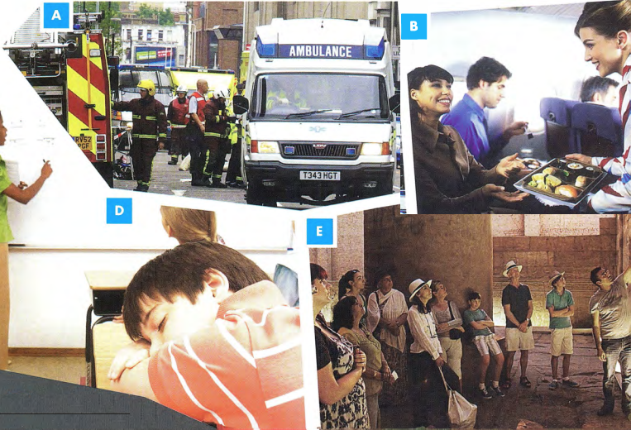
  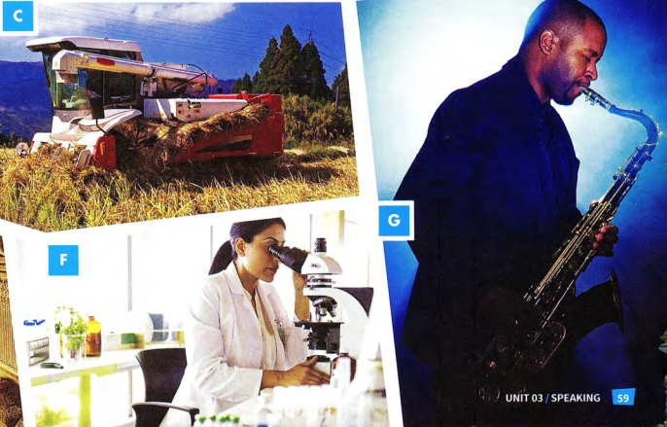

ADJECTIVES TO DESCRIBE FEELINGS AND EXPERIENCES

 | Look at the words in the box. Which words have a negative meaning?  tired, boring, embarrassed, not very exciting
  02
  tired | boring | embarrassed | challenging | fascinated
  great | thrilled | not very exciting | interesting | amazed
 | Read the words in exercise 2 again. Which words can you use to describe your feelings? Which words can you use to describe the experience of doing the things in the photographs? Put F for 'feelings' or E for 'experience' next to each word.  Which ONE word can be used to describe both your feelings and the experience?  Tired: F boring: E embarrassed: F challenging: E fascinated: F great: F, E thrilled: F not very exciting: E interesting: E amazed: F
  03
 | Complete the table. There is an example to help you.
  04
  I feel/I felt... | It is / It was
  amazed | amazing
  thrilled | thrilling
  bored | boring
  chalanged | challenging
  fascinated | fascinating
  not very excited | Not very exciting
  tired | tiring
  embarrassed | embarrassing
  interested | interesting
  great | great
 | Choose the correct word in each sentence.  - I've got a place on the course! I'm thrilled / thrilling!  thrilled  - It's a very interested / interesting job-I'm learning a lot.  interesting  - I had to give a presentation in front of my colleagues. I felt really embarrassing / embarrassed.  embarrassed  - She gets boring / bored easily, so she's changed jobs twice.  bored  - He works long hours and late nights and weekends in order to pay for his daughter's university course. It must be very tired / tiring for him.  tiring  - She's got an amazing / amazed job. She's a journalist and she's interviewed lots of famous people.  amazing
  05

 | Look at photographs A-D and answer the questions.  - Which of these jobs or activities have you done before?  - How did you feel about it?  - Which have you not done yet? Would like to try them? Why?
  06
[[[[[[[[[[SPEAKING TEST - PART 1]
◉The examiner will ask you some simple questions about your work or your studies.
It is important to try to give full answers to the questions and to say what you feel about your job or course of study, Look at the examples of Part 1 questions.
- What do you do? Do you work or are you a student?
- Are you enjoying it?
- Would you like to learn anything new in the future?
- Is there a job you would really like to do in the future?

 | Listen to a recording of Part 1 of the Speaking test. Match the speaker, Nina, with the correct photograph A-D above. Does she work or is she a student?  29  Photograph D; she's a student
  07
 | Listen again and number the following in the order Nina talks about them.  29  What job she would like to do in the future - 6  How many hours a week she studies/works - 3  What she does - 1  What she would like to learn in the future - 5  What she thinks about her studies/work - 4  Where she studies/works - 2 | TIP 07
  08
  It is very important not to simply answer a question with 'Yes' or 'No'. Try to use your imagination and invent some ideas. Remember that the examiner is testing your ability to speak English, not your views or general knowledge. For example, if there isn't a job you would really like to do in future, don't just say 'No'. Think of any job you could talk about.

 | Use the headings in exercise 8 to talk about Anna.
  09
 | Make notes using the headings in exercise 8 to speak about what you do. You may wish to use a dictionary to help you do this.
  10
 | Use your notes to tell your partner about what you do. Ask each other questions.  - What do you do? Do you work or are you a student?  - Are you enjoying it?  - Would you like to learn anything new in the future?  - Is there a job you would really like to do in the future?
  11

PRONUNCIATION: WORDS BEGINNING WITH TWO CONSONANTS

 | Listen and practise the sounds at the beginning of the words in bold.  30  a student-I'm a student.  a scarf - a beautiful scarf  I've just made a beautiful scarf.  plastic - It's made out of plastic.  ate-rate-great  It's great-I think it's great  It looks very strange, but I think it's great!  great close-up shots  I've learnt how to take some great close-up shots!
  12

[[[[[[[[[[SPEAKING TEST - PART 2]
◉In Part 2 of the Speaking test, you prepare and talk about a simple topic.
The topic will be based on your own experience. This means that you should find it familiar and easy to talk about.
You have one minute to prepare your topic.
You must talk for about two minutes.
Part 2 tests your ability to organise your ideas and speak fluently.

 | Read the information about Part 2 and then look at the following topic areas.  Which THREE do you think are Part 2 topic areas?  Topics 2, 3, 4 are possible Part 2 topics.  - Talk about how the education system in your country has changed.  - Talk about a time when you learnt something new.  - Talk about your very first day at school.  - Talk about your ideal place to study.  - Talk about how people normally travel to work in your city.  - Talk about the kind of jobs that people do in your home town.
  13

 | Read the information about Part 2 and then look at the following topic areas.  Which THREE do you think are Part 2 topic areas?  The order is: E, C, D, A, B, F  - You talk about the topic in the task, including all four points on the card.  - You stop talking when the examiner tells you to.  - You read a card with a task on it.  - You make notes on each of the separate parts of the task.  - The examiner says, 'Here is your topic card. You now have one minute to prepare your talk."  - The examiner asks you some questions about your talk.
  14
 | Look at the example of a Part 2 card. Highlight or underline the key words in each instruction. The first one has been done for you.  Describe a time when you learnt something new.  You should say:  - what you learnt  - how you learnt it  - what the result was  and explain how you felt about learning something new. | TIP 15
  15
  Describe a time when you learnt something new.
  You should say:
  - what you learnt
  - how you learnt it
  - what the result was
  and explain how you felt about learning something new.
  There are always FOUR instructions on the card, which tell you what you need to talk about. It is therefore important to identify the key words in each instruction. It is important to try to talk about all four points on the card.
 | Before you start your talk, the examiner will give you some paper to make notes on. You need to make sure your notes cover all the points on the card.  Match the key words with the candidate's notes.  What? learnt to fly a small plane  How? had lessons at a flying club  Result? got my pilot's licence  How I felt? thrilled and proud of myself
  16
  What?  How?  Result?  How I felt? | thrilled and proud of myself  learnt to fly a small plane  had lessons at a flying club  got my pilot's licence

INTRODUCING YOUR TALK

◉It is important that you introduce your talk. Here are some suggestions of ways you can begin.
- I'm going to talk about a time when I learnt something new.
- I'd like to tell you about...
-I want to talk about...

 | Practise introducing the following talks. Say one sentence for each.  - Describe a time when you learnt something new.  - Describe your very first day at school.  - Describe your ideal place to study. | TIP 17
  17
  It is a good idea to introduce your talk clearly and slowly. Doing this gives you time to think about what you are going to say next.

 | Look at the topic card with some student's notes on it. Complete the student's notes by adding notes a-d to the correct part of the card.  - was in a group  - really thrilled  - won a competition  - love snow and being active!  Now listen to Nina giving her talk and check your answers.  31 | TIP 18
  18
  Describe a time when you learnt something new.
  You should say:
  - what you learnt  - how you learnt it  - what the result was | learnt to ski; 1 d  2 a, had great instructor!  3 c, got a silver cup!
  and explain how you felt about learning something new. proud; 4 b
  The points on the topic card often begin with How or Wh-question words such as why, who, when, what or which. These points are given to help you.
 | Make your own notes for the topic card in exercise 18. Use the key words to help you.
  19
 | Practise your talk. Try to speak for two minutes.
  20

UNIT/04: FOOD AND DRINK

READING
IN THIS unIT YOU WILL
LEARN HOW TO
- locate and match information from a text
- complete gapped sentences
- correct common errors in the use of countable/uncountable nouns
- use some, any, much and many.

Lead-in

 | Find the foods in the pictures and then put the food words into the correct column: countable or uncountable.  - curry, rice  - cereal  - mashed potato  - fish, chips  - noodles, vegetables, chicken  - chicken, salad  - toast  - burger  Examples: Apple is a countable noun - we can say three apples.  Bread is an uncountable noun - we can't say three breads.
  01
  burger | cereal | chips | curry | fish | mashed potato
  chicken | noodle | rice | salad | toast | vegetable
  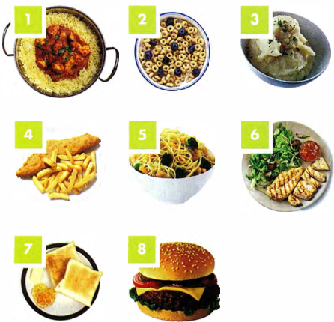
  Countable | Uncountable
  burger, chips, noodle, vegetable | cereal, chicken, curry, fish, mashed potato, rice, salad, toast
 | Answer the questions.  Which of the foods above do you eat regularly?  Which do you like/dislike?  What foods are typical of your country?
  02

LOCATING INFORMATION IN A TEXT

 | Read the text in one minute. Then cover it and tell your partner what you can remember.
  03

FOOD
CULTURE SHOCK
A CHARLES  You would think that eating with your fingers would be easy. In the US, there are only certain things you can eat with your fingers, like burgers, for example, and that's easy enough. When I went to South India, though, I realised that it is a whole new skill to learn to eat rice and curry with your fingers. You have to mix the curries together and with the rice and form a 'ball'. Daal is particularly helpful as a kind of glue.  You use your fingertips, never the palm of your hand, and use your thumb to pop it into your mouth. I thought I knew where my mouth was, but my first few attempts were a disaster. There was food everywhere!  *Daal is a lentil curry widely eaten in the Indian subcontinent.  C QIANG SHI  I enjoy trying food from different countries, but what interests me more is the culture and habits surrounding food and eating. In China, when we go to a restaurant with colleagues, when we are offered something, we say 'No thanks', even though we want it, because the person will definitely repeat the offer. In other countries, though, 'no' means 'no', so if you are just trying to be polite and don't take it the first time, you will end up with nothing! To me, it feels wrong to take something the first time it is offered, so it took me a while to get used to that when I travel abroad. | B ALFREDO  For me, when I travel, the 'fast food' culture always shocks me. I can't believe there are people in the world who live on 'junk food' like burgers and just grab a sandwich for lunch. Back home, food is very important to us. We cook fresh food for lunch and dinner and sit down and eat as a family at least once a day, twice at weekends. A lot of people grow their own vegetables and keep chickens. Food is part of your identity, so what are you saying about yourself when you eat some rubbish which contains chemicals and goodness knows what else? The worst thing I have seen on my travels is a baby being given a fizzy drink in a bottle. That really shocked me!  D PAULINE  Being a vegetarian is so easy here in the UK that we forget that not everyone in the world understands vegetarianism. For vegans the situation is even more difficult. Probably the best place I've been to is India, as everything is divided into 'veg' or 'non veg' so you know exactly what you're getting. In many countries, they don't even realise that there is a concept of not eating meat for ethical reasons. In many parts of the world, meat equates to prosperity, so the idea of going out for a meal and not having meat is alien to them. I have travelled to places where, as a vegetarian, all I have been able to eat is salad, fruit and chips. I'm glad to get home where we have special vegetarian products.
E AILEEN
I think breakfast is the meal where food culture shock really hits you. In Australia, there are certain foods you eat for breakfast and certain foods you don't. We usually eat cereal or toast, maybe yoghurt and fruit. We would never eat chicken or vegetables. But when I travelled in Asia, I realised that in many places, there is no difference between breakfast and dinner: rice, curry, noodles, soup, steamed vegetables and fish all appeared at breakfast. Even though I love all those things, I just can't face them at breakfast!

 | Quickly find the following information in the text.  - a food that can be used as a 'glue' daal  - a meat not usually eaten for breakfast In Australia chicken  - a country where 'no' doesn't always mean 'no' China  - an example of a 'junk food' burgers  - a country which is easy for vegetarians India  - a food eaten with fingers in the US burgers
  04
  ◉
  Paraphrase
  To answer some questions, you need to recognise paraphrase.
  Question: Who is concerned about healthy eating?
  Answer: Alfredo.
  Paragraph B doesn't use the phrase 'healthy eating' but these clues help us find the answer:
  …the 'fast food' culture always shocks me.
  …what are you saying about yourself when you eat some rubbish which contains chemicals...?
  The worst thing I have seen... is a baby being given a fizzy drink.
  ◉
  Some questions require you to find very specific information quickly. This exercise will help you practise this skill.
 | Match questions 1-6 with the evidence a-f.  Who:  - realised that some people eat the same dishes for different meals? f  - dislikes the takeaway culture? d  - discusses travelling for people on a special diet? a  - talks about what is considered polite in different cultures? e  - found it difficult to learn a new way of eating? b  - talks about producing your own food? c  - ... we forget that not everyone in the world understands vegetarianism.  - I thought I knew where my mouth was, but my first few  - attempts were a disaster. There was food everywhere! A lot of people grow their own vegetables and keep chickens.  - I can't believe there are people in the world who live on 'junk food'  - In China, when we are offered something, we say  - 'No thanks'... In other countries, though, 'no' means no'  - But when I travelled in Asia, I realised that in many places, there is no difference between breakfast and dinner
  05

[[[[[[[[[[SENTENCE COMPLETION]

 | Complete these sentences using a word from the text.  - In China, if you refuse food, the host will usually repeat the offer.  - For Alfredo, food plays an important role in a person's identity.  - In India, you should not use your palm(s) when eating.  - In some countries, eating meat represents prosperity.  - In many places in Asia, there is no difference between foods eaten for breakfast and dinner.
  06
  ◉ Being able to locate information quickly will help you in questions where you need to find a suitable word to complete a sentence.

GRAMMAR FOCUS: COUNTABLE AND UNCOUNTABLE NOUNS

 | Correct the errors in these sentences.  - Fresh fruit are healthy and we should eat them every day.  Fresh fruit is healthy and we should eat it every day.  - Chips cooked in the oven is healthier than fried chips.  Chips cooked in the oven are healthier than fried chips.  - The burgers and the pizza are the cheapest foods you can buy.  Burgers and pizza are the cheapest foods you can buy.  - In the India it is easy to find the vegetarian food.  In India it is easy to find vegetarian food.  - My favourite food is chickens.  My favourite food is chicken.
  07
 | Complete the sentences with some, any, much or many.  - There are some mushrooms in the fridge.  - Are many people vegetarian in your country?  - I don't put much sugar in my tea - just half a spoonful.  - Do we have any/much flour left?  - Can I have some more cake, please?  - How much rice do you eat every week?
  08

[[[[[[[[[[EXAM SKILLS]
FOOD TV: education or entertainment?
A
Shows about cookery have become more and more popular all over the world. But what are the reasons for this, and does it make us cook more? In the UK, BBC viewers complained to the programme Points of View that there were too many cookery shows on TV. In one week, the BBC showed 21 hours of cookery. When shows on other channels were included, this came to an amazing 434.5 hours of food TV.
B
In the past, TV cookery shows were there to teach people how to cook. One of the first famous TV cooks, Julia Child, was American. She began her career as a cook when, in 1948, she moved to Paris and learnt to cook sophisticated French cuisine because her husband loved good food. On her return home, she published a collection of French recipes made simple, for ordinary American housewives to use, which was an instant success. She was invited to do a TV show, where her humour and strong personality soon won her great fame.
C
Nowadays TV chefs are famous for all sorts of different reasons. Gordon Ramsay, for example, is an interesting TV chef. He is famous for having a bad temper and using foul language. In his TV show, Hell's Kitchen, he shouts at his staff when they make mistakes because he wants all the food at his restaurants to be perfect. He has many restaurants in different ccuntries. Jamie Oliver is a good-looking, working-class boy who made healthy eating fashionable. He believes children should eat healthy food and he worked with the government to make school meals healthier. His style of cooking is quick, easy and fun.
D
There are some famous pairs of TV cooks as well. The Hairy Bikers are a pair of chefs who have beards and ride motorbikes. They travel around to different places and cook there. They were both fat but then did a series of shows on how to cook diet food and both lost weight. Another famous pair was the Two Fat Ladies. They cooked unhealthy food using lots of fat and they didn't care about healthy eating. They also rode a motorbike.
E
The introduction of a competitive element to many cookery shows reminds us that food TV is more entertainment than education these days. Many of us love shows like Masterchef, where a contestant is eliminated on every show. The personalities of both the contestants and the judges are far more important than the cookery. In a popular competitive show called The Great British Bake-Off, there was a 'nice judge', Mary Berry, and a 'nasty judge', Paul Hollywood.
F
We know that cooking at home is better for us than eating ready-made or takeaway meals. However, the fact that there is more cookery on TV doesn't necessarily mean people cook more. Different studies have produced different results, but most agree that people generally spend less time cooking than they did in the past. Certain cookery shows influence viewers more than others. One study found that the most influential show was Jamie Oliver's 15 Minute Meals, which influenced 21% of viewers. This may be because his method is to cook quick, simple, healthy meals rather than 'restaurant-style' food.
G
It seems, though, that teaching children to cook at home and at school has much more influence on healthy eating than watching TV programmes on cooking. Grandparents have an important role to play because they may have more time -and experience - than parents. Cooking with family members on a regular basis and making food preparation part of the school curriculum is likely to ensure that children become adults who can and do cook.

 | Read the article about Food TV. Which paragraphs contain the following information?  Write the correct letter, A-F.  [NB You may use any letter more than once.]  - The cooking show that affects people most - F  - A TV chef who was first famous as an author - B  - The number of food shows on TV - A  - The role of cookery shows for enjoyment rather than learning - E  - Why children should be taught to cook at school - G  - Research about the amount of time people cook - F  - Examples of famous cookery partners - D
  09
 | Look at the following descriptions (1-7) and the list of famous chefs. Match each description with the correct chef, A-F.  [NB You may use any letter more than once.]
  10
  - The cooking show that affects people most - C  - A TV chef who was first famous as an author - E  - The number of food shows on TV - B  - The role of cookery shows for enjoyment rather than learning - A  - Why children should be taught to cook at school - F  - Research about the amount of time people cook - D  - Examples of famous cookery partners - E | - Mary Berry  - Jamie Oliver  - The Hairy Bikers  - Gordon Ramsay  - Julia Child  - Two Fat Ladies

UNIT/04: FOOD AND DRINK

WRITING
IN THIS unIT YOU WILL
LEARN HOW TO
- deal with a Part 1 question with two diagrams
- describe data without exact numbers
- compare data in a pie chart
- decide what information to include.

Lead-in

 | Read the task and look at the diagrams below.  The charts below show the favourite takeaways of people in the UK and the number of Indian restaurants in the UK between 1960 and 2015.  Summarise the information in both charts by selecting and reporting the main features, and make comparisons where relevant.  Write at least 150 words.
  01
  Diagram 1  Favourite takeaways in the UK  (A takeaway is a meal you buy in a restaurant or shop to eat at home.)  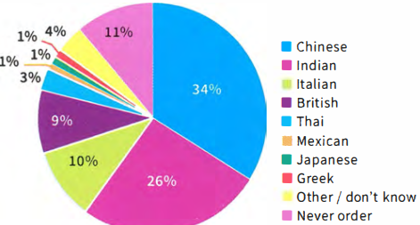 | Diagram 2  Number of Indian restaurants in the UK  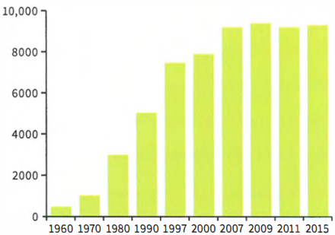
 | Look at the following expressions. Which are more suitable for diagram 1 and which are more suitable for diagram 2?  Diagram 1: 1, 2, 5, 6  Diagram 2: 3, 4, 7  - the highest proportion of people  - only a very small number of people  - there has been a steady increase  - a very small drop  - about a third of people  - approximately a quarter of people  - the greatest rise took place
  02

[[[[[[[[[[DESCRIBING TWO DIAGRAMS]
INTRODUCTION AND OVERVIEW

 | Complete this introductory sentence and overview. Write one word in each gap.  The 1 pie chart shows which type of takeaway food is the most popular in the UK, while the 2 bar chart shows how many Indian· restaurants existed in the UK between 3 1960 and 4 2015. We can see that 5 Chinese and Indian takeaways are the favourites, and that the number of Indian restaurants in the UK 6 increased/rose/grew steadily during this period. | TIP 03
  03
  ◉ Sometimes you will have to write about two separate types of diagram in the same task.
  When you are working with two diagrams, your first sentence should introduce both of them and your overview should summarise both of them.

DESCRIBING NUMBERS IN A PIE CHART

 | Match the percentages from the pie chart with their descriptions.
  04
  - 34%  c 34% - just over a third  - 26%  b 26% - about a quarter  - 10%  d 10% - one in ten  - 1%  a 1%- a tiny proportion | - a tiny proportion  - about a quarter  - just over a third  - one in ten

MAKING COMPARISONS

 | Look at diagram 1 and complete the sentences about the pie chart with the words in the box. One word is used twice.  - The most popular type of takeaway is Chinese.  - The three least popular types are Mexican, Greek and Japanese.  - Italian takeaways are slightly more popular than British takeaways.  - Japanese food is less popular than Thai food.  - More people like Chinese food than Indian food.  - Fewer people like Mexican food than Thai food.
  05
  fewer | least | less | more | most

GRAMMAR FOCUS: COUNTABLE AND UNCOUNTABLE NOUNS

 | Choose the correct words to make true sentences.  More and less are used with countable / uncountable nouns.  uncountable  More and fewer are used with countable / uncountable nouns.  countable
  06

 | Put the nouns into the correct column.
  07
  restaurant | coffee | farm | country | home | land
  language | meat | oil | person | home animal | sand
  Countable | Uncountable
  restaurant, country, farm, home, language, person, animal | coffee, land*, meat, oil, sand  * When land means 'country', it is countable.
 | Complete the sentences with more, less or fewer. Use the information in the chart.  - China has more land than India.  - India has less land than China.  - In India, fewer people live in cities than in China.  - India has more official languages than China.
  08
  Countable | China | India
  land | 9,596,960 square km | 3,287,263 square km
  percentage of population living in cities | 50.5% | 31.3%
  official languages | Mandarin Chinese | 22 official languages

GRAMMAR FOCUS: ARTICLES

 | Correct the errors with articles in these sentences about diagrams 1 and 2.  - Number of Indian restaurants in UK has risen.  The number of Indian restaurants in the UK has risen.  - The Chinese food is the most popular.  Chinese food is the most popular.  - Second most popular food is Indian.  The second most popular food is Indian.  - There was small drop in the number of Indian restaurants in 2011.  There was a small drop in the number of Indian restaurants in 2011.  - There were about thousand Indian restaurants in 1970.  There were about a thousand Indian restaurants in 1970.
  09

DESCRIBING DIAGRAMS WITHOUT EXACT NUMBERS

 | Some graphs or charts do not give the exact numbers. It is important to show that the number you use is not exact. Match these numbers with their description.
  10
  - 8950 - c  - 2019 - f  - 500,070 - e  - 3946 - a  - 103 - b  - 7223 - d | - approximately 4000  - about a hundred  - just under 9000  - between 7000 and 7500  - around half a million  - a little over 2000

 | Look at these examples from a description of diagram 2.  There were about 500 Indian restaurants in the UK in 1960.  The number rose from approximately 5000 in 1990 to just under 8000 in 2000.  The figure for 1997 was around 7500.  From 2007 to 2015 the number of restaurants was between 9000 and 9500. In 1970 there were a little over 1000 Indian restaurants.  Use the expressions in bold to complete the sentences about diagram 3, which shows the market share of four supermarkets.
  11
  - In 1995, Foodhall had just under / a little under 20% of the market, while Finco had just over / a little over 20%.  - In 1995, Bestway's share of the market was just under / a little under 5%.  - In 2005, all the supermarkets had between 11% and 30% of the market.  - In both 2005 and 2015, Alton's share of the market was approximately / around / about 16%.  - Finco had the biggest market share in 2005, which was approximately / around / about 30%. | 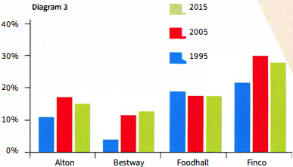

STUDYING A MODEL ANSWER: AVOIDING 'OUTSIDE' INFORMATION

 | Read the model answer, which is based on diagrams 1 and 2. Two sentences should not be included. Can you find them?  The sentences that should not be included are:  It is not surprising that people in the UK like British food as fish and chips is the national dish.  Even my village has an Indian restaurant!
  12
 | Read the model answer again and find:  - the overview  We can see that Chinese and Indian takeaways are the favourites, and that the number of Indian restaurants in the UK rose steadily during this period.  - a sentence that explains the link between the two charts  The pie chart shows us that Indian food is popular and the bar chart shows how its popularity grew. The introductory sentence [The pie chart shows which type of takeaway food is the most popular in the UK, while the bar chart shows how many Indian restaurants existed in the UK between 1960 and 2015.] also mentions the two charts, though it doesn't interpret the information to make a clear link between them.  - a comparison  Chinese and Indian takeaways are much more popular than all the others  - a passive form  were only chosen by 1% of people  - a way of saying '1990 to 2000'  in the 1990s  - an expression meaning 'has not changed much'  has remained stable  - an expression used to avoid exact numbers  from about 5000... to almost 8000  TIP 13 | MODEL ANSWER
  13
  Never include any information that is not shown in the diagram. Even if you know a lot about the data given, do not try to explain the reasons for it or give your own opinion.
  The pie chart shows which type of takeaway food is the most popular in the UK, while the bar chart shows how many Indian restaurants existed in the UK between 1960 and 2015. We can see that Chinese and Indian takeaways are the favourites, and that the number of Indian restaurants in the UK rose steadily during this period.
  The pie chart shows that Chinese and Indian takeaways are much more popular than all the others, at 34% and 26%, There are another two types that quite a lot of people like. These are Italian at 10% and British at 9%. It is not surprising that people in the UK like British food as fish and chips is the national dish, Greek, Japanese and Mexican were only chosen by 1% of people.
  The pie chart shows us that Indian food is popular and the bar chart shows how its popularity grew. Even my village has an Indian restaurant! There was a rising trend from 1960 onwards. The increase was greatest in the 1990s, from about 5000 restaurants in 1990 to almost 8000 in 2000. Since 2007, the number has remained stable at just over 9000.

[[[[[[[[[EXAM SKILLS]
 | Read the exam question below and study the charts, then answer these questions about the data.
  14
  - What is the main trend revealed in the bar chart?  The percentage of overweight or obese adults is increasing.  - Which ten-year period showed the first significant increase?  the period between 1985 and 1995  - What happened in the ten-year period after that?  There was a similar, slightly larger increase.  - What is the link between the two charts?  The pie chart looks at the number of overweight and obese people in a single year and gives information about how obese they are.  - In 2015, what percentage of people were severely obese?  6%  - Which was the largest group in 2015?  The largest group was people who were obese, but apart from the severely obese group, the groups were very similar in size. | You should spend about 20 minutes on this task.  The bar chart shows the percentage of adults who were overweight or obese (too fat or much too fat) in one country from 1965 to 2015. The pie chart shows the proportion of adults who were overweight, obese or severely obese in 2015.  Summarise the information by selecting and reporting the main features, and make comparisons where relevant.  Write at least 150 words.
  Percentage of adults who are overweight or obese  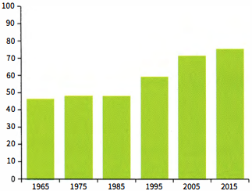 | Weight range of the adult population 2015  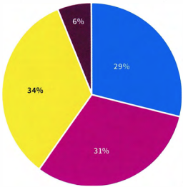
    ☐ Healthy or underweight | ☐ Obese (too fat)
    ☐ Overweight | ☐ Severely obese (dangerously fat)
 | Now write your report. Remember:  Sample answer  The bar chart shows the percentage of the adult population who were overweight or obese between 1965 and 2015, while the pie chart shows the percentage of people who were a healthy weight, overweight, obese and severely obese in 2015. The rise in the number of people who are too heavy was gradual from 1965 to 1985. The first significant increase occurred between 1985 and 1995, from around 48% to almost 60%. In the next ten-year period there was a similar large rise. By 2005, approximately 70% of people weighed too much.  The upward trend continued into the 21st century but at a slightly lower rate.  The pie chart confirms that in 2015 over 70% of adults were too heavy, and it also gives more detail about how much they were overweight. Only 6% of people were so overweight that their health was seriously at risk, i.e. severely obese. The remaining people were divided more or less equally between the other groups.  - Include an overview.  - Don't try to include all the data.  - Don't include anything from outside the data.
  15

UNIT/04: FOOD AND DRINK

LISTENING
IN THIS unIT YOU WILL
LEARN HOW TO
- find synonyms and paraphrase in matching tasks
- identify 'distractors' in matching tasks
- answer classification tasks.

Lead-in
 | Pictures A-G show different areas of work or study. Match the pictures with the words in the box.  A: boil B: fry C: bake D: grill
  01
  bake | boil | fry | grill
  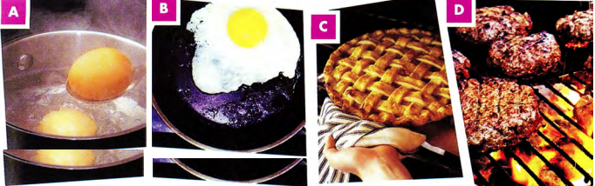
 | Match the words with the type of food they are. Put them in the correct column.
  02
  apples | bananas | beef | biscuits | burger | cake | steak | potatoes
  carrots | chocolate | lamb | cucumbers | pastries | pears | peas | strawberries
  Meat dishes | Vegetables | Fruits | Sweets
  beef, steak, burger, lamb | potatoes, carrots, cucumbers, peas | apples, strawberries, pears, bananas | biscuits, cake, chocolate, pastries

[[[[[[[[[[MATCHING TASKS]
 | Listen to two friends talking about a party they are planning. Match Mike's suggestions with Jane's answers.  32  What are they going to prepare?  They are going to prepare salad and roast chicken.
  03
  Suggestions  - What do you think about preparing a Mexican meal? c  - We could have pizza. Everybody likes pizza. a  - I know! We could have salad and roast chicken. b | Answers  - I think we should have something healthier.  - That sounds like a good idea. Let's do that.  - I think it might be too spicy for some people.
  ◉ In matching tasks in the Listening test, you may hear information about several of the options, but only one of the answers is correct.

 | Listen to two friends talking about preparing a meal. How are they going to prepare the potatoes?  A is the correct answer.  33  Why are the other answers incorrect?  Frying the potatoes won't be healthy, baking the potatoes will take too long.
  04
  - boil | - bake | - fry
  ◉ In matching tasks in the IELTS test:
  - you do not need to use all of the letters. You should put one letter next to each numbered question.
  - the questions follow the same order as the information on the recording which you need for the answers.
 | Listen to two friends discussing food shopping. Match the names of the shops (1-3) with the different types of food, A-D.  34  Which option didn't match any of the shops?  Option D was mentioned, but it didn't match any of the shops. |  | TIP 04
  05
   | Types of food
  - Arcadia - C  - Best Buy - A  - Hampton's - B | - vegetables  - meat  - fruit  - sweets
  Listen carefully to what is said about all the options to make sure you choose the correct one.

 | You will hear a radio programme in which two people are discussing the different restaurants in a town.  Look at the names of restaurants (1-3) and the list of types of restaurant.  Match each restaurant with the correct type, A-G.  35  Which option didn't match any of the shops?
  06
   | Types of restaurant
  - Adam's - E  - The Duke - C  - The Tower - D | - vegetarian  - steakhouse  - seafood  - Italian  - international  - French  - fast food
 | After you have checked your answers, look at the Listening script on page 182 and check why the other options were not correct.  - The interviewer asks if Adam's is a French restaurant (F) or a steakhouse (B), but Chris says it sells food from all over the world, so E is the correct answer.  - Vegetarian (A) dishes are mentioned when Chris talks about The Duke, but it's the fish dishes make it famous and so it can't be a vegetarian restaurant.  - Chris says that The Tower isn't a fast food restaurant (G) and it specialises in all different types of food from Italy so D is the correct answer.
  07
 | Look at the Listening script again and find words that mean the following:  - crowded - busy  - delicious - tasty  - cheap – low-cost  - smart - fashionable  - inexpensive - reasonable
  08

FOLLOWING A CONVERSATION

 | Choose the option, A, B or C which does NOT mean the same as the first sentence.  - The price of food in the restaurant is cheap.  C  - The price of a meal in the restaurant is reasonable.  - The restaurant is excellent if you want a budget meal.  - The food in the restaurant is overpriced.  - Marco cooked us a really tasty meal.  B  - The meal Marco prepared was delicious.  - Marco cooked us a really unappetising meal.  - The meal Marco made for us was mouth-watering.  - We were served food that was cooked in the old-fashioned way.  A  - The meal we had was very contemporary in style.  - The meal we had was very traditional.  - The meal was made from a historic recipe.  - When I went to Thailand, I really enjoyed trying the street food.  C  - I really liked tasting the food that was sold outdoors in Thailand.  - In Thailand I loved the food we bought from stalls in the streets.  - I enjoyed eating at restaurants when I was in Thailand.  - The chef at the Lodge Hotel is very skilful.  A  - The chef at the Lodge Hotel is bad at his job.  - The chef at the Lodge Hotel has a lot of expertise.  - The chef at the Lodge Hotel is highly trained.  - The ingredients for the recipe can be changed to ones you have available.  C  - You can use different ingredients to make this dish if you can't find everything.  - You can be flexible about what ingredients you add to this recipe.  - You should follow the recipe strictly or it won't taste good.  - The chef at the new restaurant is famous across the country.  C  - The chef at the new restaurant is well known nationally.  - The chef at the new restaurant is recognised across the country.  - The chef at the new restaurant is unknown outside of his town.  - I didn't like the soup; it was too spicy.  B  - The soup had too much pepper.  - The soup wasn't tasty.  - The soup was a bit too hot for my taste.
  09
 | Underline the words which helped you find the answers to exercise 9.  - cheap - reasonable, budget  - tasty - delicious, mouth-watering  - old-fashioned - traditional, historic  - street - outdoors, from stalls in the streets  - skilful - expertise, highly trained  - can be changed - use different ingredients, flexible  - famous - well known, recognised  - too spicy - too much pepper, too hot
  10

[[[[[[[[[[CLASSIFICATION TASKS]
◉ Sometimes in the test you will be asked to match several pieces of information with three different options. Like with other matching exercises, you must listen for ideas, since the same word will often not be used on the recording as in the question.
The options with letters (A-C) can be used more than once. The numbered information you must find (1-5) will be in the order that you will hear it.

 | Listen to a famous TV chef talking about different countries and their cuisines. Match the statements with the correct country, A-C.  36  - They use chopsticks made of several different materials.  B  - You can find a lot of different types of regional cooking here.  A  - This place is famous for hot, peppery food.  C  - In this country people use recipes that came from different countries.  B  - This country is well known for its grilled meat.  C  - China  - Japan  - Korea
  11
[[[[[[[[[[EXAM SKILLS]

 | You are going to hear an interview with a chef about a TV programme he has made about food in China.  Choose FOUR answers from the types of food in the box and write the correct letter A-F next to questions 1-4.  37
  12
  Which of the foods:  - is often enjoyed by children?  B  - can be cooked in a short time by the dinner guests?  E  - needs expertise to make?  D  - can be adapted to your tastes?  C | Types of food  - Beijing duck  - kebabs  - dumplings  - noodles  - hotpot  - jellyfish

UNIT/04: FOOD AND DRINK

SPEAKING
IN THIS unIT YOU WILL
LEARN HOW TO
- talk about food in your country (Speaking Part 1)
- use the preparation time to collect your ideas for Part 2
- organise your talk (Speaking Part 2).

Lead-in

 | Look at the photographs of different dishes. Which ingredients do you think are used to make each one? Match the pictures with the words in the box. Some ingredients are used more than once.  Suggested answers:  - Arabian Kabsa: lamb, onions, garlic, spices, carrots  - Pizza: flour, cheese, tomatoes (and other toppings)  - Egg noodles and Chinese dumplings: egg, flour, beef, onions, cabbage
  01
  beef | cabbage | carrots | cheese | chicken
  egg | tomatoes | yoghurt | ginger | chillies
  lamb | onions | soy sauce | rice | spices
  flour | garlic
  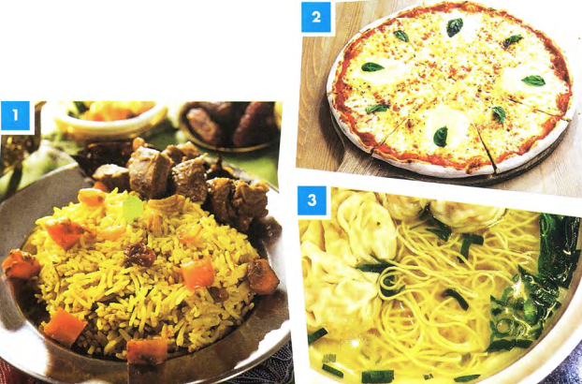
 | With a partner, discuss your favourite food. What ingredients are used to make it?
  02

GRAMMAR FOCUS: COUNTABLE AND UNCOUNTABLE NOUNS

◉Some things we eat are countable and some are uncountable. This changes some of the words we use to talk about them.
Examples:
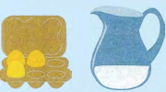  There are some eggs.  There is some water. | 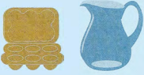  There aren't any eggs.  There isn't any water.
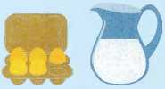  There are a lot of eggs.  There's a lot of water. | 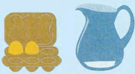  There aren't many eggs.  There isn't much water.

 | With a partner, describe what you can see in the fridge.  Use the sentences below to help you.
  03
  - There are a lot of eggs.  - There isn’t much cheese.  - There is a lot of milk.  - There are some carrots.  - There aren’t any bananas.  - There is some orange juice. | 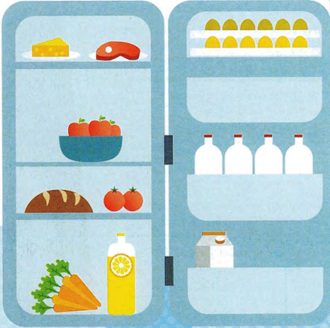

FOLLOWING A CONVERSATION

 | Listen, then read Mohammed's answers to these Part 1 questions about food. Are the phrases in bold positive or negative opinions?  38
  04
  Examiner | What kind of food is popular in your country?
  Mohammed | These days a lot of young people actually enjoy Western food like pizza and fried chicken. Our national food is often too spicy, especially for children and foreigners, and also it takes too long to cook. I think that it's delicious though!
  Examiner | What do you think of Western food?
  Mohammed | Well, I suppose Western food is quick to make and is tasty too, so everyone can eat it without too much trouble. I think that a lot of people like food to be convenient because they're so busy nowadays.  Is there any kind of food you don't like?
  Examiner | Is there any kind of food you don't like?
  Mohammed | Yes, I'm not keen on sushi at all. It's so strange eating something that hasn't been cooked. I know it's very fresh and healthy but I just don't like the taste and I can't stand the texture - it's too chewy for me.
  Positive | Negative
  enjoy, delicious, quick to make, is tasty, convenient, fresh, healthy | too spicy, takes too long to cook, not keen on, so strange, don't like the taste, can't stand, too chewy
 | Answer the three questions in exercise 4 with a partner. Use some of the positive and negative phrases in the box.
  05

USING THE PREPARATION TIME IN PART 2

 | Listen, then read Mohammed's answers to these Part 1 questions about food. Are the phrases in bold positive or negative opinions?  39  Look at the task card and listen to Angelica talking about a meal that is popular in her country. Then answer the questions below.  Describe a popular meal from your country that you like to eat.  You should say:  - what the meal is  - why it is popular in your country  - why you like it  and say why you would recommend it to a visitor to your country.  - Did Angelica introduce what she was going to talk about?  Yes  - What was the meal that Angelica described?  risotto  - Why is it popular in her country?  a lot of rice is produced there, simple to cook, you can use different ingredients  - Why does she like it?  It reminds her of home. It's a good meal to make for friends.  - Why would she recommend it to visitors to her country?  Because it is special and tastes different to risotto in other countries.
  06

 | You only have one minute to make notes on the topic for Part 2, so it is a good idea to write down key words and phrases. Match the four points on the card with some key words that another student wrote down (a-d).  1: d 2: a 3: c 4: b  - We love meat, traditional, lots of sheep!, proud of our cuisine  - better in Turkey than UK, different types (Shawarma, doner, etc.), most famous street food  - I'm busy → buy quickly, tasty, juicy, reminds me of beach holidays  - lamb, slowly grilled, spices, garlic - serve with rice / bread / vegetables | TIP 07
  07
  Describe a popular meal from your country that you like to eat.
  You should say:
  - what the meal is ⁽¹⁾
  - why it is popular in your country ⁽²⁾
  - why you like it ⁽³⁾
  and say why you would recommend it to a visitor to your country. ⁽⁴⁾
  Remember that you need to speak for 1-2 minutes on the topic you are given, so in this case make sure you choose a meal you can talk about easily.
 | Spend one minute writing notes to the questions about a popular meal in your country. |  | TIP 08
  08
  It is important to make notes and try to cover every point on the card.
 | Take it in turns with your partner to speak for two minutes. If your partner stops, think of questions to ask them.  Example  - l used to eat it at the beach in summer...  - Who did you go to the beach with?
  09

[[[[[[[[[[ORGANISING A PART 2 TALK]
◉ When you are asked to speak on a topic for two minutes you should try and organise your talk:
- Introduction - say what you are going to talk about.
- Body-answer the questions on the card.
- Conclusion-briefly give a conclusion to your talk.

 | Can you use the phrases in italics in an introduction (I) or a conclusion (C)?  - I'm going to talk about my favourite food, paella. I  - I'd like to tell you about pelmeni - it's a very famous dish in my country. I  - So, it is one of the most famous foods in my country for those reasons. C  - To sum up, I think it's popular because it is easy to cook. C  - As you can see, it's a tasty and healthy dish and that's why it's popular. C
  10
  ◉ You can help to structure your talk by saying why you chose the topic:
  I chose this topic because...
  You can also use words like firstly/first of all, secondly, thirdly to help you (and the examiner) keep track of your talk.
 | Work in pairs. Look at the students' notes relating to the task card below.  Spend one minute thinking how you will structure your talk, then take it in turns to practise presenting the information.  Describe your favourite food.  You should say:  - what the food is  - how often you eat it  - how the food is made  and say if you can make the meal yourself.
  11
  Student A | Student B
  Pizza - delicious, easy cook, filling  on Fridays - late lectures, special day  oven, bread, add cheese, tomato, toppings  only frozen! / take-away  Conclusion - easy and tasty | Vegetable soup - tasty, healthy, cheap at weekends, winter - long time to cook, better in cold weather  chop vegetables, boil, wait  yes, love cooking, relaxing, fun  Conclusion - enjoy making, filling, economical

[[[[[[[[[[EXAM SKILLS]
 | Read the task card and spend one minute preparing your talk. Take it in turns to speak. Try to speak for two minutes.  Remember to:  - make notes of key ideas  - introduce your talk  - structure your talk  - give it a conclusion. | TIP 12
  12
  Describe a special occasion when you had a really enjoyable meal.
  You should say:
  - what the occasion was
  - who was at the meal
  - what you ate
  and explain why the meal was so enjoyable.
  It is good to use different adjectives in this part of the test. Think of different ways of saying the words and avoid words like good and bad.

UNIT/05: CONSUMERISM

READING
IN THIS unIT YOU WILL
LEARN HOW TO
- identify topic sentences
- identify main and supporting ideas
- match headings with paragraphs
- use will and going to.

Lead-in

 | Which of these activities can you do at a shopping mall? Which can you see in the pictures?  The pictures show a climbing wall, a beauty treatment, skiing, a health check and having an expensive meal.  Can you think of anything else you can do at a mall?  According to the text, all these activities can be done at a mall.
  01
  buy clothes | buy or rent an apartment | check your health
  go climbing | go in a hot air balloon | go to the beach
  have a snack | have a beauty treatment | have an expensive meal
  see a film | see an art exhibition | see plants and trees
  ski
  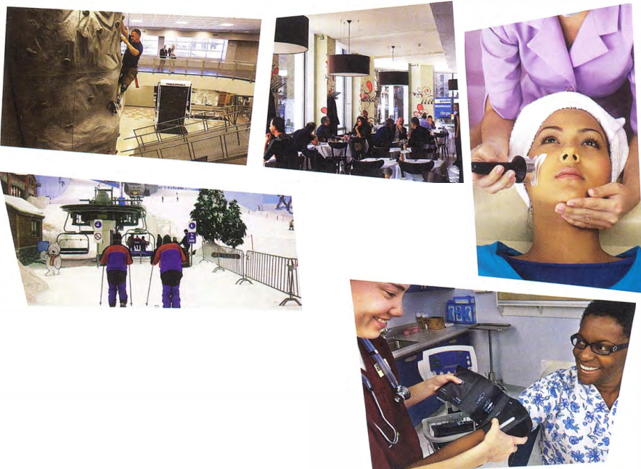

SKIM READING

 | Read the text in one minute. Answer the questions orally without looking at the text again.  - Which of the activities in exercise 1 were mentioned?  All of the activities are mentioned.  - Can you remember any places that were in the text?  The text mentions the US, China, the Middle East, East Asia, Bangkok, Singapore, Madrid, London.  - Is the text mainly about the past, present or future?  It is about the present and future.
  02

THE FUTURE OF MALLS
A  Shopping malls have never been just about shopping. They began in the United States after the Second World War and, for the young, they were always a place to 'hang out' and be seen. However, the world has moved on, and just providing shops and a food court is no longer enough to keep malls alive. Malls became less popular at the start of the 21st century, mainly because of online shopping. There is even a website, deadmalls.com, which shows the end of many US malls. Malls need to change to survive. So what will the mall of the future look like?  B  Malls are already becoming bigger and better all over the world. Asia and not the US is now the 'mall capital' of the world and is home to the five largest malls in the world. China is home to the two largest. Some malls in the Middle East and East Asia are starting to specialise. It is predicted that this will happen more and more in the future. Some malls will only sell electrical items, for example, or only fashion for young people. Some malls will only include expensive shops or cheap shops, as already happens in Bangkok and Singapore.  C  Malls are becoming 'the new downtown', with cinemas, bowling alleys, climbing walls and even concert halls. Xanadu, a mall 30 km from Madrid, is a recreation centre for a family day out as well as a shopping centre, with ski slopes, minigolf, go-karts, balloon rides, bowling and billiards. We have always been able to grab a burger at the mall, but in the future we are going to see 'fine dining' too, with more expensive restaurants based at malls, as well as spas, fitness centres and art galleries. There are also going to be more apartments and office space so that more people can live, work, shop and be entertained in one location. | D  Mall owners are going to need to think of new ideas to remain in business. One growing trend is the seasonal changes in the mall. It began with having Santa Claus in December, but now there are 'pop-ups' -temporary shops, stalls and kiosks - for other seasons and events. Brent Cross in North London has an 'urban beach' in summer, and its main lobby has different promotions and events every week, from bungee jumping for kids to free health checks.  E  So, we have looked at the facilities malls will need to offer. Malls will need to consider the environment too. There will be more open-air malls and more natural features. Mall designers will have to make sure people can get there by public transport. They will also need to use more natural sources of heat and light. We will see more plants, trees, grass and even waterfalls at our local malls in the future.  F  The future of malls looks exciting: there will be 'virtual malls' and technology will be used within malls to help us shop, find bargains and even park our car. With all these creative innovations, the mall will go from strength to strength.

[[[[[[[[[[MATCHING HEADINGS]
◉ Matching headings tests your ability to summarise and understand the main idea of a paragraph.
You are given a list of headings (more than the number of paragraphs) and you must choose a suitable heading for each paragraph.
To match headings, you need to be able to find the main idea of a paragraph. You can usually find one sentence that sums up the main idea. This is the topic sentence. This has been highlighted in paragraph A: Molls need to change to survive.
The sentence Malls need to change to survive is supported by evidence in the paragraph, including:
- The world has moved on.
- Malls became less popular at the start of the 21st century, mainly because of online shopping.
- There is even a website, deadmalls.com, which shows the end of many US malls.

TOPIC SENTENCES AND MAIN AND SUPPORTING IDEAS

 | The topic sentence in paragraph B is Malls are already becoming bigger and better all over the world. Write two pieces of evidence from paragraph B which support the topic sentence.  (1) Asia and not the US is now the 'mall capital' of the world and is home to the five largest malls in the world. (2) China is home to the two largest. | TIP 03
  03
  The topic sentence is often, but not always, the first sentence in a paragraph, so that is the first place to look.
 | Find the topic sentences in paragraphs C, D and E.  - Malls are becoming 'the new downtown', with cinemas, bowling alleys and even concert halls.  - Mall owners are going to need to think of new ideas to remain in business.  - Malls will need to consider the environment too.
  04
 | Below is one supporting idea for each of paragraphs C, D and E. Add one more for each paragraph. Write the supporting ideas in your own words.
  05
  - Xanadu... is a recreation centre for a family day out as well as a shopping centre.
  There will be more fine dining / There will be spas, fitness centres and art galleries / There will be more apartments and office space.
  - Brent Cross ... has different promotions and events every week.
  D There are 'pop-up' shops, stalls and kiosks at different times of the year.
  - There will be more open-air malls and more natural features.
  Malls will have to make sure people can reach them by public transport/ Malls will have to use natural sources of heat and light /There will be more plants, trees, grass and waterfalls.

PARAPHRASE

 | TIP
  ◉ In a 'matching headings' task, the headings you have to match will be a paraphrase of the main idea of the paragraph. Don't expect the same words to be used in the headings and the passage. The headings may contain synonyms (words which mean the same) and antonyms (words which mean the opposite) or they may use paraphrase (phrases which have a similar meaning to words in the passage).
  For example, a heading for paragraph A in The future of malls might be 'Adapt or die'. This is a paraphrase of the main idea 'Malls need to change to survive'.
  change-adapt (synonyms) survive - die (antonyms)
  As you prepare for your exam, make a list of synonyms in your notebook. Knowing different ways to say things is one of the key skills in IELTS.

 | In the test, there are always more headings than you need. Read these headings for paragraphs B to E (they are not in the right order).  - Innovate and stay alive  - Fast food paradise  - Expanding and improving  - Malls and the natural world  - A new city centre
  06
 | Match the words and phrases 1-6 (from the headings above) with the words and phrases a-f (from the topic sentences of paragraphs B-E).
  07
  - Innovate - c  - stay alive - e  - expanding - a  - improving - f  - natural world - b  - city centre - d | - becoming bigger  - environment  - think of new ideas  - downtown  - remain in business  - becoming better
 | Choose a heading from exercise 6 for paragraphs B to E.  Write the correct number i-v in the gaps.  Paragraph B: iii  Paragraph C: v  Paragraph D: i  Paragraph E: iv
  08

GRAMMAR FOCUS: FUTURE FORMS

 | Find examples of future forms in the passage The future of malls. Which two ways of talking about the future are used? Write one example of each.  will - So what will the mall of the future look like? / It is predicted that this will happen more and more in the future. / Some malls will only sell electrical items / Some malls will only include expensive shops/the facilities malls will need to offer / Malls will need to consider the environment too. / There will be more open-air malls / designers will have to make sure / They will also need to use more natural sources of heat and light / We will see more plants, trees / there will be 'virtual malls' / technology will be used within malls / the mall will go from strength to strength  going to - in the future we are going to see 'fine dining' too / There are also going to be more apartments / Mall owners are going to need to think of new ideas
  09

◉ Will + infinitive and going to + infinitive are both used to talk about the future.
Going to is used when there is a link to the present, for example if something is already planned or a change has started:
Mall owners are going to need to think of new ideas to remain in business.
We see from the text that many malls have already started thinking of new ideas.
Will + infinitive is used for prediction: something the writer believes about the future. It does not
have to be based on present evidence:
... the mall will go from strength to strength.
This is the writer's prediction or belief about the future.

 | Complete the sentences with the correct form of will or going to.  - Look at these plans for the new mall! There is going to be a climbing wall!  - This newspaper article says they are going to spend $25 million on the project.  - I think it will be great when it is finished!  - I agree, but I'm afraid many local businesses will / are going to have to close.  - I heard there are going to be 12 different restaurants!  - I expect most of the shops will be expensive ones.
  10

[[[[[[[[[[EXAM SKILLS]
 | Which paragraph in the passage Markets around the world contains information on the following? Write the correct letter, A-G.  - markets put on at a particular time of year - F  - markets where anyone can sell anything - D  - markets selling things to eat - B  - advice for people who want to dress differently from others - C  - examples of markets outside Europe - E
  11
 | The reading passage has seven paragraphs, A-G. Choose the correct heading for paragraphs B-F from the list of headings (i-vii) below. Write the correct number, i-vii. There are two headings you won't need.  - Paragraph B - ii  - Paragraph C - iv  - Paragraph D - vii  - Paragraph E - i  - Paragraph F - vi
  12
  List of headings
  - Local art and craft work to take home
  - Inexpensive things to eat straight from the countryside
  - Toys for children of all ages
  - Invent a new style for yourself at bargain prices
  - London has the best markets
  - Find gifts for winter celebrations
  - Sell what you don't need

Markets around the world
A  We have become so used to shopping in big supermarkets and chain stores, identical in every town, that we have forgotten about one important way to shop-markets. Markets are found in every country in the world, but wherever you go they are different and reveal the local culture- and agriculture. From farmers markets selling fresh produce to craft and antique markets, they are the best place to find something unique at a great price.  B  Food is at its cheapest and freshest  in markets. Farmers often sell direct to the consumer, without all the packaging, shipping and advertising that increases costs in shops and supermarkets. You can often find unusual products and those that are not mass-produced. Food markets vary hugely according to where they are in the world. For example the Kauppatori market in Helsinki, Finland sells moose, reindeer and bear salami. Wherever you are, food will be locally produced and reasonably priced.  C  Markets are also good places to buy clothes. Some sell cheap new and second-hand clothes, while others specialise in vintage or ethically made clothes and original items. The markets of London are some of the best in the world for those who want to create a unique look for themselves. Many new designers start with a market stall, so if you are looking for a totally original item of clothing, you could get something really special at a bargain price at Brick Lane, Spitalfields or Portobello Road markets. | D  Another type of market is a flea market. This is a much more informal type of market, where second-hand products can be sold by anyone. If you have unwanted items at home, you could take them to a flea market and sell them yourself. There are also antiques and possibly local crafts at this kind of market. In some parts of the world there may not even be stalls, rather, vendors lay out their goods on a sheet on the ground. In other parts of the world, flea markets have developed into car boot sales, where people sell their unwanted items from their cars.  E  In some places, markets are directed at visitors and tend to sell handicrafts typical of the region. For many tourists, a visit to a nearby market to buy souvenirs is an important part of their holiday. Guadalajara in Mexico has a huge range of traditional textiles, glassware, ceramics and art works and Seoul in Korea has some wonderful original designs of all kinds of products at affordable prices. Countries in the Middle East usually have beautiful hand-made rugs and carpets, and Indian markets sell colourful handloom fabrics and beautiful silk scarves.  F  In Europe, Christmas is the time when seasonal markets are held to sell decorations and gifts for the festive season. One of the most famous of these is held in Wenceslas Square in Prague in the Czech Republic. The market is made up of colourfully decorated wooden huts selling traditional handicrafts, embroidered lace, wooden toys, scented candles, Christmas tree ornaments, and puppets and dolls beautifully dressed in traditional costumes. This looks very pretty, especially in the snow.  G  So, wherever you are in the world and whatever you are looking for, there is a market for you. You can get all kinds of unusual things at great prices.

UNIT/05: CONSUMERISM

WRITING
IN THIS unIT YOU WILL
LEARN HOW TO
- organise a Part 2 essay
- write an introduction
- write about points for and against, and give opinions
- give examples and evidence to support your views.

Lead-in

 | Put the words and phrases into the correct column.
  01
  advantages | all things considered | benefits
  disadvantages | drawbacks | in my view
  negative aspects | positive aspects | personally
  Good points | Bad points | Opinion
  advantages, benefits, positive aspects | disadvantages, drawbacks, negative aspects | all things considered, in my view, personally

 | These sentences are from an essay on the advantages and disadvantages of shopping online. Are they talking about good points (G), bad points (B) or giving an opinion (O)? Write G, B or O. The first one has been done for you.  - A wider range of products is available online. G  - You can't try on clothes and shoes if you buy online. B  - I prefer going to shops and choosing things in person. O  - There is no need to carry heavy shopping to your car. G  - You save money on petrol, parking or bus fares. G  - Goods might be delivered when you are out. B  - It isn't a good idea to give your credit card details online. O  - You often have to pay a lot for postage and wait for your goods. B  - I think it is better to support local shops. O
  02
[[[[[[[[[[PART 2 QUESTION TYPES]
◉ In Part 2 you have to write an essay of about 250 words. There are different types of question in Part 2, and you must write a well-organised answer considering different points of view.
The topics in Part 2 are all general and do not need special knowledge.

 | Three of the question types you might find in Part 2 are:  - Do you agree (or disagree) that...? c  - Do the advantages/benefits of ... outweigh the disadvantages/drawbacks? a  - Discuss two different views and give your opinion. b  Match the question types 1-3 with what you have to do (a-c).  - Say if you think there are more good points than bad points.  - Write about both sides and say what you think.  - Give your opinion on this. | TIP 03
  03
  Read newspapers and websites to find out about current issues.
 | Look at the following question.  Do you agree that supermarkets are a threat to small shops and local communities?  Decide on your own opinion. Choose from these options.  - I strongly agree. Supermarkets will force small shops to close and this will damage local communities.  - I agree to some extent. There may be a slight threat to small shops and local communities.  - I generally disagree. There is a place for both small shops and supermarkets.  - I strongly disagree. Supermarkets will not have an impact on small shops and local communities. | TIP 04
  04
  Do you agree that supermarkets are a threat to small shops and local communities?
  Avoid being totally neutral: even if you don't have an opinion on the topic, it is better to agree or disagree. Choose the side you can find most points for.

 | The same topic could be expressed as a different question type:  Are these advantages or disadvantages of supermarkets?  Suggested answers  Advantages: 1,2,5,7  Disadvantages: 3, 4, 6, 8  - They are cheap.  - There are many different products.  - You often need a car to get there.  - You don't usually meet your friends there.  - Food is usually fresh.  - There are sometimes queues at the checkout.  - There is plenty of free parking.  - Small shops lose their customers.
  05
  Do the advantages of supermarkets outweigh the disadvantages?

WRITING AN INTRODUCTION

◉It is important to begin your essay with a clear introduction.
An introduction should contain:
- background information about the topic or a description of the present situation. (Nowadays you can find a supermarket in every town.)
- a brief plan of your essay. (I will consider both sides of the argument and give my own view.)
An introduction may also contain:
- your opinion. (I think there are too many supermarkets.)
An introduction should not contain:
- your main points for or against. (Supermarkets give jobs to local people.)
supporting evidence for the points. (In my city in China we have five different supermarkets.)

 | Which of these, A or B, is the better introduction for the essay topic in exercise 5? Give reasons.  Introduction B is better because the writer's opinion is not given in the introduction. In an 'advantages/disadvantages' essay it is better to give views on both sides before you give your own opinion. Introduction A also gives some of the main points in favour of supermarkets, which is not appropriate in an introduction.  - I totally agree that the advantages of supermarkets outweigh the disadvantages. There are many benefits - cheap prices, plenty of choice, late opening hours, and only a few drawbacks. In this essay I will explain my opinion.  - Nowadays you can find a supermarket in every town. There are often several to choose from and there is strong competition between them. This clearly has many benefits, but there are some drawbacks too. I will consider both sides of the argument and give my own view.
  06
 | Study the information about introductions in the box above, and then read the following Part 2 question and a student's introduction. What are the good and bad things about this introduction?  See exercise 8.  Online shopping has increased in popularity over the last few years. People now shop for a wide variety of items on websites. Other people still prefer going to the shops to buy things. There are a lot of reasons why online shopping is growing. One of them is that there is a wider choice of items. In this essay, I will consider each of these opinions and give my own view.
  07
  Some people think shopping online is better, while others prefer going to the shops. Discuss both these views and give your own opinion.

 | Check the notes below. Did you find the same points?  Online shopping has increased in popularity over the last few years. People now shop for a wide variety of items on websites. Other people still prefer going to the shops to buy things. There are a lot of reasons why online shopping is growing. One of them is that there is a wider-choice of items. In this essay, I will consider each of these opinions and give my own view.
  08
  Background/current situation.
  X Uses almost the same words as the questions - should have used different words.
  X Main point - shouldn't be in the introduction.
  Gives a brief plan of the essay, but no personal information.
 | Write a three-sentence introduction to this question.  Sample introduction  More and more people are relying on debit and credit cards and also on their phones to pay for things in shops and online. If this trend continues, we might become a 'cashless society'. There are both advantages and disadvantages to this, as I will outline in this essay.
  09
  A 'cashless society' is one where people use debit/credit cards and other forms of payment instead of cash. Do the advantages of a cashless society outweigh the disadvantages?
 | Match the main points (1 - 4) * with the supporting evidence (a-d).  Main points  - Supermarkets are often in competition with each other. c  - Supermarkets keep increasing the range of services they offer. d  - Supermarket chains also offer online grocery shopping. a  - Shopping can be an enjoyable and social experience. b  Examples/evidence  - You can sometimes get free delivery on some days of the week.  - When I was a child, my mother enjoyed talking to shopkeepers and neighbours while she was shopping.  - Some supermarkets will refund money if the same goods cost less at another supermarket.  - You can now buy insurance and foreign currency at large supermarkets.
  10
  ◉ To write a well-developed argument you need to include main points and examples which support them.
 | Can you think of examples which support these main points?  - Supermarkets provide jobs for local people.  In my local town the employment offered by the shops is essential as there are not many other jobs.  - Large supermarkets can offer a large choice of products.  You can get expensive, mid-price and cheap versions of many products.  - Some large supermarkets offer loyalty cards.  By shopping at the same supermarket you can earn points which save you money.
  11

STUDYING A MODEL ESSAY

 | Read the essay question and answer the questions below.  MODEL ANSWER  - Do you agree or disagree?  - Note down a few points which support your opinion.
  12
  Small, independent shops will have no place in the future. To what extent do you agree with this statement?
  Many people now do most of their shopping online or in large supermarkets. Many small, family-run shops do not have enough customers to survive. Some people believe that this is going to happen more and more in the future. However, my view is that there will always be a place for smaller shops.
  There are many disadvantages to shopping online. Sometimes you have to wait for delivery for several days and sometimes the goods are not what you want. I often have to return clothes and other items because the size or colour is wrong for me. Supermarkets, too, have their drawbacks. The goods are all the same everywhere. For example, if you buy a coat from a supermarket, you will probably meet other people with exactly the same one.
  Small, independent shops are more interesting places to shop. You can find unique items which other people will admire. I have a friend who collects antiques and he finds them in local shops, not supermarkets or websites. Some small shops specialise in one area, which is very useful. For instance, in music shops, the staff are very knowledgeable about music and instruments. You can get advice about what to buy. Finally, small, local shops give character to a town. In my parents' village there are a few shops selling boating equipment, which suits the place as it is near the sea.
  I strongly believe that there will always be a place for small shops. However, the owners will need to make sure they sell different things from the supermarkets and keep their shops interesting.
 | Read the essay. Were any of your points made?
  13

 | Complete the essay plan.
  14
  PARAGRAPH 1: Introduction
  Current situation
  Opinion
  PARAGRAPH 2
  Main idea 1: There are disadvantages to shopping online
  Supporting evidence: Wait for delivery, goods not what you want
  Main idea 2: Supermarkets have drawbacks
  Supporting evidence: a)
  goods are all the same
  PARAGRAPH 3
  Main idea 1: Small shops are interesting
  Supporting evidence: b)
  They have unique items, e.g. antiques.
  Main idea 2: Small shops specialise
  Supporting evidence: c)
  Music shops have staff who know about music.
  Main idea 3: d)
  Small shops give character to a town.
  Supporting evidence: Boating equipment shops in parents' village near sea
  PARAGRAPH 4: Conclusion
  Briefly summarise your opinion
 | Find the following in the essay.  - two expressions for giving opinions  my view is, I strongly believe  - two expressions for introducing examples  for example, for instance  - an expression to show it is the last point  Finally  - two different future forms  Some people believe that this is going to happen...; there will always be a place for smaller shops  - two more linking expressions  too, however
  15

[[[[[[[[[EXAM SKILLS]
 | Write an essay on the following topic.  In the future, the main reason for going to the shopping mall will be for entertainment, not to shop. Do you agree or disagree?  Give reasons for your answer and include any relevant examples from your own knowledge or experience.  Sample answer  In some countries a mall is known as a shopping centre. The main purpose of a mall was to shop. This is beginning to change and I believe that in the future, the main purpose of a mall will be for entertainment.  More and more of us enjoy shopping online. It is safer than ever and much more convenient. Many websites offer free next-day delivery. On sites like eBay and Amazon, there is far more choice and there are also many discounts and special offers. Obviously, this means that fewer shops will be needed. However, people still want to go out, meet their friends and have fun. A mall is a place which offers space to do that. If people have done their shopping online, the mall will have to offer other facilities to attract visitors.  Some malls already have cinemas and places to eat. However, as well as cheaper cafés and fast food chains, malls are beginning to offer better restaurants and places to eat. I believe this trend will continue.  In addition, malls will offer all kinds of leisure facilities such as gyms, swimming pools, children's play areas, spas, and so on. There will be more live shows, including music, theatre and dance, and a range of exhibitions and special events.  I believe malls have an important role in future society but they will have a different purpose from today. There will still be a few shops but most people will go to the mall to relax and enjoy themselves with their family and friends.  Write at least 250 words.  - You may use some of the following ideas or your own ideas.  - Most people shop online.  - People enjoy shopping at malls with friends.  - Malls have cinemas, bowling alleys, restaurants.  - Malls have plans for even more entertainment facilities.  - At the mall you can try on clothes and get advice on products from shop assistants.  - Shops and entertainment are under one roof.  Remember to:  - organise your ideas into four paragraphs  - for 'agree or disagree' questions, give your opinion in the first paragraph  - consider both sides of the argument  - use examples to provide supporting evidence  - use linking expressions  - use future forms.
  16

UNIT/05: CONSUMERISM

LISTENING
IN THIS unIT YOU WILL
LEARN HOW TO
- answer multiple-choice questions
- (3 options)
- identify 'distractors'
- recognise paraphrase and synonyms.

Lead-in
 | Match the places in the box with pictures A-E.  - supermarket  - shopping centre  - outdoor market  - department store  - coffee shop
  01
  coffee shop | department store | outdoor market | shopping centre | supermarket
  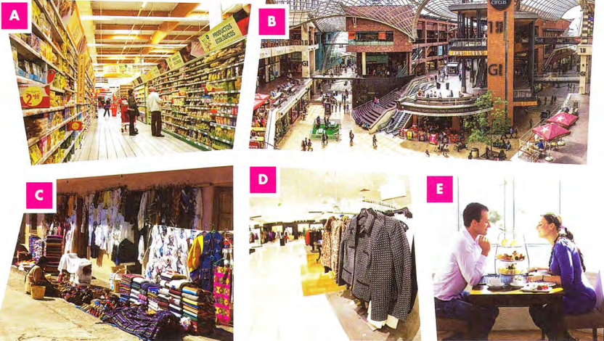
 | Listen to three short recordings. Which place, A-E, is each speaker talking about?  40  - D- department store  - C- outdoor market  - B- shopping centre
  02

[[[[[[[[[[SECTION 2 OF THE LISTENING TEST]
◉ Section 2 of the Listening test is a little more difficult than Section 1. You will hear a recording spoken by one speaker, or mainly one speaker, on a topic of general interest.
You have to listen for information about important details or facts on the recording, usually without the help of another speaker's questions to guide you.
You hear the recording in two parts and there are questions on each part.

IDENTIFYING DISTRACTORS

 | Listen to four short recordings and answer questions 1-4 in the table below. Write NO MORE THAN ONE WORD AND/OR A NUMBER for each answer.  41
  03
  Questions | Distractors
  - The new sport shop is going to be located in the east of the town. | - ___  - ___
  - What does the tour guide recommend they buy?  tea | - ___  - ___
  - The shopping centre opens at 11 / eleven o'clock on Sundays. | - ___ o'clock  - ___ o'clock  - ___ o'clock
  - What is the most popular product in the shop?  trousers | - ___  - ___
  ◉ Distractors are words and phrases on the recording that are incorrect answers to a question. Identifying distractors helps you to choose the correct answer and shows that you have understood the recording.
 | Listen to the recordings again. Write the distractors in the second column of the table (questions 5-13).  Can you remember the exact words which told you what the correct answer was?  - south  - north  - souvenirs  - cameras  - 9 / nine  - 6 / six  - 5 / five  - shirts  - jackets  41
  04

RECOGNISING PARAPHRASE AND SYNONYMS

 | Match the words and phrases 1-6 with their synonyms or paraphrases a-f.
  05
  - a good selection - e  - at the weekend - c  - shoes - d  - under one roof - a  - walk - f  - picture - b | - in one building  - photograph  - on Saturday and Sunday  - footwear  - a wide choice  - go on foot
  ◉ The words the speakers use on the recording are often different to the words in the questions. Often, you will hear a synonym (a word with the same meaning or a similar meaning) or a paraphrase (a group of words with a similar meaning, or the same thing expressed in a different way).

[[[[[[[[[[MULTIPLE-CHOICE QUESTIONS]
◉ In this type of task, you choose the correct answer from three options, A, B or C.
There are two types of multiple-choice question:
- a question followed by three possible options
- an unfinished statement followed by three possible endings.
You must only answer A, B or C on the answer sheet because there is only ever one correct answer.

 | Read the question and match the underlined words with paraphrases 1-3.  Then listen and choose the correct answer, A, B or C.  The correct answer is C.  42
  06
  - What kind of T-shirts does the man sell most of?  - T-shirts with a picture on them - 3  - T-shirts with words on them - 2  - plain T-shirts - 1 | Paraphrases  - nothing on them  - writing on them  - photograph on them
 | Read the question and identify the key words.  The key words are 'writer' and 'arrive'.  Then choose the correct paraphrase for each option A-C.  Then listen and choose the correct answer, A, B or C.  The correct answer is B.  43
  07
  - The writer will arrive at  - 12.00 pm. noon  - 2.15 pm. quarter past two  - 3.30 pm. half past three | Paraphrases  - midnight/noon  - quarter to two/quarter past two  - half past three / half past four
 | Read the question and identify the key words.  Then choose the correct paraphrase for each option A-C.  Paraphrase A is wrong. The staff are the people who serve the customers.  Then listen and choose the correct answer, A, B or C.  The correct answer is B  Then listen again and explain why the other options are wrong.  44
  08
  - The writer will arrive at  - 12.00 pm.  - 2.15 pm.  - 3.30 pm. | Paraphrases  - midnight/noon  - quarter to two/quarter past two  - half past three / half past four

[[[[[[[[[[EXAM SKILLS]
 | Follow the advice below and answer the questions  45  Listen and choose the correct letter, A, B or C.  - The Shopping Tour bus is outside  A  - the theatre.  - the train station.  - some cafés.  - Nowadays the theatre is popular because of  C  - its modern architecture.  - its music performances.  - the famous actors that appear there.  - The shopping tour will begin at...  B  - 9.10.  - 9.30.  - 9.45.  - What can people buy in Market Place today?  A  - souvenirs  - fruit and vegetables  - clothes  - The main purpose of the visit to the Regional Food Centre is  A  - to have a meal.  - to buy local fruit juices.  - to taste cheeses from the region.  - At the Fashion Fair, how will people on the tour know which building the footwear is in?  B  - It is a red building.  - It has a green roof.  - It has blue doors.
  09
  ◉
  - First identify the key words in the questions.
  - The questions follow the order of the recording, but the options A, B and C might not.
  - Listen for the key words in the questions, or words with a similar meaning.
  - Be aware of distractors - think about the whole meaning of the sentences you hear. Don't choose an option just because you hear words from it on the recording.

UNIT/05: CONSUMERISM

SPEAKING
IN THIS unIT YOU WILL
LEARN HOW TO
- talk about different experiences you might have when shopping
- plan your Part 2 talk using techniques for developing ideas.
- express your feelings through intonation.

Lead-in

 | Discuss these questions with a partner.  - Where do you like to go shopping?  - What do you like to buy when you go shopping?  - How often do you go shopping?
  01
 | Complete the script of Daniel talking about his choices for shopping using the words and phrases in the box.  - Where do you like to go shopping?  - What do you like to buy when you go shopping?  - How often do you go shopping?  Listen and check.  46
  02
  afford | all sorts of | atmosphere | convenient | keen on | out-of-the-way
  place | original | selection | traditional | trying on | reasonable
  Daniel | 1 convenient because it isn't far from where I live. It isn't a 2 traditional food market, though at one time it used to sell fruit and vegetables. Now, it's a collection of 3 all sorts of independent shops and stalls. There's an amazing 4 selection of things to buy- clothes, jewellery, books, art and crafts. I love it because it has a great 5 atmospher. There are cafes outside in the square, and often you can see street performers. It's very lively and friendly. I avoid the big malls because they're often 6 out-of-the-way you need a car to get to them. And what do I enjoy buying? Well, I'm 7 keen on fashion and like to go clothes shopping whenever I can. I love 8 trying on clothes even if I can't 9 afford to buy them! And I absolutely love going to the sales! Sometimes I manage to find great designer shoes at very 10 reasonable prices. And I like shopping for really fun and 11 original gifts for my friends -things that nobody else has. Covent Garden's a great 12 place to do that.

 | Match words and phrases 1-6 with their opposites a-f.
  03
  - convenient - d  - traditional - c  - amazing selection - e  - reasonable - f  - has a great atmosphere - b  - out-of-the-way - a | - local  - doesn't have any atmosphere  - modern  - inconvenient  - lack of choice / not much choice  - expensive
 | With a partner, discuss again where you like to go shopping. Provide reasons for your answer using some of the words and phrases above.
  04
[[[[[[[[[[DEVELOPING IDEAS IN PART 2]
◉ To do a good Part 2 talk, it is important to develop ideas about the topic. You have one minute to make notes. It's important that you use this time and find a way of making notes that works for you.

 | Match words and phrases 1-6 with their opposites a-f. | TIP 05
  05
  SHOPPING
  What kind of place?  Covent Garden Market  not real market now  independent shops  amazing selection | Where?  near where I live  convenient
  Why?  great atmosphere  cafés outside  street performers | What buy?  fashion, clothes shopping  sales  designer shoes  fun original gifts
  SHOPPING
  What kind of place?  Covent Garden Market  not real market now  independent shops  amazing selection  Where?  near where I live  convenient | Why?  great atmosphere  cafés outside  street performers  What buy?  fashion. clothes shopping  sales  designer shoes  fun original gifts
  Don't try to write full sentences when making notes - you don't always have time for this!
 | Exchange your notes with a partner and try to speak on the topic using their notes.
  06

 | Read the task card. Then listen to Yunmi giving her Part 2 talk. As you listen, make notes on her talk. Choose the style of notes that suits you best.  Sample notes  What kind of place? department store - 100 years old, famous, 4 floors, 30 departments  Where? centre of town - near car park, station  What I like: jewellery department - rings, necklaces, gold  Why I like it: atmosphere - traditional, assistants friendly, helpful  47
  07
  Describe a place where you like going shopping.
  You should say:
  - what kind of place it is
  - where it is
  - what you like to do there
  and explain why you like shopping there so much.
 | With a partner, try to recreate Yunmi's talk using the notes you have made. Talk for as long as you can using the notes.  When you have finished, read Yunmi's script on page 184.  Complete the checklist below.  If you answered YES to the final point in the checklist, discuss with your partner how you can improve your note taking.
  08
  Could I talk for two minutes using the notes? | Yes | No
  Did my notes cover all the points on the card? | Yes | No
  Did my notes cover enough (not all) of Yunmi's talk? | Yes | No
  Did I need to write notes in full sentences? | Yes | No
  Do I need to change the way I write my notes? | Yes | No
 | Work in pairs. You have one minute to prepare to speak about your two questions. Spend 30 seconds on each question. Use the question words in the box to help you.  Student A  - What do you enjoy spending money on?  - Can you remember a present you bought somebody that they really liked?  Student B  - What is the most expensive thing that you have ever bought?  - Can you remember something you bought that was very useful?  Take it in turns to answer your questions. Spend one minute on each question. If your partner stops before the minute is finished, try to help them by asking questions.
  09
  when? | where? | why? | How much? | what?

PRONUNCIATION - INTONATION

 | Match words and phrases 1-6 with their opposites a-f.  48  - I love shopping at the Galleria. It's amazing!  - I wish there were more places to go shopping where I live.  - It's a pity that so many shops here have closed down.  - I'm really excited that they're building a new shopping mall.  Listen again and try to copy the way the speaker shows a positive or negative feeling.
  10
  ◉ When we speak, we can change how we say something to show the listener how we feel.

 | Write three reasons why you like shopping and three reasons why you don't like shopping. With a partner, say each sentence out loud twice, first by just reading it in a neutral way and then with the correct intonation.
  11
  Reasons I like shopping  - ___  - ___  - ___ | Reasons I don't like shopping  - ___  - ___  - ___
[[[[[[[[[[EXAM SKILLS]
 | Read the task card and then make notes for your talk. Time yourself for 60 seconds, then stop writing.  Talk about the topic with a partner. Try to talk for two minutes.  Then listen to your partner's talk. Make notes of any interesting vocabulary or ideas.  Then, give your talk again to your partner.
  12
  Describe a shop that you enjoy going to.
  You should say:
  - where it is
  - what it sells
  - how often you go there
  and explain why you enjoy visiting this shop.

UNIT/06: LEISURE TIME

READINGREADING
IN THIS unIT YOU WILL
LEARN HOW TO
- scan a text to find information quickly
- answer True/False/Not Given questions
- complete a summary of a text.

Lead-in

 | Can you name these sports?  - baseball  - martial arts (Wu Shu)  - hockey  - table tennis  - rugby
  01
  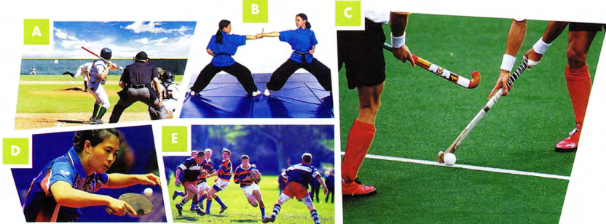
 | Match the sports 1-9 with the descriptions a-l in the box. Each sport matches several descriptions.
  02
  - hockey  a, b, c, i, j, l  - tennis  e, g, i, k  - volleyball  a, e, h, i | - football  a, b, c, i, j, l  - rugby  a, i, j, l  - baseball  a, f, i | - table tennis  e, f, g, i  - martial arts  d  - basketball  a, b, i
  - It's a team sport. | - You hit the ball over a net. | - It's played with a ball.
  - You score goals. | - You hit the ball with a bat. | - You tackle other players.
  - There's a goalkeeper. | - You can play singles or doubles. | - You use a racket.
  - You earn coloured belts. | - You mustn't run with the ball. | - You play on grass.
 | Which of these sports have you played or watched? Which would you like to try?
  03

[[[[[[[[[[TRUE / FALSE / NOT GIVEN]
◉ In this type of task you have to say if a statement is True (it agrees with the information in the passage), False (it does not agree with the information in the passage - it says the opposite, or something different) or whether the information in the statement is Not Given in the passage (there is nothing in the passage to indicate if it is true or false). You must give your answer only according to what is in the passage - you must not use your own knowledge about the topic.
The questions are in the same order as the information in the text.

 | Read the text in ONE MINUTE.  Tell your partner anything you can remember. Don't worry about giving exact information. You could use these expressions.  There was something about...  I don't remember the details, but it involved...  There's a game which is a bit like...
  04

UNUSUAL SPORTS
A  Do you ever get bored with the same old sports? If you're tired of tennis, fed up with football or bored of basketball, don't worry. There are plenty of new and unusual sports out there for you to try. Many of these are a mix of existing sports, sometimes with a local element added. Bossaball, for example, is a mix of football and volleyball, played on an inflatable pitch with a trampoline in the middle. To make it more exciting, it also has elements of Brazilian martial arts!  B  If you are very good at horse riding, you could try the national sport of Afghanistan, buzkashi. Many versions have been played in the Central Asian region for hundreds of years. The game involves players on horseback trying to get hold of a dead goat. The Afghan Buzkashi Federation wants the game to spread throughout the world and has finally written down the rules because they hope to get Olympic status for the sport. | C  A sport that is more likely to become famous is kabaddi. It is popular in India and other parts of South Asia. It is similar in some ways to the game called 'tag' or 'it' which schoolchildren play. One person is 'it' and has to catch the others. In kabaddi, a 'raider' from one team tries to tag a player from the other team and then return to their own half of the field without getting caught. In some versions of the game, the raider must chant the word 'kabaddi' as he returns to his place. Kabaddi is good fun, good exercise and doesn't need any equipment. It is played at the Asian Games.  D  There is an unusual sport which describes itself as a 'classic mix of brains and brawn'. The game, called 'chess boxing', involves a round of chess and then a round of boxing, then another of chess, and so on. There is one minute between rounds. The first chess boxing world championship took place in 2003 in Amsterdam and was won by a Dutchman, lepe Rubingh. Since then, it has become more popular, particularly in Germany, the UK, India and Russia. It is a difficult sport, as players need to be very good at two very different activities and be able to switch quickly between the two.  E  Finally, an unusual sport that will be familiar to most of us is roshambo, which began in China about 2000 years ago and spread gradually to the rest of the world. Played by young and old, in the UK it is known as 'rock-paper-scissors'. It is surprising that it is called a sport and taken so seriously: there's a World Rock Paper Scissors Society and a league which holds championships every year. So, whatever kinds of sport you like, there is something new and interesting for you to try.

 | Quickly scan the text to find the paragraph which contains information about these sports as quickly as you can.  - a sport which is trying to get into the Olympic games - B  - a sport which has been played for more than a thousand years and is based on an activity most of us know - E  - a sport influenced by two very popular sports - A  - a sport which may involve repeating a word - C  - a sport which involves two activities which are very unlike each other - D |  | TIP 05
  05
  When answering True/False/
  Not Given questions you must scan the text to find the information as quickly as possible, as you also need time to read a few sentences in detail.
 | The following questions relate to the sections you just found. Decide if they are True or False.  - Players of chess boxing only need to reach a high level in one of the activities. False  - Buzkashi got written rules long after the game first started. True  - Roshambo can be played by anyone, even children and the elderly. True  - Bossaball is played on grass. False  - It could be quite expensive to play kabaddi. False
  06
 | Does this statement agree with the information in the passage?  Write True, False or Not Given.  Not Given  - Kabaddi is only played by men.  Hint: You ONLY need to read the paragraph about kabaddi, which is paragraph C. You will already know from your initial skim reading that information about kabaddi is not found anywhere else in the text. | TIP 07
  07
  Don't waste time going through the whole passage to find the information. Not Given answers will relate to one part of the text. Once you have read the relevant part in detail, if you can't find the information, choose Not Given.
 | Read only the relevant paragraphs. Is this information True (write T) or Not Given (write NG)?  - Bossaball is only played in Brazil. NG  - Buzkashi is sometimes played with a sheep instead of a goat. NG  - There are different versions of the game kabaddi. T  - Chess boxing is played in several different countries. T  - The roshambo world champion is from China. NG
  08
 | Answer True, False or Not Given to these questions about the text.  - People play bossaball on a soft surface. True  - Buzkashi is an Olympic sport. False  - Kabaddi is often played in schools. Not Given  - lepe Rubingh invented chess boxing. Not Given  - lepe Rubingh is from Germany. False  - People consider roshambo a serious sport. True
  09

[[[[[[[[[[SUMMARY COMPLETION]
◉ In this type of task you have to choose words to complete a summary of the text, or part of the text.
Sometimes the instructions tell you to choose words from the passage to fill the gaps.
Sometimes you are given words in a box and you have to choose the correct ones. Not all the words in the box will be needed.

 | In the task below you have to fill the gaps by choosing words from the box. Look at gap 1 and follow the steps in the example. Then complete gaps 2-6.  Complete the summary using the list of words A-L below.  If you have had enough of the ordinary sports people play, you can try a number of 1 K new sports. Some of these were created when people 2 G(mixed) two well-known sports. Sometimes they added a 3 D(feature) from the part of the world where they live. Bossaball is an example of this. It takes volleyball and football, adds a trampoline and some Brazilian martial arts. Buzkashi, a sport from Afghanistan, is played on 4 E(horses) and uses a dead goat instead of a ball! People in Afghanistan would like this sport to become international. Chess boxing is a sport where you need to 5 B(change) rapidly from one type of activity to another. You need to be 6 C(clever) and also fit. It is becoming more and more popular and now holds world championships.
  10
  ◉ Example
  Notice that gap 1 is followed by an adjective (new) and a noun (sports).
  This tells you that the word you need could be an adverb or an adjective.
  There are adjectives in the box, but no adverbs.
  The adjectives are boring and strange.
  A writer is unlikely to suggest boring sports.
  The answer is strange. This matches what the text says.
  - boring | - change | - clever | - feature | - horses | - join
  - mixed | - moving | - serious | - sport | - strange | - trampolines

GRAMMAR FOCUS: COMPARATIVES

 | Complete these comparative sentences with your opinions on the sports in the text.  Students' own answers  - Kabaddi is faster than roshambo.  - ___ is more dangerous than ___.  - ___ is more exciting than ___.  - ___ is harder than ___.  - ___ is not as unusual as ___.
  11
  ◉ Kabaddi is a sport that is more likely to become famous.
  Since then it has become more popular...

[[[[[[[[[[EXAM SKILLS]
 | Skim read the text for one minute before moving on to answer the questions on the next page.  PARKOUR
  12
  A  Parkour was developed in France in the 1980s by  Raymond Belle and later by his son David Belle and his friends. It is based on military obstacle course training. The aim is to get from one point to another in any way you can, and express yourself while doing so. There are no limits on how you move in parkour: running, climbing, swinging, jumping, rolling and any other types of movement are possible. Parkour is more of a philosophy or set of ideas than a sport. It is a new way of seeing the environment and finding ways to go over, under, around, across or through obstacles.  B  Parkour can be done alone or in groups. The most  famous group of traceurs (people who do parkour) were the Yamakasi, a group made up of David Belle and his friends and cousins. They formed in the late 1980s and became popular during the 1990s and 2000s after appearing in several films, documentaries and advertisements. In the Yamakasi, there were strict rules. Members had to arrive on time and they were not allowed to complain or make excuses. They valued humility, so they were not allowed to show off or compete with other members.  C  Parkour is a 'state of mind'. It is about getting over  mental as well as physical barriers. It teaches people to touch the world and interact with it. It is about understanding what it means to be human. The organisation Parkour.net believes that parkour can never be a competitive sport. It is an art and is concerned with self-development. They say you can't ask, 'Who is the best at parkour?' Raymond Belle's advice is: 'If two roads open up before you, always take the more difficult one. Because you know you can travel the easy one. | D  There are some gyms and camps where you can practise and learn parkour. However, many traceurs do not like the idea of special places for their activity. The idea behind parkour is to adapt to any environment and be creative about how you get through it. It is about freedom and self-expression. The founder of parkour refused to teach people how to do moves or get over obstacles. The whole point is to learn your own technique and way of moving. So the idea of having classes or a limited space to practise in conflicts with the values of parkour.  E  Parkour is also known as freerunning. Sometimes freerunning refers to another form of parkour developed by Sebastien Foucan, which has more focus on the individual. The term freerunning came out of the film Jump London (2003). It told the story of three French traceurs practising parkour around the famous monuments of London. Freerunning was the English translation of parkour. There are more similarities than differences between the two activities, and the Parkour UK website uses the two terms to refer to the same activity.

 | Questions 1-8  Do the following statements agree with the information in the text?  Write  - You have to use a limited number of moves in parkour. False  - Parkour is mainly done in the countryside. Not Given  - Parkour began in the twentieth century. True  - The Yamakasi did not allow latecomers. True  - When doing parkour, Raymond Belle recommends that you always choose the easy route. False  - There are many gyms in France where you can do parkour. Not Given  - The founder of parkour was a very good teacher of parkour. False  - Freerunning and parkour are similar. True  Questions 9-15  Complete the summary of the text using the list of words A-M below.  Parkour is an activity that involves 9 H(moving) in many different ways through different environments. People who practise parkour are called 10 M(traceurs). They believe that parkour is not a sport and can never be part of a 11 C(competition). The values of parkour are adaptability, 12 E(creativity) and freedom. Parkour should not be taught because it is about discovering your own way of moving and overcoming 13 B(barriers). Although there are gyms and other places where you can learn and practise parkour, many feel that this 14 D(conflicts) with the values of the discipline. Freerunning is a type of parkour. However, it is more about 15 I(personal) development than parkour, which is often, but not always, done as part of a group.  Use the strategies you have learnt:  - Read the whole summary first.  - Decide what type of word is needed for each gap.  - Make a prediction before looking at the words given.  - Remember that there are more words than gaps.  - Read the sentence, checking for grammar and meaning. | TIP 12
  12
  TRUE | if the statement agrees with the information
  FALSE | if the statement contradicts the information
  NOT GIVEN | if there is no information on this
  - agrees | - barriers | - competition | - conflicts | - creativity
  - latecomers | - move | - moving | - personal | - respect
  - team | - tournaments | - traceurs
  Be careful of words like some, often, occasionally that change the meaning of a sentence. For example, some sports does not mean the same as many sports.

UNIT/06: LEISURE TIME

WRITING
IN THIS unIT YOU WILL
LEARN HOW TO
- organise and write a Part 2 essay
- compare two different time periods
- link and signpost your ideas.

Lead-in

 | Choose the correct option(s). In each case, either one or two are correct.  - go running/go for a run / go for running  go running/ go for a run  - go to the cinema / go to cinema / go for the cinema  go to the cinema  - see a film / look at a film/ watch a film  see a film / watch a film  - visit to friends / visit friends / visit some friends  visit friends / visit some friends  - play the sports / play sport / play sports  play sport / play sports  - join to a club / join a club / join for a club  join a club  - go walking/ go to a walk / go for a walk  go walking/ go for a walk (slight difference in meaning)  - go gym / go to the gym / go for the gym  go to the gym  Which of the activities do you enjoy doing?
  01

[[[[[[[[[[EVALUATING A PART 2 ESSAY]
 |  | Read a student's essay on the following topic. (Ignore the highlighting for now.) What are the good things about it?  The essay is well organised with an introduction, two main paragraphs and a conclusion. It is clear and easy to follow.  MODEL ANSWER
  02
  People nowadays spend their free time less actively than in the past. Do you agree or disagree?
  Some people are saying that people are less active than they were in the past. There are points for and against this idea, but overall I agree with the statement. In this essay I explained why.
  In my opinion, the main reason why people less active is computers. Several years ago we go to speak to our colleagues. We walked to their desk or office. Now we send an email without getting up from our seat. Even our free time is less active because we playing computer games and go on social media. Before, people were walking to a café to meet their friends or they went to their house. Nowadays, though, we chat online at home. In the twentieth century, children do many activities. In today's world, parents are scared for their children's safety, so they prefer to keep them at home. For many, it is easier to stay at home than to go out.
  On the other hand, some physical activities are become more popular. There are more gyms than there used to be and it is fashionable to go running or to the gym. In my view, though, only some people do these things. Most people join a gym but they are not going regularly. However, they never stop playing computer games and watching TV! Also, these days everyone took their driving test as soon as possible and starts driving. In the past, young people walked and went by bus.
  To sum up, I am agree that people are less active in their free time compared with the past. Now people are lazier and less fit than they were before. (273 words)
 | Answer these questions about the essay.  - Does it have the right number of paragraphs? Yes  - Is every paragraph clear? Yes  - Are linking expressions used? Yes  - Is the writer's opinion given clearly? Yes  - Has the writer looked at both sides (for and against)? Yes  - Are tenses used correctly? Not Given  - Are there any grammatical mistakes? Yes
  03
 | The teacher has highlighted the student's errors. Can you correct them?  are saying - say  explained - will explain  people less active - people are less active  go-went/used to go  we playing - we play  were walking - walked / used to walk  do - did/ used to do  are become - are becoming  are not going - don't go  took - takes  I am agree - I agree
  04

GRAMMAR FOCUS: COMPARING PAST AND PRESENT

 | In the essay, the student is comparing the situation now with the situation in the past. Complete the expressions she uses to refer to the present or the past. | TIP 05
  05
  Present | Past
  now  nowadays  in today‘s world  these days | before  in the past  several years ago  there used to be
  Try to use different phrases to compare past and present or present and future. Make a list of them, as this kind of question is quite frequent.

 | Look at the following sentences from the essay:  People are less active.  Some physical activities are becoming more popular.  People are lazier and less fit.  It is easier to stay at home.  Choose the correct form to make some more comparisons between the past and present.  - Joining a gym is expensiver / more expensive than it used to be.  more expensive  - It is more hard / harder to find the time to do exercise.  harder  - Most people eat healthier / more healthy food than they did before.  healthier  - It is dangerous / more dangerous for children to play outside.  more dangerous  - The pace of life is faster / more faster than it used to be.  faster
  06

LINKING IDEAS

 | Find the following expressions in the essay.  - two expressions used to give an opinion  I agree with, in my opinion, in my view, I agree that  - two expressions used to introduce the opposite view  on the other hand, however  - an expression to show there are two sides to the argument  on the other hand, however  - an expression to introduce the conclusion  To sum up  - an expression to show that a point is the most important  the main reason
  07
 | Read this Writing Part 2 question and then, before you read the essay in exercise 9, think of some advantages and disadvantages.
  08
  Some children spend most of their free time taking part in clubs and other planned activities. Do the advantages of this outweigh the disadvantages?

 | Fill in the gaps in the essay with the linking expressions in the box.  Many parents think that their children should have many free-time activities, such as joining sports clubs and having music lessons. Children often have no time which can really be called free time. In this essay I will look at the advantages and disadvantages of this and give 1 my own opinion.  2 Firstly, if we think of all the great artists, musicians and sportsmen and women in the world, they all started by doing their activity as a hobby. They found they had a talent and developed their skills to become world class. Secondly, children usually enjoy their activities, make friends and become well-developed people.  3 Thirdly, parents think that being busy will stop the children getting into trouble. Their parents know what they are doing at all times.  4 Unfortunately, this is not always a positive trend. 5 One reason is that children can become stressed when they have to run from activity to activity.  6 In addition, they need time to play freely and use their imaginations. They can get to know themselves and their likes and dislikes during this time. It is important to give them time to relax, watch TV, read and be with 7 also their parents, grandparents and siblings.  8 My own view is that we need to have a balance. Children should choose one or two activities they really like, and have free time to just be themselves the rest of the time.
  09
  My own view is | Unfortunately | Firstly | also
  my own opinion | One reason is that | Thirdly | In addition

[[[[[[[[[EXAM SKILLS]
 | Read the following essay question and then write Agree (A) or Disagree (D) next to each point 1-6 below.  Children are now less active in their free time than in the past. Therefore, sports lessons must be compulsory in schools. To what extent do you agree or disagree? Give reasons for your answer and include any relevant examples from your own knowledge or experience.  Write at least 250 words.  - If people are unfit, the government will have to spend a lot of money on medical care in the future.  - Physical activity improves children's mental well-being.  - Sports lessons are a waste of valuable study time.  - Schools need to spend a lot of money on sports facilities.  - Sports help children learn discipline and working with others as a team.  - Some young people do not enjoy sports.
  10
 | Write your essay using the following plan:  Sample answer  Nowadays young people often spend their free time at home watching TV or playing computer games. Very few do sports outside of school. This means that if they don't do exercise during school time, they will be unfit and suffer from health problems. I agree that children should do sports lessons at school. In this essay I will explain why.  Some people say that sports lessons are a waste of time. Students have to prepare for exams and should spend all their time on academic work. This is what many people think in my country. In my opinion they are wrong. A healthy mind needs a healthy body. Doing exercise every day makes you happy and relaxed. Studying all the time can make you stressed.  Another reason for my opinion is that having an unfit generation will cause many problems for society. When today's children get older, unfortunately they may suffer from illnesses like heart disease. The government will have to spend a lot of money on doctors and hospitals. It is much better to create a fit and healthy adult population by getting children to do sports when they are still at school. In addition, sports teach people discipline and working as a team. This will help them in their future life.  In conclusion, I can say that prevention is better than cure. Children who do sports will be healthier, happier adults. They are more likely to continue with their active lifestyle when they grow up. In this way we can make a better society for the future. (263 words)
  11
  Paragraph 1 | Introduction - a general opening sentence (a paraphrase of the question)  I agree or I disagree - in this essay I will give reasons
  Paragraph 2 | Summarise the opposite view: Some people believe...  Say why you disagree with them - give your main point
  Paragraph 3 | Give your view - at least two more points, with supporting evidence
  Paragraph 4 | Conclusion - state your view again and give a brief summary of your main arguments
 | Check your essay using this checklist.  - Are my paragraphs clearly shown? (leave a line or indent)  - Have I used linking words and expressions?  - Have I used phrases to introduce my opinion?  - Are my tenses correct (mostly present and future)?  - Have I checked my spelling, grammar and punctuation? | TIP 12
  12
  In the exam, leave a few minutes at the end to read through your essay with a checklist like this one in your mind.

UNIT/06: LEISURE TIME

LISTENING
IN THIS unIT YOU WILL
LEARN HOW TO
- understand a description of a place
- follow directions
- label a map
- recognise distractors.

Lead-in
 | Match the places in the box with pictures A-E.  - turn right  - go straight ahead / straight on  - turn left  - go past  - next to  - opposite  - in front of  - behind  Useful verbs  Useful prepositions of place  Check with a partner. Did you get the same answers?  Can you think of any more useful words for giving directions?  Examples of other words and phrases: go over/across (the bridge), drive along, pass, come to / get to / reach, on the other side of
  01
  behind | go past | go straight ahead / straight on
  in front of | next to | opposite | turn left | turn right
  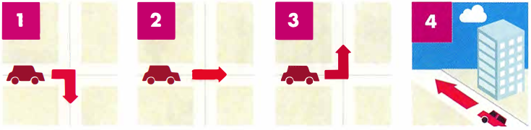
  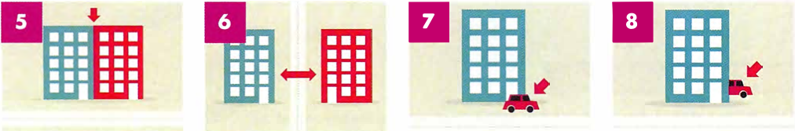
  ◉ A common task in the Listening test is labelling a map. In order to complete this type of question, it is important that you are familiar with words and phrases for giving directions.
 | Describe a route you often take to a partner.  To walk to my local shop, I have to turn left outside my house and then turn right onto a main road. I then walk straight ahead until I get to a mini-roundabout...
  02

[[[[[[[[[[LABELLING A MAP]
◉ There are three types of map labelling task:
- You listen and identify where places are on a map by choosing the correct letter.
- You listen and choose the correct label for places on a map from the list of words provided. There will be more words than you need.
- You listen and label places on a map by writing up to three words.

UNDERSTANDING THE MAP AND THE QUESTION

 | Study the map. What does it show?  The map shows the streets and places in a small town. |  | TIP 03
  03
  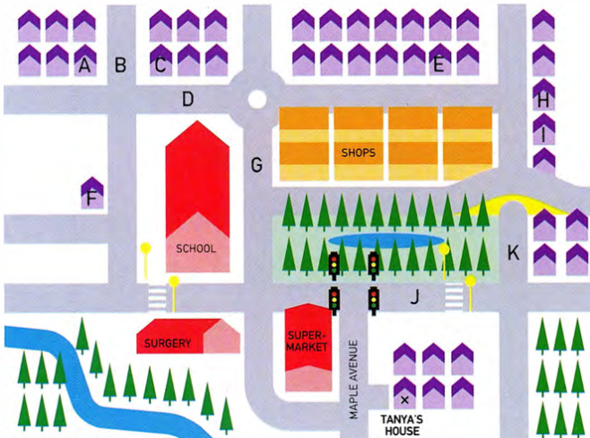
  First read the question and try to understand what the map shows and what you have to do. Then study the map carefully and try to predict the type of language you might hear.
Match the places that appear on the map (the words in the box) with the pictures.
- roundabout
- park
- traffic lights
- pond
- zebra crossing
- crossroads
- river
- bridge
 | 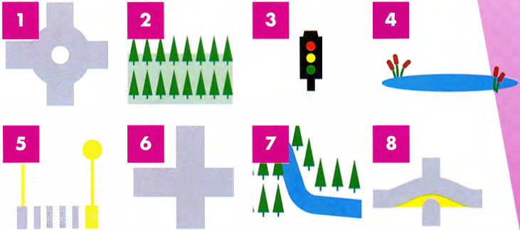
  bridge | crossroads
  park | traffic lights
  river | roundabout
  pond | zebra crossing
Can you think of any other places or features in a town that might be useful when you are giving someone directions?
Examples of other useful places: railway station, bus stop, cinema, statue, fountain

 | Look at the map and find Tanya's house. Then listen to the phone message. Tanya has offered to give Melissa a lift to a concert. Listen to Melissa giving Tanya directions to her house and label the map. Write the correct letter, A-K, next to questions 1 and 2.  Then listen again and find Melissa's house. Write the correct letter, A-K, next to question 3.  49  - Main Street: G  - Silver Street: D  - Melissa's house: C | TIP 04
  04
  Once you have understood the map, you are in a much better position to complete the listening task. Note that the questions are in the order in which you will hear the answers on the recording.

 | Now listen to Melissa's second message. She wants Tanya to pick up another friend, Sarah, on the way. Listen and label the map. Write the correct letter, A-K, next to questions 4-6.  50  - New Road: K  - Sarah's house: I  - Oak Avenue: B  Listen again and check your answers.
  05

RECOGNISING DISTRACTORS

 | Read the extracts below from Melissa's messages, and underline any words and phrases which may distract you from choosing the correct answer.
  06
  (Question 1) | Then, you need to turn left at the traffic lights and then take a sharp right onto Main Street. You can also go straight on here, past the surgery, but I usually drive down Main Street.  You can also go straight on here
  (Question 4) | Again, you need to turn right onto Maple Avenue, and up to the lights. Instead of turning left here, turn right, with the park on your left.  Instead of turning left here
  (Question 5) | Drive along New Road until you reach the bridge. Sarah's house is the second house after the bridge. That's on the right; there are shops on the left.  there are shops on the left.
  ◉ The words the speakers use on the recording are often different to the words in the questions. Often, you will hear a synonym (a word with the same meaning or a similar meaning) or a paraphrase (a group of words with a similar meaning, or the same thing expressed in a different way).

MAP OF A BUILDING

 | Listen to Tanya's message to another friend, arranging to meet before the concert.  Listen to Tanya's description and label the map. Choose the correct letter A-H and write the answers next to questions 1-4.  51
  07
  - art gallery | - restaurants | - F
  - cinema | - exhibition centre | - A
  - live music | - Arena | - H
  - car park | - shopping centre | - G
  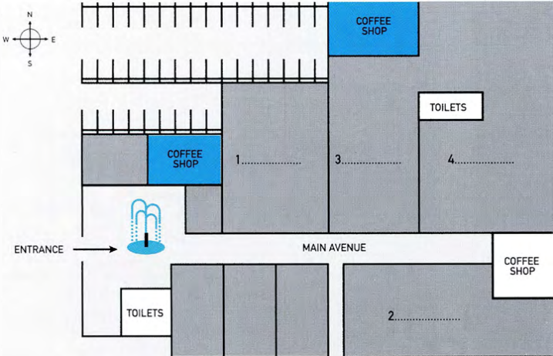
  ◉ In this type of task, you could also be given a map of a building.

MAP OF A PARK

 | at the map with a partner and discuss the different things you can see Look on the map.
  08
  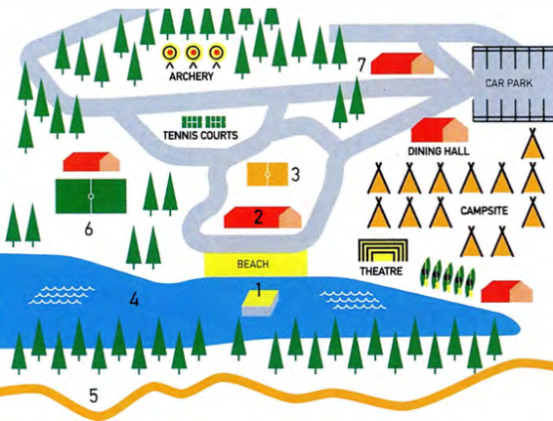
  ◉ Another type of map you might find in a map-labelling task is a map of a park. The illustration below is a map of an activity camp.
 | Listen to the manager giving a tour of the activity camp to a group of teenagers. Label the map with which activity they can do in each place. Use no more than TWO WORDS for each activity.  1: diving 2: badminton 3: basketball 4: swimming 5: cycling 6: football 7: table tennis  52
  09

[[[[[[[[[[EXAM SKILLS]
 | You will hear someone giving a talk about plans for a new forest centre.  Label the map. Choose the correct letter A-M and write the answers next to questions 1-8.  53  Pine Woods Centre
  10
  - tickets on sale here - J  - picnic field - L  - barbecue area - M  - Tree Tops Challenge - I  - playground for young children - B  - indoor play area - F  - sheep - G  - goats - E | 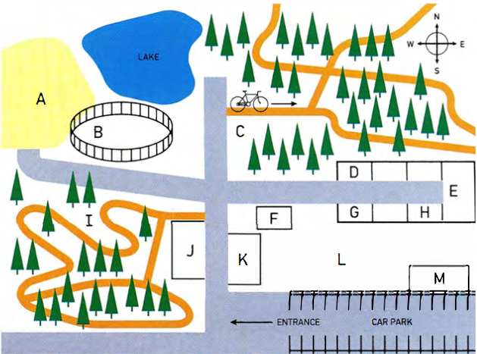

UNIT/06: LEISURE TIME

SPEAKING
IN THIS unIT YOU WILL
LEARN HOW TO
- use positive and negative adjectives to talk about free-time activities
- recognise and use linking words in your talk (Speaking Part 2)
- pronounce weak forms of words
- give a complete talk and assess your own performance (Speaking Part 2).

Lead-in

 | Ask and answer these questions with a partner.  - Do you do any of the activities in the pictures?  - Which of these activities do you like or dislike?  - Are there any other things you do in your free time? | TIP 01
  01
  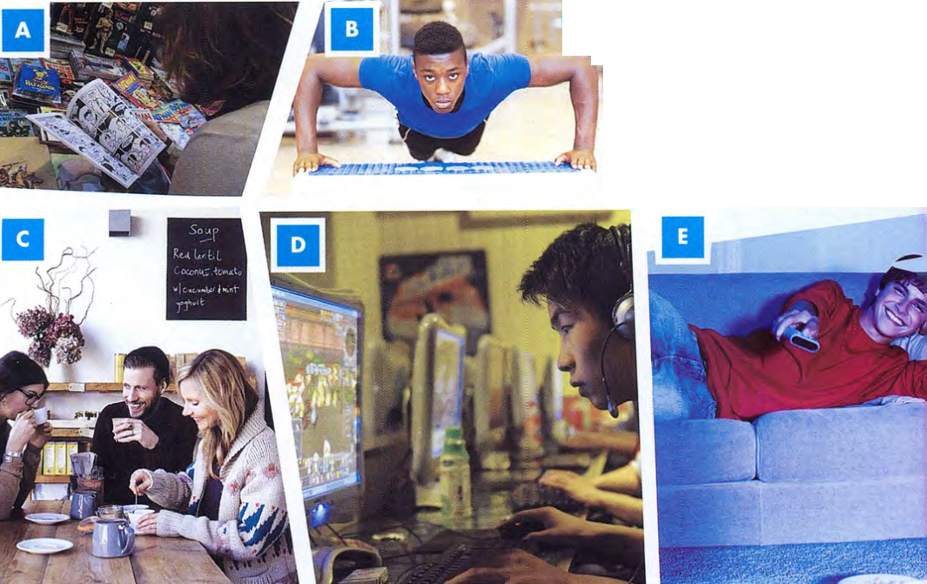
  ◉ In the first part of the Speaking test you may have to answer simple questions about how you spend your free time.
  It is useful to know which verbs go with different sports and activities. Common verbs used with leisure and sports activities include play, do and go.
  play soccer ✔
  do soccer ✗

 | With a partner, use the positive adjectives in the box to say how you feel about various free-time activities.
  02
  amusing | great | enjoyable | excellent | exciting
  brilliant | healthy | peaceful | relaxing
  Examples | Yoga is a very peaceful and relaxing activity.  I am excellent at taekwondo.
 | With a different partner, use the negative adjectives in the box to talk about free-time activities.
  03
  Examples | I feel miserable when I play football in the rain.  Boxing can be an exhausting sport - you need to be fit and strong.
  dangerous | exhausting | useless | harmful | hopeless
  miserable | frightening | tiring | stressful

[[[[[[[[[[EXTENDING YOUR TALK]
◉ It is important to use a variety of language in your talk. It is useful to use linking words such as and, or, but, also, so, in fact, for example, and because. These will make your talk flow better and will help you to give extra information.

 | Listen to a candidate called Serena giving her talk.  54  I'm going to talk about a hobby I'd like to take up in the future. I really want to learn ballroom dancing. This is because I love Latin music and I love the way the dancers move and shake. I also want to give myself a challenge and learn something new. Watching ballroom dancing always makes me feel excited. I don't think it'll be too difficult for me, because I already do ballet and tap dancing. I like learning new steps. For example, I really want to learn the tango or the samba because these are exciting and look good to people watching. I've tried Flamenco dancing but I'm not very good. I'm also worried about finding the right dance partner, because I'll be a little slow to learn in the beginning. So I might fall over sometimes. In fact I'll probably fall over quite a lot!
  04
 | The words Serena uses to connect her ideas are in bold. Match phrases 1-7 with the connecting words and phrases A-G.  Listen again and check your answers.  54
  05
  - This is because I love Latin music - F  - I love the way the dancers move and shake. - D  - I like learning new steps - B  - I really want to learn the tango - C  - I've tried Flamenco dancing - E  - I'm also worried about finding the right dance partner - G  - I might fall over sometimes. - A | - In fact, I'll probably fall over quite a lot!  - For example, I really want to learn the tango  - or the samba  - I also want to give myself a challenge  - but I'm not very good.  - and I love the way the dancers move and shake.  - because I'll be a little slow to learn in the beginning.
 | With a partner, use the positive adjectives in the box to say how you feel about various free-time activities.  - I like [activity] and ...  I like table tennis and I'm a member of my college team.  - I like [activity] because...  - I love [activity], but...  - I'm not keen on [activity] - in fact ...  - I love all kinds of [activity]. For example, ...  - A lot of people in my country [activity]. They also ...  - At weekends I enjoy [activity] or [activity] with my friends.
  06
  baseball | going on social media | dancing | watching TV
  hiking | playing computer games | travelling | sewing
  sport | making jewellery

 | Now, read the script of Marco giving a talk about a leisure activity he would like to do in the future. Choose the correct linking words.  1: because 2: and 3: also 4: and 5: because 6: but 7: also 8: For example 9: or 10: because 11: and 12: so 13: In fact,  I'm going to tell you about a leisure activity I'd like to do in the future. I'd really like to learn how to play the acoustic guitar. This is (1) because / so I love music (2) and / but I love the beautiful sound this kind of guitar makes. I (3) and / also want to give myself a challenge (4) so / and learn something new. I don't think it'll be too difficult for me (5) but / because I already know how to read music. I play the piano (6) but/ so I'm not very good. I think playing the guitar will be easier. I (7) for example / also like the fact that you can carry a guitar round easily and play it anywhere. (8) For example/Because I can play it in the park (9) but / or on the beach.  I can't think about learning it at the moment (10) and / because I'm too busy. I need to focus on my studies (11) and/or prepare for my exams. I think that I'd like to take up the guitar next year. All my exams will be over by then, (12) so / but I'll have more time, and more money too. (13) In fact, / Because I'll need money to pay for lessons! I think that learning the guitar would change my life in a positive way. If I learn to play it really well, I'll start my own band. I'd love to perform live on stage at a concert. I think that would be fantastic!  Listen and check your answers.  55
  07
[[[[[[[[[[FOLLOW-UP QUESTIONS]
◉ After you have given your Part 2 talk, the examiner may ask you one or two questions related to the topic you talked about.

 | Listen to students answering the following questions.  After listening, practise asking and answering the questions with a partner.  56  - Do you generally enjoy trying new things?  - Is there any other activity you would like to try one day?  Share your ideas with a partner. | TIP 08
  08
  If the examiner asks you a question at the end of Part 2 you should answer with two or three sentences.

PRONUNCIATION - STRONG AND WEAK FORMS

 | Listen to the following words pronounced (a) when they are stressed and (b) how they might sound in a sentence.  57
  09
   | stressed | weak form
  to  and  a  of  some  for  from | /tuː/  /ænd/  /æ/  /ɒV/  /SʌM/  /fɔːr/  /frɒm/ | /tə/  /ənd/ or /ən/  /ə/  /əv/  /səm/  /fə^{r}/  /frəm/
  ◉ When we speak English, we pronounce the key words in a sentence more clearly than the other words. These are usually nouns, verbs, adjectives. We say the little 'grammar' words (and, some, to, for, of, etc.) quickly and don't give them their full pronunciation. We call these 'weak forms'.

 | Look at the sentences. Underline the words that you think will NOT be stressed.  - I want to learn to play the guitar.  I want to learn to play the guitar.  - I enjoy playing football and baseball.  I enjoy playing football and baseball.  - I bought a new golf club.  I bought a new golf club.  - I would like to learn to play chess.  I would like to learn to play chess.  - I need some driving lessons.  I need some driving lessons.  - I played drums in a band for a long time.  I played drums in a band for a long time.  - I plan to cycle from the north of Africa to the south.  I plan to cycle from the north of Africa to the south.  Listen and check your answers.  Practise saying the sentences with a partner.  58
  10
[[[[[[[[[[EXAM SKILLS]
 | Make your own notes for this task card. Use the key words to help you.
  11
  Talk about a new sport or hobby you would like to take up.
  You should say:
  - what it is
  - how you would start it
  - why you have not started it yet
  and explain what help you would need.
 | Use your notes to complete the task with a partner. You should try to talk for two minutes.  Listen to your partner talk on the same topic. Make notes of any interesting vocabulary or phrases they use. Complete the checklist.  Finally, both complete the task again.
  12
  Did your partner talk for two minutes? | YES | NO
  Did your partner cover all four points on the task card?
  Did your partner link their ideas together well?

UNIT/07: FAME AND THE MEDIA

READINGREADING
IN THIS unIT YOU WILL
LEARN HOW TO
- match features of the passage
- identify the writer's views
- write first conditional sentences.

Lead-in

 | How much do you know about the internet?  - Name two search engines.  Google, Yahoo, Bing, MSN  - Name two news websites.  BBC, CNN, New York Times, Yahoo News  - Name two social media sites.  Facebook, Twitter, Instagram, China: Weibo  - Name a website that has factual information on many topics.  Wikipedia, Britannica.com, Encyclopedia.com
  01
 | What do you use the internet for?  Students' own answers
  02

SKIM READING

 | Skim read the passage in ONE MINUTE.  What is the purpose of the passage?  B  - to give the advantages and disadvantages of the internet  - to advise people how to become famous on the internet  - to explain how beginners can start to use the internet
  03

BECOME
RICH AND FAMOUS
THROUGH THE INTERNET

In the past, to become famous you needed a talent: singing, playing an instrument, dancing or writing books. Nowadays, it is much easier to become famous. This is because of the internet. All you need is a camera or webcam, computer, internet connection and a bit of creativity.  First of all, you need to decide what you are going to write or speak about: hair and makeup, comedy, sport, news and current affairs, raising money for a charity or something specialist like keeping tropical fish. Then choose a site to post on. Some sites are international and some may be particular to one country, such as Weibo in China. YouTube is a good site to choose if you make your own videos. It is easy to upload your short films, and many people use it.  If you want to become famous on YouTube, you should make lots of videos and release one every day. YouTubers who become popular are often those who present tips, advice, 'how to' guides and opinions on entertainment or stories in the news. If you allow advertisements in your videos, you will make money when people view the adverts. Facebook is a good platform for those who want to make money, but not for those who want to be famous. To earn money through Facebook, you need a very original and/or funny page, with interesting photos which can get you a few hundred thousand 'likes'. If you achieve fame on Facebook, it probably won't last.  Twitter is a social media site where people can communicate through short messages. It works well for those who want to be well-known but are not so interested in making money. If you want to become known on Twitter, you will need to post lots of entertaining content. Instagram is a site where people mainly put up photos and videos. It is a site which can make you well-known, particularly if you want to become a famous photographer. | Creating your own blog is possibly the best way to become internet famous and make money, through advertising, especially once you have become known on one of the sites above. You need to be aware of the topics and issues that are 'trending' (that are popular right now) and post about those ideas. Learn to create 'vines' (a series of short extracts from videos put together in a creative way) and become an expert on photo editing. With these few easily learnt skills and some imagination, you can achieve the fame you've always dreamed of online at least.

[[[[[[[[[[MATCHING FEATURES]

 | Read the instructions and statements (1-6) and the list of websites (A-E). Then follow the steps in the box below and complete the task.  Choose the correct website (A-E) for each statement. You may choose any website more than once.  - You want to be rich and become famous. E  - You want to take photographs as a career. D  - You want people to know you but don't care about money. C  - You want to make money but not be famous. B  - You can post a new film daily. A  - You want to show people how to do something. A  - YouTube  - Facebook  - Twitter  - Instagram  - your own blog | TIP 04  TIP 04
  04
  - Scan the text for the websites A to E. If possible, underline them.
  - Find the key words in sentences 1 to 6 and underline them.
  - Find every time 'YouTube' is mentioned in the passage. Read all the information about it.
  - Which of sentences 1 to 6 refers to YouTube?
  Write A next to that sentence.
  - Do the same for websites B to E.
  ◉ In this type of task you get a list of people, places or things and a list of sentences. You need to match each sentence with a person/place/thing.
  In this task type the questions will not be in the same order as the passage but the options e.g. people/places will be in text order. You will need to jump around' the passage a bit rather than reading it from beginning to end.
  Only use information from the passage to answer the question, even if you think some information in the passage is incorrect.

[[[[[[[[[[IDENTIFYING THE WRITER'S VIEWS]
 | Look at statements A to C. All of them give information about social media.  Only one of them contains the writer's personal view. Which one?  C  - 'Weibo' is the Twitter of China, but actually has twice as many users as Twitter.  - In the United States, over 70% of the population have a social media account.  - Over 1.5 billion people waste their time on Facebook.  Does the writer directly state his/her opinion? How can you identify his/her opinion?  The opinion is not stated directly, but the phrase 'waste their time' shows the writer doesn't like Facebook.
  05
  ◉ This task tests your ability to decide if statements represent the writer's views. The views will not be stated directly.
 | Read this short text about what it is like to be famous.  Then answer the questions below.  Being famous is not as much fun as it sounds. I am only a little bit famous. About two or three times a day people stop me to ask me to sign a piece of paper or to have their photo taken with me. For me, it is not at all enjoyable, as it often makes me late. However, I feel I should be polite to the person and have a chat with them. Sometimes I wonder how it would feel to be very famous. You wouldn't be able to get a quick coffee with a friend or go to a movie. I don't think life would be very easy.  Do the following statements agree with the claims of the writer? Write  - The writer considers herself to be very well known. No  - It is inconvenient for her to be stopped by people she doesn't know. Yes  - She would like to drink more coffee. Not Given  - Being very famous would be enjoyable. Yes
  06
  YES | if the statement agrees with the claims of the writer
  NO | if the statement contradicts the claims of the writer
  NOT GIVEN | if it is impossible to say what the writer thinks about this

 | Read the instructions and statements and look at the passage 'Becoming rich and famous through the internet' again. Then follow the steps in the box below and complete the task.  See exercise 8.  Do the following statements agree with the claims of the writer of the passage 'Become rich and famous through the internet'? Write  - Before the internet, you didn't need any special skills to become famous.  - If you choose a specialist subject, you are more likely to get known.  - Having your own blog is an excellent way to find fame. | TIP 07
  07
  YES | if the statement agrees with the claims of the writer
  NO | if the statement contradicts the claims of the writer
  NOT GIVEN | if it is impossible to say what the writer thinks about this
  - Read each statement carefully. The statements come in the order of the text.
  - Sometimes you will need to read the whole passage quickly to decide; for other statements you only need to read a sentence or two.
  - Remember the statement might not use exactly the same words as in the passage.
  Don't waste time going through the whole passage to find the information. Not Given answers will relate to one part of the text. Once you have read the relevant part in detail, if you can't find the information, choose Not Given.
 | Check your answers, and the reasons for them, in the notes below.  - The answer is at the beginning of the text: In the past, to become famous you needed a 'talent', another way of saying 'special skills'. The text states that it is now easier to become famous 'because of the internet'. So the answer is No.  - Specialist subjects are mentioned in the second paragraph, along with other possible things to write about. The writer does not say if writing about a specialist subject is more likely to make you famous than writing about the other topics mentioned (comedy, sport, etc.), so the answer is Not Given.  - To answer this, you only need to read the last paragraph, about blogs. The writer states that blogs are possibly the best way to become internet famous. This is the same as saying that blogs are an excellent way to become famous, so the answer is Yes. | TIP 08
  08
  You should be able to tell from the statement which part of the text to read in order to find the answer. If you can't answer Yes or No for that part of the text, the answer is Not Given. You do not need to continue searching in the rest of the text.
 | Now follow the same steps for statements 4 to 6.  - You can get famous easily through Facebook. No  - It is not worth the effort needed to get famous through Twitter. Not Given  - Learning to make 'vines' could help you, if you are aiming to become famous, so the answer is Yes. Yes
  09

GRAMMAR FOCUS: FIRST CONDITIONAL

Look at this sentence from the passage 'Become rich and famous through the internet'.
If you want to become known on Twitter, you will need to post lots of entertaining content.
This is called a first conditional. It has two clauses, an 'If' clause and a result clause.
The 'If' clause is in the present tense. The result clause has 'will / won't + infinitive'.
 | Find three more sentences from the passage which begin with 'If'. Complete the table.  What is used instead of will/ won't in one of the result clauses?  Should is used instead of will/won't in one of the result clauses.
  10
   | If clause | Result clause
   | If you want to become famous on YouTube, | you should make lots of videos and release one every day.
   | If you allow advertisements in your videos, | you will make money ...
   | If you achieve fame on Facebook, | it probably won't last

[[[[[[[[[[EXAM SKILLS]
 | Read the passage and answer the questions below.  Famous animals  Questions 1-7  Choose the correct animal (A-C) for each question. You may choose any animal more than once.  Which animal...
  11
  A  Like people, animals each have their own personality and talents. And like some people, some animals achieve fame. Some of them become famous through films, TV or advertisements, and others through their work, for example rescuing people or playing a role in a war. Still others have done something special or been the first to do something.  B  There have been many famous dogs in history.  One of them is Hachiko, a dog remembered for his loyalty to his owner. Hachiko was born in Japan in 1923 and was owned by Hidesaburō Ueno, a professor at Tokyo University. Every day, Hachiko waited for Ueno at Shibuya station and the pair walked home together. One day in May 1925, Ueno died suddenly while he was at work. For the next nine years, nine months and 15 days, his faithful dog continued to meet the train his owner used to take every day. At first the station staff did not welcome him, but gradually people understood his loyalty and began giving him food and treats. Hachiko did not stop waiting for Ueno until his own death in 1935. There have been films and books about Hachiko, and every year there is a ceremony to commemorate him at the railway station in Tokyo, where he waited so faithfully. | C  One animal that achieved fame in the twenty-first century is Knut the polar bear. Knut was born in Berlin Zoo in December 2006. Sadly, Knut was rejected by his mother, Tosca, and was raised by zookeepers. Knut was extremely popular with the public, not only in Germany, but across the world. Knut's story increased attendance at the zoo by about 30% and increased the zoo's revenue by five million euros. The zoo made substantial amounts of money by selling Knut toys, candy and other products. There were even songs written about him. By the time he was a year old, Knut weighed almost 100 kg and it was too dangerous for him to be handled by humans. Poor Knut missed his favourite keeper. Knut suffered in his short life without his mother, and later without human contact. He died of a virus at the age of four.  D  Even some wild animals have become famous. One of them is Elsa the lioness, born in 1956. Elsa's mother was killed by a game warden, a person whose job it was to protect wild animals. The warden, George Adamson, had killed the lioness to defend himself, but he felt guilty about the orphaned cubs. He and his wife, Joy, took them home and brought them up. They trained Elsa, one of the cubs, to live in the wild. During her adult life in the wild, she had three cubs and took them to visit her human foster parents. Joy Adamson told Elsa's story in a book called Born Free. Born Free was made into a film, which was popular with both adults and children. In 1984, the actors who had starred in the film started the Born Free Foundation, an organisation that protects wildlife in many ways. The Foundation's important work includes improving conditions in zoos and circuses, stopping hunting for 'sport' and working against the killing of elephants for ivory.  E  Many of us enjoy learning about famous animals. They can inspire us with their characters and stories, just as human celebrities can. Some of them are remembered for years through books, films, toys and other items created in their memory. But in the end, it is humans and not the animals themselves who benefit from that fame.
  - never forgot their human friend? A  - lived part of their life in the wild? C  - made large profits for the humans who cared for them? B  - was not wanted by their parent? B  - has had valuable work done in their memory? C  - is formally remembered at regular times? A  - had souvenirs of them made? B | - Hachiko  - Knut  - Elsa

 | Questions 8-16  Do the following statements agree with the claims of the writer in the reading passage?  Write  - All animals are very much the same. No  - There are many different reasons why animals might be remembered. Yes  - Ueno died after a long illness. No  - After some time, the people who worked at the railway station were kind to Hachiko. Yes  - The songs written about Knut were very popular. Not Given  - Knut had a happy life because of his fame. No  - The Adamsons made money from Elsa. Not Given  - The Born Free Foundation does useful work. Yes  - Famous animals get many advantages from their fame. No
  11
  TRUE | if the statement agrees with the claims of the writer
  FALSE | if the statement contradicts the claims of the writer
  NOT GIVEN | if it is impossible to say what the writer thinks about this

UNIT/07: FAME AND THE MEDIA

WRITING
IN THIS unIT YOU WILL
LEARN HOW TO
- avoid repeating words in your Part 2 essay
- develop a paragraph
- provide specific support for your main points.

Lead-in

 | Put the words into the correct column.
  01
  celebrity | blogger | famous | fan | paparazzi | media
  newspaper | model | fortune | star | photographer | popular
  reporter | talented | wealthy | website | well-known
  Nouns (things) | Nouns (people) | Adjectives
  media, newspaper, fortune, website | reporter, photographer, celebrity, fan, model, paparazzi, blogger, star | wealthy, popular, talented, famous, well-known

[[[[[[[[[[EVALUATING A PART 2 : PARAGRAPHS]
 |  | Look at this essay title.  Read this second paragraph (the paragraph after the introduction) from a student's essay on this topic. What are the good and bad things about it?  Good things: well organised, main points are clear, supporting evidence is given  Bad things: repetition of key words
  02
  Does being famous have more advantages or more disadvantages?
  There are many advantages of being famous. If you are famous, you might also be wealthy. You can buy a big house and an expensive car. Another advantage is that you have fans. They take photographs of you and send you letters. One more advantage is if you are famous you don't have to wait in queues. You can go to the front. The last advantage of being famous is you can use your fame and money to help good causes. If you give money to charity, others will do so too. In this way, you can make a real difference in the world.
 | The paragraph gives four advantages of being famous. Each point is supported by evidence. Complete the table. The first point has been done for you.
  03
   | Point | Evidence
   | you might be wealthy | you can buy a big house and an expensive car
   | you have fans | they take photos of you, send you letters
   | you don't have to wait in queues | you can go to the front
   | you can help good causes | others might also give to charity
 | Rewrite the paragraph. Instead of always using famous and advantages, try to use some of these words:  Fame has many advantages. If you are well-known you might also be wealthy. You can buy a big house and an expensive car. Another benefit is that you have fans. They take photographs of you and send you letters. One more good point is if you are someone that everyone knows, you don't have to wait in queues. You can go to the front. The last positive aspect of being famous is that you can use your fame and money to help good causes. If you give money to charity, others will do so too. In this way, you can make a real difference in the world.
  04
  famous: | (have) fame, well-known, someone that everyone knows
  advantages: | benefits, good points, positive aspects
 | Read the student's next paragraph and answer the questions.  - How does the student avoid repeating the words disadvantages and famous?  Disadvantages: uses pronouns (the main one) and similar words (drawback, negative aspect, problem) Famous: uses similar words (well-known, fame) and avoids using 'being famous' when it is not necessary (the main one, a final problem...)  - What are the student's FOUR main points?  - You don't have a private life.  - People say bad things about you.  - Your family may suffer.  - It is stressful.  - What evidence does the student provide for each point?  - Reporters follow you everywhere and take photos of you.  - They even tell lies about you.  - Your children may have paparazzi following them.  - Some actors or singers are badly affected by the pressure.
  05
  There are also disadvantages of being famous. The main one is that you do not have a private life. Reporters follow you everywhere. Even if you are tired or sick, they take photographs of you. *The second drawback of being well-known is that people say bad things about you. They even tell lies about you. The third negative aspect of fame is your family may also suffer. Even your children may have paparazzi following them. A final problem is that it can be very stressful. Some actors or singers are badly affected by the pressure.

GIVING SPECIFIC EXAMPLES

◉ It is also good to give specific examples for some of your points.
For example, 'Many celebrities have got into trouble after getting angry with reporters and photographers who were following them' could be added at to support the first point in the student's second paragraph.

 | Where in the paragraph could you add these sentences?  There are also disadvantages of being famous. The main one is that you do not have a private life. Reporters follow you everywhere. Even if you are tired or sick, they take photographs of you. Many celebrities have got into trouble after getting angry with reporters and photographers who were following them. The second drawback of being well-known is that people say bad things about you. They even tell lies about you. Even people like Bill Gates, who gives most of his money to charity, are criticised! The third negative aspect of fame is your family may also suffer. Even your children may have paparazzi following them. For example, everyone has seen pictures of Harper, the young daughter of David and Victoria Beckham. A final problem is that it can be very stressful. Some actors or singers are badly affected by the pressure. Many famous people have become ill due to overwork and always being in public view.  - Even people like Bill Gates, who gives most of his money to charity, are criticised!  - Many famous people have become ill due to overwork and always being in public view.  - For example, everyone has seen pictures of Harper, the young daughter of David and Victoria Beckham.
  06
 | Add specific support to these points. The person or situation can be from your own country.  Sample answers  Famous people are often rich. Jackie Chan is worth $350 million. You might have a lot of fans. Taylor Swift gets thousands of fan letters a week.  You can use your fame and money to help others. Bill Gates donates most of his money.  - Famous people are often rich.  - You might have a lot of fans.  - You will be able to use your fame and money to help others. | TIP 07
  07
  You will get more marks if you give specific examplies to support your points. It can be something that happened to you or a friend, something you read or something that happens in your country. Make sure it provides evidence of the point you are making.

GRAMMAR FOCUS: PRONOUNS

◉ Using pronouns is a way of avoiding repetition.
Examples
Lionel Messi is a famous footballer. Lionel Messi / He plays for Barcelona and Argentina. I can think of many drawbacks. The first drawback / one is the cost.

 | Replace the repeated words. with pronouns.  - Fan Bingbing is a popular actress in China. Fan Bingbing starred in My Fair Princess.  Fan Bingbing is a popular actress in China. She starred in My Fair Princess. (Also accept: Fan Bingbing is a popular Chinese actress who starred in My Fair Princess.)  - Benedict Cumberbatch is one of my heroes. I met Benedict Cumberbatch when I was in London.  Benedict Cumberbatch is one of my heroes. I met him when I was in London.  - Our country has laws that protect people from paparazzi. Some countries' laws are not as strict as our laws.  Our country has laws that protect people from paparazzi. Some countries' laws are not as strict as ours.  - There are some reasons for my opinion. The first reason for my opinion is it is difficult to be famous.  There are some reasons for my opinion. The first one is it is difficult to be famous.
  08

SUPPORTING YOUR POINTS
 | Read the essay title. Which of the statements a-d below best matches your opinion on the essay topic?  - I strongly agree. Laws must be very strict to protect children.  - I tend to agree. It is probably not a good idea to allow photos of children.  - I tend to disagree. I think people are interested in seeing photos of famous children.  - I strongly disagree. People have the right to take pictures of whoever they want. |  | TIP 09
  09
  There should be strict laws banning people from taking photographs of people under 18 in order to protect young celebrities and the children of celebrities. To what extent do you agree or disagree?
  'To what extent do you agree or disagree?' means 'How strongly do you agree or disagree?' Use phrases like I strongly agree, or I tend to disagree.
 | Read the essay and answer the questions about it that follow.  - What is the writer's opinion?  The writer agrees that taking photographs of under 18s should be banned.  - What three pieces of specific support does the writer give?  The Beckham children, Prince William and his children, the 'Celebrities with ugly kids' website  - Does the writer consider the opposite opinion?  Yes. The writer understands that people are interested in seeing photos of celebrities and acknowledges (but rejects) the point of view 'fame has a price'.  - These are all possible plans for this essay. Which one has the writer used?  Plan 1 | MODEL ANSWER
  10
  Plan 1
  Opinion
  Opposing argument + why I disagree
  Opposing argument + why I disagree
  Restate opinion
  Plan 2
  Opinion
  My main arguments
  Opposing arguments
  Restate opinion
  Plan 3
  General introduction (no opinion) Arguments for Arguments against My opinion (given for the first time)
  All children have the right to a normal childhood. On the other hand, everyone is interested in child stars and the children of celebrities. Overall, I agree that it is more important to protect children, so we should not allow people to take photographs of people under 18.
  It is true that people are interested in seeing photos of famous children. They want to see if they look like their celebrity parents. The Beckham children, for example, are often in the newspapers. People think the Beckham boys should play football like their father. The little girl has to be perfectly dressed like her mother. In my opinion, this is not fair on the children. Another problem is that people believe they have the right to see pictures of famous children, particularly important ones like those of the British royal family. Prince William is working hard to make sure his children, Prince George and Princess Charlotte, can grow up with their privacy protected.
  People say that 'fame has a price'. They think that if photographers take pictures of well-known people, that is part of the price. I disagree with children 'paying for fame'. They didn't choose to be famous. They have the right to be badly dressed or have a bad day like everyone else. I once saw a website called 'Celebrities with ugly kids'. How will those children feel when they see that website one day?
  In conclusion, I understand that photos of famous children sell newspapers. However, I think such photos should be banned to protect the children.

[[[[[[[[[EXAM SKILLS]
 | Write an essay answering the following question. Use the advice in the box. You may use the ideas below if you wish.  Do you agree or disagree that celebrities are paid far too much money?  Give reasons for your answer and include any relevant examples from your own knowledge or experience.  Write at least 250 words.  Sample essay  Every year a list of the highest paid celebrities is published. Some stars are paid hundreds of millions of dollars every year. Some people think they deserve this money for their talent and hard work. I personally disagree. I don't believe anyone should have such excessive amounts of money. In this essay I will explain the reasons for my view.  Some people argue that the highest earning celebrities are special.  They have a talent that few of us possess and they have worked incredibly hard to become the best. My view is that we all have our own skills and abilities and most of us work hard. Just because someone's talent is for making things or teaching, why should they get paid so much less?  It is true that we create the demand for celebrities that lets them become so wealthy. However, I think we are all paying too much for tickets to concerts and sporting events. This is unfair because people with low incomes don't have the opportunity to see these events in person. If celebrities earned less, more people would be able to afford to buy music and go to concerts.  In addition, I think that it is bad for society that only singers, actors and sportsmen are valued. Children no longer want to grow up to be train drivers, carpenters, plumbers or even teachers because they want a 'celebrity lifestyle' of expensive houses and private jets. To conclude, I strongly agree that famous people should have a lifestyle which is more similar to that of ordinary people.  (261 words)  Agree  - Essential workers such as nurses and teachers often receive low salaries.  - Celebrities are often born with their talent for singing or acting. They have not spent years at university like doctors and engineers.  - Most of them waste their money on expensive houses, cars and parties.  Disagree  - Celebrities do not have a private life and work very hard.  - Very few people reach the top levels of music, acting or sport - we should reward those that do.  - It is a case of supply and demand. We create demand by going to see their concerts and buying their music.
  11
  ◉
  - Write a brief plan.
  - Give your opinion clearly.
  - Make sure each main point has supporting evidence.
  - Briefly consider the opposite opinion.
  - Leave a few minutes to check your essay.

UNIT/07: FAME AND THE MEDIA

LISTENING
IN THIS unIT YOU WILL
LEARN HOW TO
- complete a flow-chart
- predict what information is missing in a flow-chart
- deal with technical or scientific flow-charts.

Lead-in
 | Do you know who this famous person is and what he does?  Do you know how he became famous?  - He is Justin Bieber, a famous singer and songwriter.  - The answer is found in the recording for exercise 2.
  01
 | You will hear a journalist talk about how this artist became famous. Complete the flow-chart below. Write NO MORE THAN TWO WORDS for each answer.  59
  02
[[[[[[[[[[FLOW-CHART COMPLETION]
◉ Flow-chart completion tasks are similar to other completion tasks. Either:
you are given a list of words to choose from, or you complete the chart by using words from the recording.
The instructions will tell you how many words you can use. The answers come in the same order as the recording.

He learnt how to play a variety of instruments: 1 piano, guitar, drums and trumpet.

↓
He entered talent 2 competitions in his home town and his mother posted some videos on YouTube.

↓
The You Tube clips brought him a lot of 3 fans.

↓
He was discovered by a 4 music executive.

↓
He signed a recording 5 contract and became a 6 (global) superstar.

 | Think about how you completed the flow-chart in exercise 2 and answer the questions.  - Were the words in the recording exactly the same as the words in the flow-chart? No  - Was there extra information in the listening which you didn't need to use and which might have led you to give the wrong answer? Yes
  03

PREDICTING THE ANSWER

 | Read the opinions below on being famous and complete these tasks:  - Underline the key words in each sentence.  - Read the word before and after the gap.  - Make a note of the possible grammatical forms of the missing word, i.e. adjective, noun, verb, etc.  - Try to guess the missing word, or some possible words.  - I wouldn't like to be famous. I would hate people to 1 verb the time. You would always be followed by 2 noun me all and never able to have a private life. Being followed on a good day, when you've been to the hairdresser and are wearing your best jeans, is perhaps 3 adjective can you imagine how it would make you feel on a bad day? but  - I would love to be famous. I would adore all the 4 noun and the special treatment. Everywhere I went, people would know my name and I wouldn't need to 5 verb any more. The best part, though, would be meeting other famous people. I can imagine that would be so 6 adjective would come to my 7 adjective their mansions. yacht and I would 8 verb They  Compare your answers with a partner. Were some of your guesses the same? | TIP 04
  04
  In the exam it is unlikely that you will be able to guess the actual missing word. However, it will help you a lot if you think about the type of word you are listening for.
 | Listen and fill the gaps in exercise 4.  - recognise  - journalists  - acceptable  - attention  - queue  - interesting  - private  - visit  60
  05

 | Now read the flow-chart below. Using the technique demonstrated in the previous exercise, predict the grammatical form of the missing words. Try also to think about the possible meaning.  Complete the flow-chart below. Write NO MORE THAN TWO WORDS for each answer.
  06
  How to become famous
  Find something you like doing and 1 verb at becoming the best in that particular skill.
  ↓
  Study 2 noun or adverb and try to learn as much as possible.
  ↓
  Create 3 noun and market yourself. You need to be able to sell yourself. Social media is a great way to do this these days.
  ↓
  Don't worry if sometimes you 4 verb. You can learn from the experience.
 | Listen and fill the gaps in exercise 6.  - work (hard)  - (the) experts  - opportunities  - fail  61
  07

TECHNICAL / SCIENTIFIC FLOW-CHARTS

◉ The subject matter for this type of task can vary. It is possible to be presented with a flow-chart which is technical or scientific. The language used, therefore, can often seem challenging at first.
One approach to handling this type of flow-chart is this:
- Underline the key words you do understand.
- Decide which type of word is missing from each gap: adjective, noun, verb, etc. (make a note).
- Try to work out the overall meaning of each stage of the chart.

 | Read the flow-chart below, which uses a lot of technical language, and follow the advice on the previous page. | TIP 08
  08
  Getting the best from your camcorder
  Most camcorders can perform all necessary tasks using automatic functions. But for a more professional result, you must also learn how to use the 1 adjective controls.
  ↓
  The Focus function on the camera is very 2 adjective You need to turn the focus ring one way or the other, depending on whether the object you want to film is 3 adjective or further away.
  ↓
  The Iris is an adjustable opening (aperture) which controls the amount of 4 noun coming through the lens (the exposure). As you open the iris, more light comes in and the picture appears 5 adjective.
  ↓
  Finally, the Zoom is a very 6 adjective manual function and therefore often over-used. This feature moves your shot closer or further away from the subject. For 7 adjective zooms a tripod is recommended.
  Try not to panic when you see technical or scientific words you don't recognise. Focus on the words you do understand.
 | Look at the options in the box. Discuss with a partner which are possible for each gap.
  09
  - bigger | - brighter | - closer | - important | - light
  - long | - manual | - popular | - short | - useful
 | You will hear a talk on how to get the best from your camcorder. Choose SEVEN answers from the list and write the correct letter, A-J, next to questions 1-7 in exercise 8.  - G manual  - J useful  - C closer  - E light  - B brighter  - H popular  - F long  62 |  | TIP 10
  10
  Listen carefully, as some of the options in the box are distractors.

[[[[[[[[[[EXAM SKILLS]
 | You will hear a lecture on how to make a short film. Complete the flow-chart below. Write NO MORE THAN TWO WORDS for each answer.  63
  11
  Making a short film When deciding which type of film to make, use the 1 talents you have among you.
  ↓
  Make the plot of your film 2 simple
  ↓
  Have a 3 notebook with you at all times.
  ↓
  Write the screenplay: a description of the scene, the location, the actors' words, the 4 camera movements and directions for the actors about what they should do.
  Prepare a storyboard. This is a bit like a 5 comic book
  ↓
  Choose a director. He or she is in control of the 6 creative elements of the film.
  ↓
  Cast your film. One way to find actors might be to 7 advertise

UNIT/07: FAME AND THE MEDIA

SPEAKING
IN THIS unIT YOU WILL
LEARN HOW TO
- discuss the topic of fame for Speaking Parts 2 and 3
- think about the different types of question you may be asked in Speaking Part 3
- use the appropriate tense when answering Part 3 questions.

Lead-in

 | What are these people famous for?  What words would you use to describe them? Match the words below with each person. There can be more than one answer.  If you can't match the words with these people, think of a famous person they could describe.  - Angelina Jolie (actor, famous for her humanitarian work) - active, charming, talented, generous  - Paul McCartney (singer and songwriter, member of The Beatles -brilliant, talented, experienced  - Bill Gates (started the company Microsoft) - active, brilliant, professional, powerful, generous
  01
  active | brave | brilliant | charming | professional | talented
  cruel | expert | powerful | generous | experienced | honest
  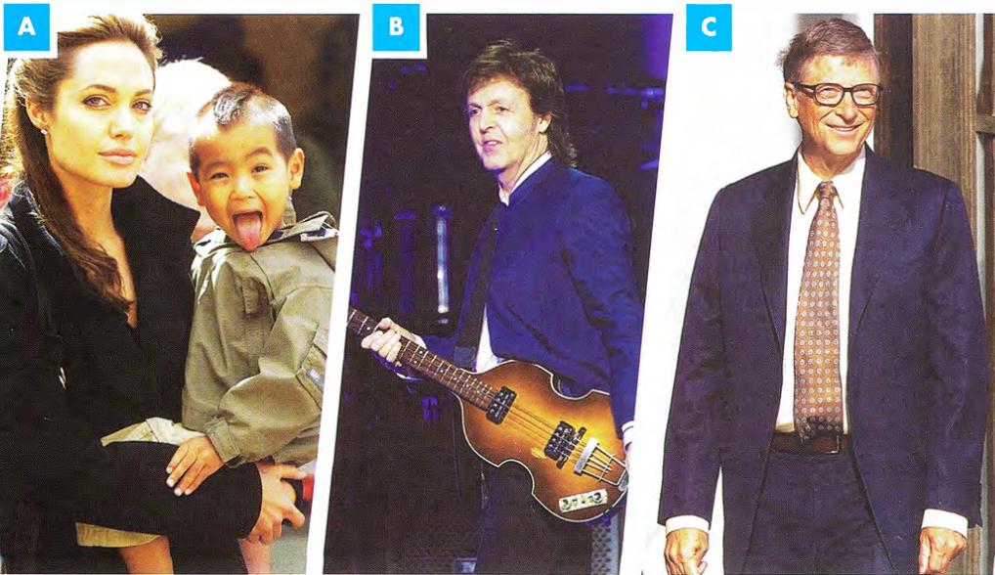

[[[[[[[[[[SPEAKING PART 2]
 | Listen to a candidate talking about a famous person. The task is shown here. Then answer questions 1-5 below.  64  - Who was the famous person?  Bill Gates  - What does the famous person do?  computer programmer, creator of Microsoft  - Where did the candidate see this person?  on television  - When did the candidate see this person?  2001, when Windows XP came out  - Why does the candidate like this person? (Give three reasons.)  Reason 1:  He is responsible for bringing computers into family homes.  Reason 2:  He was the world's youngest self-made billionaire.  Reason 3:  He gives a lot of his money to charity.
  02
  Describe a famous person who you like or admire. You should say:
  - who they are
  - why they are famous
  - where and when you saw them
  and explain why you like this person.
 | Listen to another candidate doing the same task. As you listen, complete the script using the connecting words in the box. One of them can be used more than once.  65  Well, the famous person I'm going to describe is David Beckham. He was a footballer 1 who played for Manchester United, 2 and he also played for England. I first saw him play for United 3 when I was only seven, 4 so that was probably in about 2002. I remember it as one of the most exciting days in my life!  David Beckham became famous 5 because he was a very talented footballer. His speciality was scoring amazing goals from free kicks. 6 But he wasn't well-known only for his football skills. He became even more famous when he married a pop star- Victoria, one of the Spice Girls. And another reason for his fame was his good looks and his style. I think almost every boy in the world wanted to have a David Beckham haircut! I know I did.  I adored him as a boy 7 because I was mad about football and he was my hero. The reason 8 why I still like him is that 9 in spite of his fame he behaves like a normal guy. I heard a story from someone 10 whose car was broken down in the middle of the countryside. And then a car stopped and a man got out and asked him if he needed a push. It was David Beckham! | TIP 03
  03
  and | because | but | in spite of | so | when | who | whose | why
  use these words to make longer, connected answers for Speaking Parts 2 and 3.

 | Now, it is your turn to do the Part 2 task. Read the card again and complete the set of notes below. Try to do this in 60 seconds.
  04
  Describe a famous person who you like or admire.
  You should say:
  - who they are
  - why they are famous
  - and when you saw them
  and explain why you like this person.
  Notes
  Who? ___
  Why famous? ___
  Where? ___
  When? ___
  Why like? Reasons ___
  - ___
  - ___
  - ___
 | Using your notes, do the Part 2 task with a partner. You should each try to talk for two minutes. When your partner is speaking, listen to your partner's talk and make notes of any useful phrases you hear.
  05

[[[[[[[[[[PART 3 QUESTIONS]
◉ In Speaking Part 3, the examiner will ask you some general questions about the topic you have been speaking about. These might ask you to do certain things, for example explain something or compare something.

 | Match the questions (1-5) with what each question is asking you to do (a - e)  - Do you think people are too interested in the lives of famous people? e  - How can people use their fame to do good? a  - Are there any differences between famous people now and in the past? c  - What will people be famous for in the next few years? d  - What would be the advantages and disadvantages of being famous? b  - make a suggestion about a topic  - explain about the details of a topic  - compare two different things about a topic  - predict what will happen in the future  - give an opinion about a topic | TIP 06
  06
  It is important to listen carefully to the examiner's questions so that you understand what he/she is asking you to do.
 | Now match questions 1-5 above with answers A-E below.  - E  - B  - A  - C  - D  - I think that people used to be famous more for what they did rather than who they were or what they looked like.  - Charity work seems like it could be a good idea. Most famous people earn a lot of money and it would be great if they could give some of that money to help others.  - I think we will see more normal people like you or me becoming famous over the internet. Anyone can upload a video now and get millions of views.  - If you are famous you can make a lot of money and be given a lot of free things to advertise. On the other hand, it might be difficult to do normal things, like go shopping in the supermarket.  - Well, I think that there are maybe too many celebrity TV shows and magazines these days, so that might be true.
  06

[[[[[[[[[[EXAM SKILLS]
 | Think of your own answers to the Part 3 questions from exercise 6 with a partner.  If possible, record yourselves and listen to the recordings together.  Make notes of which tenses your partner uses, and also any interesting phrases, then try to answer the questions one more time.
  08

UNIT/08: NATURAL WORLD

READINGREADING
IN THIS unIT YOU WILL
LEARN HOW TO
- complete notes with words from the text
- match sentence endings with their beginnings
- use modals of possibility and ability.

Lead-in

 | Do the two underlined words in each sentence have a similar meaning or the opposite meaning? Use a dictionary if necessary.  - A predator catches and eats its prey. opposite  - A group of dolphins is called a pod. similar  - Environmentalists work for the conservation and protection of the planet. similar  - Only a few baby turtles survived; all the others died. opposite  - Mothers have an automatic desire to protect their babies; keeping them safe is instinctive behaviour. similar
  01

SKIM READING

 | Skim read the text in ONE minute and check your answers to exercise 1.
  02

OUR FRIENDS AND PROTECTORS

A  When asked their favourite animals, many people answer 'dolphins'. They are known as friendly, intelligent creatures that have a special relationship with humans. For example, dolphins can tell when a woman is pregnant. They can also tell when someone is in trouble. No one is really sure why this is the case. Experts think they may understand that humans are similar to them and try to protect them from predators and other dangers. Dolphins' protection of humans might not be just automatic or instinctive: they may actively decide to help in certain situations.  B  There are many stories about dolphins protecting humans from sharks. Wildlife filmmaker Hardy Jones was filming a group of dolphins, when a large shark swam towards him ready to attack. Four dolphins came to his rescue and drove the shark away. Perhaps they could tell he was a person who cared very much about dolphins. In fact, Jones was a well-known campaigner against the killing of dolphins. In another incident, in 2004, in New Zealand, four people were saved from a great white shark by a pod of dolphins. The dolphins herded the swimmers into a group and formed a protective ring around them. As they had not yet seen the shark, one of them tried to swim away. He couldn't get away, because every time he tried, he was pushed back inside the ring by the dolphins.  C  Dolphins don't only save humans from sharks, but protect them in other situations too. A scuba diver was hit by a boat near the Channel Islands (between England and France) in 2006. The man was unconscious, but survived 56 hours in the water, watched over by a pod of about 150 dolphins. In 2014, dolphins again came to the help of a human. Joey Trevino was losing hope. He had been in the sea for 24 hours after his boat sank in the Gulf of Mexico. He felt he couldn't keep going any more. A friendly dolphin approached him and gently pushed him, as if to say 'don't give up'. That moral support and encouragement may have saved Trevino's life.  D  Dolphins have also been known to help other species. In New Zealand, two pygmy sperm whales were in difficulty next to a sand bank. People were trying their best to get them back out to sea, but the whales couldn't find their way past the sand bank. After several hours of failed attempts, they were ready to give up. Along came 'Moko', a bottlenose dolphin, who seemed to communicate with the whales and led them to a channel which took them back to the ocean. | E  Whales have also been known to protect both humans and other mammals. In California, in 2012, a BBC Planet Earth film crew filmed a group of humpback whales who were protecting migrating grey whales from attacks by orcas (killer whales) over a period of at least seven hours. In China, Yang Yun applied for a job training whales at Polar Land in the city of Harbin. For the 'interview' she had to dive down as far as possible in the seven-metre deep pool. When she was about five metres down, Yang Yun found she couldn't move her legs due to the freezing temperatures. Two beluga whales, Mila and Nicola, sensed that she was in trouble. Mila gripped Yang Yun's leg in her mouth and pushed Yun to the surface, saving her life.  F  Stories of marine mammals helping humans - and each other - date back to Ancient Greece. Although we may never be sure why they help us, many people feel that it is a good reason for us to do whatever we can to protect them.

[[[[[[[[[[NOTES COMPLETION]

 | One question type in the Reading paper is 'notes completion'.  Read the advice in the box and study the example below.  Example  Look at the gapped sentence and read paragraph F.  The answer is Ancient Greece. | TIP 03
  03
  ◉
  - Read the instructions carefully. Check how many words you can use. Do the words need to come from the passage or from a box of words that you are given?
  - Read the notes carefully.
  - Think of similar words to the key words in the notes.
  - Decide what kind of word is needed in the gap. Use clues like prepositions (in, from) and articles (a, an, the).
  - Find the relevant part of the passage. Look out for the similar words you noted earlier.
  - Find a word or words that seem to fit.
  - Read the notes carefully with your words added.
  - Make sure that the completed notes match the meaning of the passage and that your words match the grammar of the sentences.
  Stories of | Whales  and dolphins | assisting  people | were first  heard of | in | ___
   | | | | | | | |
   | = marine mammals | = helping humans | = date back to | 'in' tells us the answer is likely to be a year or a place
  The notes usually only relate to one part of the passage. Find the correct part and read it in detail.
  The information in the notes may not be in the same order as in the passage.
 | Read paragraph B in detail. Then match the words and phrases 1-5 from paragraph B with words and phrases a-e which have similar meanings.
  04
  - filming - c  - came to his rescue - a  - well-known - b  - against the killing of - c  - pod - d | - saved the life of  - famous  - videoing  - group (of dolphins)  - for the protection of
 | Complete the notes below. Write NO MORE THAN TWO WORDS from the passage.  A pod of dolphins saved the life of a man called 1 Hardy Jones, while he was videoing them. The man was a famous 2 campaigner for the protection of dolphins.  Which paragraph did you need to read in detail to complete the notes above? Did you need to read the whole paragraph?  The information was in paragraph B. No.
  05
 | Complete the notes below. Write NO MORE THAN THREE WORDS from the passage.  Orcas were trying to catch and hurt a group of 1 gray whales who were travelling from one place to another. The migrating whales were helped by 2 humpback whales. The whole incident lasted more than 3 seven/7 hours.  Beluga whales helped a diver who couldn't get to the surface. Because of the icy waters she was unable to 4 move her legs. One of the whales saved her life by taking hold of her 5 leg and giving her a push upwards.  Which paragraph did you need to read?  The information was in paragraph E.
  06

[[[[[[[[[[MATCHING SENTENCE ENDINGS]
◉ In this question type you are given the first part of some sentences. You have to choose the correct ending from a list. There are more sentence endings than you need.
- Read the sentence beginning carefully.
- Find the key words and think of some similar words for them.
- Find the part of the text where the answer is.
- Read the sentences carefully, looking out for the key words or similar words.
- Remember the information may be presented in a different order from the question.
- Try to complete the sentence in your own words.
- Check the list and find an ending that is similar to yours.
- Check that the completed sentence is grammatical and that the meaning matches the text.
- If the answer is a noun, check that you have used the correct form: singular or plural.

 | Which paragraph do you need to read to find the ending to this sentence?  D  Moko 'spoke' to the beached whales...  Write your own ending.
  07
 | Choose one of these endings for the sentence above.  See exercise 9.  - because her first attempts had failed.  - to help them return to the deep water.  - because she led them to safety. | TIP 08
  08
  Don't be tricked by endings that have words and phrases from the text in them. It doesn't mean the ending is correct.
 | Read the explanations below and check your answer to exercise 8.  - The words 'attempts' and 'failed' are in the text, but they were not Moko's attempts; they were the people's attempts.  - In the text the words 'led them to a channel which took them back to the ocean' are similar to 'help them return to the deep water'. This is the right ending.  - Moko led them to safety but that is not the reason she spoke to the whales.
  09
 | Complete each sentence with the correct ending a-h.
  10
  - Dolphins may protect humans - d  - Dolphins swam towards Hardy Jones - g  - The swimmer tried to leave the protective ring of dolphins - f  - A dolphin nudged Joey Trevino - b  - Dolphins and whales help us - a | - so we should protect them.  - to encourage him not to lose hope.  - because there were so many dolphins.  - because they recognise that humans are similar to them.  - because they sometimes actively decide to help.  - because he had not seen the shark.  - because a shark was about to attack him.  - because he was a campaigner for dolphin protection.

GRAMMAR FOCUS: MODALS OF POSSIBILITY AND ABILITY

◉ Modal verbs may, might and could are used when something is possible but not certain:
Experts think dolphins may understand that humans are similar to them.

 | Find two more examples of modals of possibility (look in paragraphs A and F).  (in A) Dolphins' protection of humans might not be just automatic or instinctive: they may actively decide to help in certain situations.  (in F) Although we may never be sure why they help us...
  11
 | Find more examples of modals of ability in paragraph B.  they could tell, he couldn't get away
  12
  ◉ The modals can and could are used to talk about ability in the present and past.
  Dolphins can tell when a woman is pregnant. Yang Yun found she couldn't move her legs due to the freezing temperatures.

[[[[[[[[[[EXAM SKILLS]
 | Read the passage and answer the questions opposite.  THE MODERN ZOO
  13
  The first zoo is believed to have been in Egypt in around 3500 BC. Early collections of animals on display often belonged to royalty. King Henry I of England had lions, leopards and camels. He had received them as gifts. Until the late twentieth century, the main purpose of zoos was for entertainment. They existed to give people the chance to see animals they could not see in the wild. In 1959, famous wildlife expert Gerald Durrell opened the first zoo which put conservation of animals first.  Nowadays zoos' aims are: conservation, education, entertainment, in that order. Modern zoos try to get a balance between providing safe, comfortable homes for the animals and opportunities for visitors to see animals in natural surroundings. Zoos now share their knowledge and support each other. The World Association for Zoos and Aquariums (WAZA) works to educate people about animal welfare and conservation. It also helps to coordinate breeding programmes.  Behave in a normal way, such as scratching, climbing, digging and solving problems. Another type of enrichment is mixing up types of animal that would naturally mix in the wild. Colchester Zoo in England has a 'kingdom of the wild' paddock where several species live together. They have found positive changes to the behaviour of these animals as a result.  Different types of technology are used to help create natural environments for animals. In Indianapolis Zoo, in the United States, for example, there is a 'functional forest' called the Hutan Trail, a series of towers and cables 20 metres above the ground. This allows the orangutans to swing around the zoo as they would swing around the forest in their native Indonesia. The cables are strong enough to give them a safe and comfortable trip around | From the 1990s, zoos began to see their main role as saving the most threatened species. Each zoo focuses on a small number of species. The Siberian tiger and the orangutan are two species that have been saved through breeding programmes run by zoos. For example, in 2005 there were between 331 and 393 Siberian tigers in the Russian Far East. By 2015, there were 562. The tigers were helped to breed under the Species Survival Plan of the Association of Zoos and Aquariums (AZA). Often the aim is to reintroduce endangered species into their natural habitats. In Indonesia, Borneo Orangutan Rescue teaches orangutans how to live in the wild. When they are ready, they are taken to protected forests to live naturally.  Now that we have a better understanding of animals, zoos try to recreate natural habitats of animals as accurately as possible. For example, polar bears live in a plain, white open space. Zoos try to provide 'enrichment' for the animals to improve their wellbeing. This includes climbing frames, feeding puzzles, unusual objects and different types of food. It allows animals to the zoo. They have access to three oases, where they can go when they want to be apart from the group.  Likewise, technology has been used to engage the public more with the animals. In many zoos there are webcams in some enclosures so visitors can keep up with their favourite animals between visits to the zoo.  Zoos have moved on over the last few decades. They now play an important role in protecting animals and in making people more aware of the importance of animals. Zoos have made people aware that animals should not be over-hunted and that they play an important role in the ecology of the planet and in helping to maintain the balance of nature.

 | Questions 1-6  Complete the notes below.  Choose NO MORE THAN TWO WORDS from the passage for each answer.  Before the 1990s, zoos existed mainly for 1 entertainment  The first zoo to focus on protecting animals was started by 2 Gerrald Durrel  Since the 1990s a number of zoos have introduced programmes which aim to breed  threatened animals and return them to their 3 natural habitats But first the animals have to learn how to survive in the 4 wild  Zoos offer animals 5 enrichment  by making it challenging for them to find their food, providing them with climbing equipment, and even mixing them with other species.  6 Webcams enable the public to view zoo animals from their homes.  Questions 7-11  Complete each sentence with the correct ending, A-H.  - The first zoo - H  - The World Association for Zoos and Aquariums (WAZA) - G  - Borneo Orangutan Rescue - D  - Colchester Zoo - E  - Indianapolis Zoo - A  - has created an environment that copies the animals' natural habitat.  - was started by Gerald Durrell.  - has webcams in all the enclosures.  - prepares one species to return to their own environment.  - does not always separate different types of animal.  - is part of the AZA.  - is involved in teaching about how to better care for animals and protect them and in helping zoos work together.  - was a private collection of animals.
  13

UNIT/08: NATURAL WORLD

WRITING
IN THIS unIT YOU WILL
LEARN HOW TO
- deal with two-part questions
- link different parts of the essay
- write a conclusion.

Lead-in

 | Put the words into the correct column.
  01
  - endangered - d  - air - c  - renewable - f  - natural - e  - global - b  - fossil - a | - fuels  - warming  - pollution  - species  - habitats  - energy
 | Fill in the gaps with the word pairs above to make sentences you could use in a conclusion.  - In conclusion, global warming is already causing sea temperatures to rise.  - In my opinion, loss of natural habitats is a continuing threat to wild animals.  - To sum up, air pollution is having a serious effect on people who live in cities.  - If we don't take action now, the number of endangered species will continue to increase.  - I suggest governments stop using fossil fuels and start using clean sources of energy.  - Finally, I believe that renewable energy can offer us hope to save our planet.
  02

[[[[[[[[[[WRITING A CONCLUSION]
 |  | Which of these may be included in your conclusion?  a, b, d, g, h, i and j may be included  Which of them should be included?  a, d, g and j should ideally be included |  | TIP 03
  03
  - a concluding phrase  - a prediction (what will/might happen in the future)  - supporting evidence  - your opinion  - an idea you haven't mentioned before | - plenty of detail  - a summary of your main ideas  - what you hope (or fear) might happen in future  - your recommendations  - your answer to the question  - at least four sentences
  The conclusion is a very important part of your essay. It is the last thing the examiner reads, so it must be good!
 | Match examples 1-6 with the features a-k in exercise 3.  - In short, all types of pollution are increasing. g  - So, in conclusion, we can say that... a  - Personally, I feel that there is a limit to what we can do. d  - I think there will be very few wild animals left in 25 years' time. b  - I hope people will work hard to protect our beautiful planet. h  - Governments should use the law, education and clean energy to improve the situation. i
  04
 | Which paragraph, A or B, is a better conclusion to the essay title? Why?  Paragraph A is better because it includes the points in exercise 3. Paragraph Badds new information and supporting evidence, which are not appropriate for a conclusion, though B does also give the writer's opinion and answer to the question.  - To conclude, my view is that everyone can help protect the environment. We can recycle as much as possible, maintain our vehicles properly and ask our Member of Parliament to support laws that prevent damage to the environment. If we all do this, we can ensure the planet is in good condition for future generations.  - Another issue is how we use our vehicles. We should walk or use public transport whenever possible and only have one car per family. The main reason public transport in my home town is not very good is because it is not used enough. We must get our cars serviced regularly to make sure we don't pollute the air. So this is another reason why I say, in conclusion, that people can help protect the environment.
  05
  The individual has an important role to play in protecting the environment. To what extent do you agree with this statement?

LINKING THE MAIN IDEAS AND CONCLUSION

 | Phrases 1-7 are useful in an essay. What can you use them for? Match the phrases 1-7 with their function a-g.
  06
  - In this essay I will... f  - In my view, ... d  - Another reason for ... g  - On the other hand, ... a  - For instance, ... f  - It is clear that... b  - To conclude, ... c | - to introduce the opposite view  - to introduce a main point  - to begin your final paragraph  - to introduce an opinion  - to introduce an example  - to explain your plan  - to introduce a similar point
 | Read this essay title and spend two minutes noting down any ideas you have on the topic.
  07
  Many wild animals have become endangered. Why has this happened?
  What can governments do to stop this from continuing to happen?
 | Read the essay and answer the questions below.  MODEL ANSWER  - Complete the chart with the main points of the essay.  - Tick the causes and government actions that are mentioned in the conclusion.  All of them are mentioned in the conclusion.  - Complete the sentence by choosing the correct option.  The conclusion ends with a prediction/hope/fear/recommendation.  The conclusion ends with a recommendation. | TIP 08
  08
  Many species of wild animal are now endangered. For example, the number of black rhinos has declined from over 65,000 in the 1960s to just 2,500 today. Sea animals like some types of whale are also at risk. In this essay I will look at some of the causes of this situation. I will then move on to consider what governments can do to deal with this problem.
  It is clear that animals are dying out because of human activity. People have hunted animals for sport or for their fur, horns or other body parts. For instance, they hunted tigers for their bones, which were used for medicines.
  Another reason for species to become extinct is that humans have destroyed their natural habitats. One example of this is gorillas in the rainforests, which are now endangered. Finally, pollution from industry has created problems for many sea creatures.
  Governments can help in several ways. First of all they need to make strong laws and give punishments to those who hunt illegally. Next, they need education programmes in schools and on television to help everyone understand the problem. Finally, governments should invest in renewable and clean energy sources such as solar and wind power.
  So, in conclusion, we can say that hunting and damage to the environment are the main threats that animals face. Governments should use the law, education and clean energy to improve the situation. Everyone must work together to save endangered animals.
   | The causes | Government actions
  1 | hunting for sport or body parts | laws/punishments
  2 | habitats destroyed | educations programmes
  3 | pollution | invest in clean energy
  Some questions have two parts to them. Your essay must answer both parts. Your two main paragraphs should answer one part of the question each.

GRAMMAR FOCUS: PRESENT PERFECT AND PAST SIMPLE
 | According to the model essay above, how have past human actions affected animals today? Complete the list.  - People have hunted animals for sport or for their body parts.  - Humans have destroyed their natural habitats.  - Pollution has created problems for many sea creatures. |  | One use of the present perfect tense is to talk about actions that happened in the past which have results in the present.
  09
 | Find the present perfect sentence in the introduction to the model essay above.  For example, the number of black rhinos has declined from over 65,000 in the 1960s to just 2,500 today.
  10
  ◉ Introductions often contain a sentence or two in the present perfect tense. Showing how the past has affected the present is often a good way to introduce the topic.
[[[[[[[[[EXAM SKILLS]
 | Read the essay title. How would you organise this essay? What ideas do you have for this topic?  Global warming is one of the biggest threats to our environment. What causes global warming? What solutions are there to this problem?  Give reasons for your answer and include any relevant examples from your own knowledge or experience.  Write at least 250 words.
  11
 | Read a student's plan for this essay.
  12
  Paragraph 1 - Introduction
  - Definition of global warming: increasing temperatures due to air pollution (climate change)
  - Plan of essay: causes/solutions
  Paragraph 2 - Causes
  - Cutting down trees (e.g. due to population growth)
  - Burning fossil fuels (cars, power stations, factories)
  - Using too much electricity (computers, TV, lights)
  Paragraph 2 - Solutions
  - Renewable energy (solar, wind)
  - Manage the rainforests (less cutting, more planting)
  - Transport solutions (share cars, use public transport)
  Paragraph 4 - Conclusion
  - Summarise causes and solutions
  - Recommendation: we can all try to be more 'green'
  Make sure your answers to two-part questions are balanced. Don't spend too much time on one part so that you don't develop the other.
 | Write the essay in full, following the advice in the box.  Sample answer  Global warming, also known as climate change, is the rising of temperatures all over the world because of human activity. In this essay I will explain the main causes of global warming and also suggest some solutions.  The earth's temperature is rising due to greenhouse gases, such as carbon dioxide, which get stuck in the air. One major cause is the increase in air pollution from burning fossil fuels like coal in factories and power stations. As the population grows, more energy is being used. Also, nowadays everyone owns several devices, such as computers, tablets and phones. These have to be charged every day. Another major problem is cutting down trees. Trees use carbon dioxide and release oxygen so we need a lot of them. People have cut down trees to use the wood for different purposes.  Although global warming is a major problem, there are some solutions. One of these is to use clean or renewable energy sources. For instance, solar power uses the sun to generate energy; we can also use the power of the wind and waves instead of fossil fuels. We need to protect the rainforests. For every tree that is cut down we need to plant a new tree. We can all help in different ways. One of them is to use public transport when possible and only have one car per family.  To sum up, humans have created the problem of global warming.  Therefore, humans must also try to solve the problem. We can all try to live a 'green' lifestyle by saving electricity and not buying things we don't need. (267 words)
  ◉
  - Give examples to support your ideas.
  - Use linking expressions.
  - Refer back to the main points of the essay in the conclusion.
  - Use phrases such as 'in conclusion' or 'to conclude' for the final paragraph.
  - Don't introduce any new points in the conclusion.
  - In your last sentence, suggest what should happen in the future.

UNIT/08: NATURAL WORLD

LISTENING
IN THIS unIT YOU WILL
LEARN HOW TO
- listen to people talking about a topic related to work or study
- complete notes in a task
- use headings in the notes to guide you through what the speaker is saying
- use the speaker's 'signposting' words to help you follow notes.

Lead-in
 | Match photographs A-D with the names of the animals.  - mountain gorilla  - blue ring octopus  - Pere David's deer  - Arabian leopard
  01
  Arabian leopard | blue ring octopus | mountain gorilla | Pere David's deer
  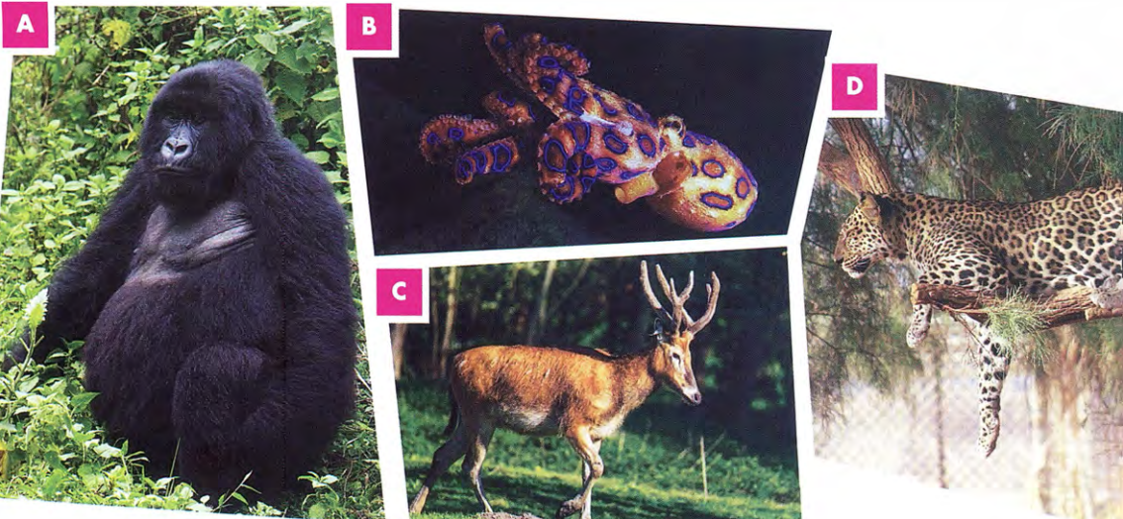
 | Listen to the four short extracts. Which animal in exercise 1 is each speaker describing?  66  - mountain gorilla  - blue ring octopus  - Arabian leopard  - Pere David's deer
  02

[[[[[[[[[[NOTE COMPLETION]
◉ In this type of task you complete a set of notes by writing up to three words, or two words and/or a number, in each gap. The instructions tell you how many words you are allowed to write.
You must complete the notes with the words you hear on the recording.

USING HEADINGS TO HELP YOU
 | Match the headings 1-5 with the questions a-e. | TIP 03
  03
  - Country of origin - b  - Dangers - e  - Diet - a  - Habitat - c  - Physical description - d | - What does it eat?  - Where does it come from?  - Where does it live?  - What does it look like?  - What threats does it face?
  The notes often have headings to guide you.
  They can help you follow what the speaker(s) are saying.

PREDICTING THE ANSWER

 | Look at the notes about the animals. Match the headings 1-5 in exercise 3 with the notes below. There is an example to help you.  - People are using its land for cows and sheep - 2  - Mainly eats grass - 3  - Has long arms - 5  - Lives on wet lands - 4  - Comes from Africa - 1 | TIP 04
  04
  Notes often do not follow grammatical rules or layout. For example, there may be auxiliary verbs or articles missing. The notes may also be lists with bullet points.
 | Look at the signposting phrases 1-6 below. They signal different kinds of information. Match them with the meanings a-e. One meaning can be used twice.  - So, now I'm going to talk a little about... - b  - Let's have a look at two reasons why ... - d  - So, I'll move on to talk about... - b  - Firstly... Secondly ... - e  - I'd like to conclude by talking about ... - a  - In other words - c  - The speaker is going to talk about a new topic and this will be the last thing he/she talks about (might be the last heading on the Notes).  - The speaker is going to talk about a new topic - which might be a new heading on the Notes.  - The speaker is going to say the same thing using different words.  - The speaker is going to give two reasons - listen carefully for both.  - Here is the first (reason)... and here is the second (reason).
  05

 | Read the notes about the mountain gorilla.
  06
  THE MOUNTAIN GORILLA
  Country of origin
  Comes from Central Africa
  Habitat
  Lives in mountain forests
  Builds a nest on the
  1 ___
  Physical description
  Has a thick coat of fur
  Older males have a
  2 ___ coloured coat
  Younger males are called
  3 ___
  Diet
  Eats plants, including leaves, fruit and flowers
  Plants provide the
  4 ___ they require
  Dangers for gorillas
  - People are destroying the environment where the gorillas live
  - 5 ___
 | Look at the gaps 1-5 in the notes in exercise 6. What kind of word do you have to listen for? Match gaps 1-5 with a-e below.
  07
  - e  - a  - d  - b  - c | - a colour  - something gorillas need to eat or drink  - something bad for gorillas  - a name  - the name of a place
 | Listen to a talk about mountain gorillas and tick the signposting phrases in exercise 5 when you hear them.  67
  08
 | Listen again and complete the notes. Write NO MORE THAN TWO WORDS for each answer.  - ground  - grey  - blackbacks / black backs  - water  - Hunting  67 |  | TIP 09
  09
  The speaker will mention some possible answers but only one is correct in each case.
  It is important to listen carefully for the information you need for each space.
  Use the headings and the notes to help you.

 | Read the notes about the mountain gorilla. | TIP 10  - How much does it weigh?  - What colour is the throat of the male?  - What part of its body is flat?  - When did it come to Britain?  - What kind of animals does it eat?  - How much money has been spent on control measures?
  10
  THE AMERICAN BULLFROG
  Origin
  - East United States
  - was introduced into the UK at the beginning of the 1 d century
  Physical description
  - female weighs up to 2 a grams
  - has a green and brown body
  - has a flat 3 c
  - male frog has a 4 b coloured throat
  Reasons for unpopularity
  - breeds rapidly, so numbers are increasing
  - eats the food of native British frogs insects, fish, birds and animals including 5 e and also eats the frogs themselves!
  - carries a disease that can kill other frogs
  - financial cost -a total of £ 6 f already spent on research into American bullfrogs
  It can be useful to rephrase the notes to form a question in your own words. This will help you know what kind of information to listen for.
 | Listen and complete the notes in exercise 10. Write ONE WORD AND/OR A NUMBER for each answer.  - 19th/nineteenth  - 750/seven hundred and fifty  - head  - yellow  - snakes  - 100,000/ one hundred thousand  68
  11
 | Check your answers carefully.  - Did you spell your words correctly?  - Did you write numbers as digits?  - Did you write a singular noun or plural noun for question 5?
  12

[[[[[[[[[[EXAM SKILLS]
 | Read the notes about the mountain gorilla.  69
  13
  THE BOX JELLYFISH
  Habitat
  In warm seas, not far from the coast
  Most dangerous box jellyfish found in
  the sea near 1 Australia
  Appearance
  Shaped like a box
  Light blue in colour
  Tentacles grow up to
  2 3/three metres in
  Length
  Has 3 24/twenty-four eyes
  How the box jellyfish stings
  - cells on tentacles can produce a powerful poison
  - when tentacles touch a human or a fish, they 4 stick to them and deliver a strong sting
  Dangers to people
  - The sting can result in death
  - by causing a heart attack
  - if a swimmer can't swim back to the shore because the sting has caused such great 5 pain
  What to do if someone has been stung
  - heart attack try to revive them
  - pour vinegar over the tentacles
  - if vinegar not available, put 6 (sea)water on the skin

UNIT/08: NATURAL WORLD

SPEAKING
IN THIS unIT YOU WILL
LEARN HOW TO
- extend your knowledge of vocabulary related to animals and their habitat
- talk at length about animals and pets for Speaking Parts 2 and 3
- develop your answers in Part 3.

Lead-in

 | Match pictures A-D with a word or phrase from each box.  - eagle: big claws, nest  - dolphin: long fin, underwater  - camel: round hump, desert  - deer: hard antlers, forest
  01
  Animals
  camel | deer | dolphin | eagle
  Characteristics
  hard antlers | big claws | long fin | round hump
  Habitat
  desert | forest | nest | underwater
  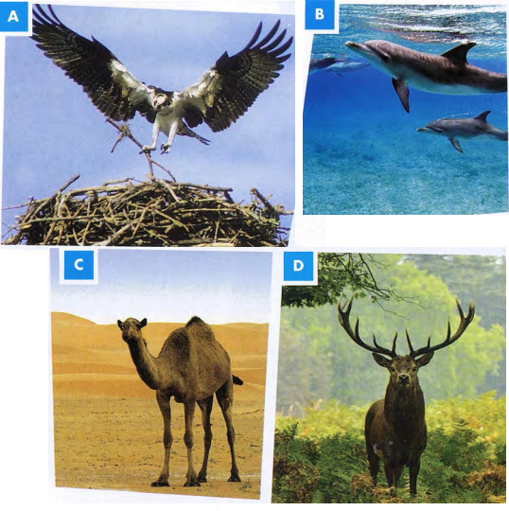
 | Take turns to describe one of the animals in the pictures to your partner. Talk about what the animal is, anything special about the animal (its characteristics) and about where the animal lives (its habitat).
  02

[[[[[[[[[[SPEAKING PART 2]
 | With a partner, use the positive adjectives in the box to say how you feel about various free-time activities.
  03
  plains | ears | thick coat
  fur | horn | mountains
  jungle | trunk | ocean
  long/short tail |  | sharp teeth
  brightly coloured feathers
  Describe a wild animal from your country.
  You should say:
  - what the animal is and what it looks like
  - what it eats
  - where it lives
  and explain how people feel about this animal.
  Animal
  What it looks like
  1
  2
  3
  Where it lives
  What it eats
  How you feel about the animal
  1
  2
  3
 | Now, complete the Part 2 task with your partner. Talk for two minutes each. When your partner has finished, think of one or two further questions to ask them about their animal.
  04

[[[[[[[[[[PART 3 QUESTIONS]

◉ In Part 3 of the Speaking test the examiner will ask you some questions about the topic in Part 2. They will be questions which require you to think. For example you might be asked for your opinion, or for ideas, solutions to problems or for an explanation about why something happens.

 | Read the Part 3 questions 1-4 on the topic of animals and match them with the beginning of some students' responses a-d.
  05
 | Using your notes, do the Part 2 task with a partner. You should each try to talk for two minutes. When your partner is speaking, listen to your partner's talk and make notes of any useful phrases you hear.  - What can governments do to prevent illegal hunting? b  - Should the government provide more money for zoos? a  - How might we be able to protect wildlife in the future? d  - Is there any difference in how children learn about wildlife now than in the past? c  - They definitely should. It seems to me that...  - There are two things X can do. The first is...  - There's a big difference, I think. In the past, we...  - Well, in the future, it might be a good idea to...  Listen and check.  70 | TIP 05
  05
  Listen for key words. You must always answer the question the examiner asks you. You will lose marks if you talk about the topic without answering the question. So you must listen carefully to the question and then begin your answer in an appropriate way.
 | Answer the questions 1-4 in exercise 5 with a partner, using the sentence beginnings to start your answer. | TIP 06
  06
  Don't always use I think .... It's good to learn some other phrases such as I feel ... , I believe ... , it seems to me that …

DEVELOPING YOUR ANSWERS FOR PART 3

◉ After making sure you have answered the question, you need to develop your answer further with reasons or examples.

Giving examples | Giving reasons
For example, we could ...  For instance, the government should ...  By way of example, maybe we would... | The reason why I think that is ...  One reason for this is that...  A good reason for X is that ...

 | Listen to a candidate answering some Part 3 questions. Complete the table.  71 | TIP 07
  07
   | Answer | Example | Reason
  - What should be done to people caught hunting illegally? | They should have their money given to animal charities and the same for people buying the animal products. | The government in Kenya took money from people who were caught buying animal furs. | This will help those charities better protect wild animals.
  - Is there anything we as individuals can do to prevent hunting? | Answer: We can stop buying things made from animals. | Many fashion designers no longer use real fur, they use fake fur instead. | The demand for things made from animals will drop, and so will demand for hunting.
  - Will there be more or less hunting in the future? | Many of our animals are already close to becoming extinct. | Many of our animals are already close to becoming extinct. | There are almost no white rhinos left.
  In Part 3 of the Speaking test try to think of real-life examples or relate the examples to your experience. But if you can't, consider inventing a fictional example to help you develop your answer. You might say, 'For example, I heard that ...' or 'For instance, I read that...

 | Using the formula in exercise 7 for developing your answer, make a similar table with your own ideas, then practise answering the questions with a partner. | TIP 08
  08
  You do not have to give examples first, then reasons. Feel free to change the order if it will help your answer make more sense.
 | Look at the words and phrases below and check that you understand them.  - responsibility, trust, patience  - unnatural, risky, unique, challenging  - interesting, friendship, relaxing but expensive, inconvenient  - gadgets, robots replace?  - breed, release, monitor in wild  - cages not good for animals, but educational  - better conditions and animal welfare now  - important to help animals, but people will prefer other entertainment
  09
 | Match the words and phrases in A-D with the Pets table and those in E-H with the Zoos table.
  10
  Pets
  - advantages and disadvantages of owning pets | C
  - keeping dangerous animals as pets | B
  - children learning from keeping pets | A
  - popularity of pets in the future | D
  Zoos
  - differences between zoos in the past and today | G
  - zoos a good idea | F
  - protecting endangered animals in zoos | E
  - zoos in the future | H

[[[[[[[[[[EXAM SKILLS]
 | Ask and answer these Part 3 questions with a partner. Use the tables and ideas in Exercise 10 to help you or use your own ideas.  [Topic: pets]  - What are some of the advantages and disadvantages of keeping a pet?  - Do you think that dangerous animals should be kept as pets?  - What can children learn from looking after pets?  - Do you think it will be popular for people to keep pets in the future?  [Topic: pets]  - Are there any differences between zoos in the past and zoos today?  - Do you think zoos are a good idea?  - How can we protect endangered animals in zoos?  - Will zoos continue to be important in the future?
  11

[[[[[[[[[[MATCHING HEADINGS]  TIP 03 | MODEL ANSWER  [[[[[[[[[[PART 2 QUESTION TYPES]  TIP 03  [[[[[[[[[EXAM SKILLS]
  buy clothes | buy
  go climbing | go
  01
  SKIM READING
  GRAMMAR FOCUS: FUTURE FORMS
  The topic sentence is often, but not always, the first sentence in a paragraph, so that is the first place to look.
  ◉ Matching headings tests your ability to
  ◉ Matching headings tests your ability to
  The pie chart shows which type of takeaway food is the most popular in the UK, while the bar chart shows how many Indian restaurants existed in
  fff
  hh
  fff aspects | dddd
  fff
  hh
  Good | Bad | bbb
  Read newspapers and websites to find out about current issues.
  ◉ In Part 2 you have to write an essay of about 250 words. There are different types of question in Part 2, and .
  The topics in Part 2 are all general and do not need special knowledge.
  WRITING AN INTRODUCTION
[[[[[[[[[[SENTENCE COMPLETION]  TIP 04 | [[[[[[[[[[ORGANISING A PART 2 TALK]  TIP 03
  coffee shop | department store
  aaa | bbb | ccc
  It is important to listen carefully to the ending of words.
  ◉ In this type of task you complete
  ◉ In this type of task you
  FOLLOWING A CONVERSATION
  afford | all sorts of
  place | original
  Lead-in
  ◉ When you are asked to speak on a
  ◉ When you are asked to speak
  Read newspapers and websites to find out about current issues.
  Describe a place where you like going shopping.
  You should say:
  - what kind of place it is
  - where it is
  - what you like to do there
  and explain why you like shopping there so much.
26 K
aaa | bbb

- a good selection  - at the weekend  - shoes  - under one roof  - walk  - picture | - in one building  - photograph  - on Saturday and Sunday  - footwear  - a wide choice  - go on foot

